Business Requirements Document (BRD)

Document Registration Module
Field | Value
Document ID | BRD-K3-DOC-001
Version | 1
Status | Draft for review — built from the latest Document Registration process diagrams: Citizen Pre-Registration Entry (v15), Document Scrutiny (v3), Payment, Digital Signing and Appointment (v2), Presentation, Photo & Thumb, Registration, Refusal and Withdrawal (v10), District Registrar Referral (v3) and Refund (v1)
Module | Document Registration
Legal basis (primary) | The Registration Act, 1908 (Central Act 16 of 1908) as amended in its application to Karnataka; The Karnataka Stamp Act, 1957 (Karnataka Act 34 of 1957)
State rules (primary) | Karnataka Registration Rules, 1965; Karnataka Stamp Rules, 1958; Karnataka Stamp (Payment of Stamp Duty by means of e-Stamping) Rules, 2009; Karnataka Stamp (Prevention of Undervaluation of Instruments) Rules, 1977; Table of Registration Fees (RD 403 ESR 85, as amended by RD/46/MNMU/2025)
Author (BA) | Nandha Kumar
Product Owner | M V Prashanth
Domain expert / SRO reviewer | Review Committee members (to be confirmed)
Target audience | Kaveri IT Cell, Department of Stamps and Registration, Government of Karnataka
Last updated | 07-10-2026

Document control
Version | Date | Author | Summary of change | Approver
1 | 07-10-2026 | Nandha Kumar | Initial BRD for Document Registration: legal references (Registration Act 1908 with Karnataka amendments, Karnataka Stamp Act 1957, Karnataka Registration Rules 1965, Stamp / e-Stamping / Undervaluation Rules), Article determination masters, To-Be process diagrams and step tables for the six processes, functional and non-functional requirements, business rules, integrations, RTM, risks, fallbacks and training | Prashanth

Contents
Document Registration Module 1
Document control 1
1. Executive summary 5
2. Scope 5
3. Legal and regulatory reference 6
i. Applicable Acts 6
ii. Relevant sections followed by the Department for Document Registration 7
iii. Relevant rules followed by the Department for Document Registration 12
iv. Relevant notifications and amendments 14
v. Stamp duty Article determination 16
vi. Statutory registers, books and forms 21
vii. Sakala — Karnataka Guarantee of Services 21
4. Stakeholders and actors 22
5. Definitions and glossary 23
6. Current state 25
i. As-Is pain points 25
7. Future state (To-Be) 26
i. Citizen pre-registration entry 26
ii. Document scrutiny by the Sub-Registrar 35
iii. Payment, digital signing and appointment 40
iv. Presentation, photo & thumb capture, registration, refusal and withdrawal 46
v. District Registrar referral, appeals and applications 59
vi. Refund of fees and stamp duty on withdrawal 67
vii. Application status model (end-to-end) 72
viii. What is new in Kaveri 3.0 74
8. Functional requirements 76
i. Citizen pre-registration entry 76
ii. Document scrutiny 81
iii. Payment, digital signing and appointment 83
iv. Presentation, photo & thumb capture and registration 85
v. Refusal to register 90
vi. Withdrawal before registration 91
vii. District Registrar referrals, appeals and applications 92
viii. Refunds 94
ix. Post-registration services 96
x. Notifications 97
xi. Reports and MIS 97
xii. Sakala integration (Karnataka Guarantee of Services) 98
xiii. Scanning Module (shared platform) 98
xiv. Business rules 99
xv. User interface (high-level) 101
xvi. Integrations 102
xvii. Data requirements 103
xviii. Requirements traceability matrix (RTM) - template 104
9. Non-functional requirements 106
i. Performance and Scalability 106
ii. Security and Data Privacy 107
iii. System Availability and Error Handling 107
iv. Security Audit and Compliance (VAPT Policy) 108
10. Risk and Mitigation Strategy 108
11. System Fallbacks & Error Handling 109
12. Training and Change Management 110
i. Target audience 110
ii. Training delivery 110
iii. Citizen change management 111
iv. Post-Go-Live support 111
13. Appendix A — References 111
14. Acceptance and sign-off of BRD 111

Executive summary
This document sets out the business requirements for the Document Registration module of Kaveri 3.0. It covers the complete life of a document from the citizen's online pre-registration entry, through scrutiny by the Sub-Registrar, payment of stamp duty and fees, digital execution (e-Sign / DSC) and appointment booking, to presentation, admission, photo and thumb capture, endorsement and registration at the Sub-Registrar Office. It also covers the exception paths that the Registration Act, 1908 and the Karnataka Stamp Act, 1957 provide: delay and condonation, absent executants (summons and commission), under-valuation references under Sec. 45-A, impounding under Sec. 33, refusal to register, appeals and applications to the District Registrar, withdrawal before registration and refunds.
The future-state design replaces manual selection and calculation with rule-driven services. The citizen picks the Transaction Intent and Nature of Document; the system determines the Article of the Schedule, imports property and owner data from the source-of-truth systems (E-Swathu, BBMP E-Aasthi, E-Aasthi, BDA, KHB, Bhoomi and Mojini), checks stays, Sec. 22-A prohibited properties and Sec. 22-B stays through a separate microservice, and calculates the guidance value, stamp duty, surcharge, cess and registration fee through dedicated microservices. Statutory time limits (4 months for presentation and appearance, condonation windows, 30-day appeal limits, refund limitation periods) are calculated and enforced by the system rather than tracked on paper.
Each process is described with its To-Be swimlane diagram, a numbered step table, key characteristics and an application status model, followed by functional requirements, business rules, integrations, a requirements traceability matrix and non-functional requirements. Statutory references are taken from the Acts, Rules and notifications held in the Acts_Rules/Document folder; items that depend on documents not held in that folder are marked for confirmation by the Department.

Scope
- Citizen pre-registration entry (online): transaction intent and nature of document, property capture (immovable, movable, TDR; inside or outside Karnataka; agricultural or non-agricultural), import from source-of-truth systems, parties, representatives, witnesses, identity verification (Aadhaar e-KYC or manual ID), PAN / Form 97 rule, allotment, transaction details, Article determination, fee calculation, exemptions, denoting / credit claims, recitals, covenants, draft deed and submission.
- Scrutiny by the Sub-Registrar: verification checklist (common and Article-specific checks), cross-check with the source of truth, guidance value and fee re-calculation, and the decision to approve for payment, revert or reject.
- Payment, digital signing and appointment: full or partial payment (Sec. 45-A under-valuation / Sec. 33 short levy), Khajane-II / payment gateway, signing list and tracker, e-Sign / DSC by parties and witnesses, deed lock, last date for presentation, and slot booking at the jurisdictional Sub-Registrar Office.
- Presentation and registration at the Sub-Registrar Office: presentation checklist, presenter, admission or denial of execution, Party Appearance Pending, summons and commission, delay checks and condonation referral, identifiers, photo, thumb impression, e-KYC and e-Sign capture, endorsement, DSC and registration number generation.
- Refusal to register (Part XII, Registration Act; Chapter XXIV, Karnataka Registration Rules): refusal order, partial registration, Book 2, blocking of re-presentation, refund of half the registration fee and return of the document.
- Withdrawal before registration (Rules 23(f), 193(i)) and refunds: registration fee and copying fee refund (Rules 193–195) and stamp duty refund for e-stamp certificates (Karnataka Stamp Act, Sec. 47–51; e-Stamping Rules 31, 32).
- District Registrar referrals and appeals: condonation of delay (Sec. 25, 34; Rules 51–55), Sec. 45-A under-valuation references, Sec. 33 impounded instruments, appeals under Sec. 72 and applications under Sec. 73, and the further remedies available against the District Registrar's orders.
- Shared microservices used by the module: Guidance Value, Stays & Liabilities, Fee Calculation, and the Article determination rules (Decision_Flow).
- Integrations: source-of-truth property systems, UIDAI e-KYC, Protean (passport), Income Tax Department (PAN), e-Sign service provider, DSC certifying authorities, Khajane-II / payment gateway, e-stamp (SHCIL / CRA) database, SMS / email gateways, DigiLocker and Sakala (if notified).
- Bilingual user interface (English and Kannada), notifications, audit trail, role-based access, reports and MIS.
- Out of scope for this BRD: deposit and opening of sealed wills (Sec. 42–46), certified copies and encumbrance certificates (Chapter XX of the Rules), marriage registration, firm and society registration, and cancellation of registered forged documents by the District Registrar under Sec. 22-C (to be covered in a separate BRD).

Legal and regulatory reference

Applicable Acts
The Department of Stamps and Registration (through Sub-Registrars, District Registrars and the Inspector General of Registration) administers the following Acts for document registration:
Act | Description
The Registration Act, 1908 (Central Act 16 of 1908), as amended in its application to Karnataka | Governs which documents must or may be registered (Sec. 17, 18), the time and place of presentation (Parts IV and V), who may present (Sec. 32, 33), the enquiry before registration and admission of execution (Sec. 34, 35), enforcing the appearance of executants (Part VII), endorsements and the certificate of registration (Sec. 58–61), refusal to register and appeals (Part XII) and fees (Part XIII). Karnataka amendments insert Sec. 22-A (documents opposed to public policy), Sec. 22-B to 22-D (refusal and cancellation of forged and prohibited documents, appeal), electronic and photocopy-based record keeping and penalties under Sec. 81-A and 81-B.
The Karnataka Stamp Act, 1957 (Karnataka Act 34 of 1957) | Levies stamp duty on instruments under the Articles of the Schedule. Governs instruments relating to several matters or falling under several descriptions (Sec. 4–6), denoting duty (Sec. 16), time of stamping (Sec. 17), adjudication (Sec. 31), examination and impounding (Sec. 33), dealing with impounded instruments (Sec. 37–41), under-valued instruments and the market value guidelines (Sec. 45-A, 45-B), allowances and refunds for spoiled stamps (Sec. 47–51) and revision by the Chief Controlling Revenue Authority (Sec. 53, 53-A).
The Indian Stamp Act, 1899 (Central Act 2 of 1899) — instruments under the Union List | Duty on the instruments reserved to the Union (bills of exchange, cheques, promissory notes, bills of lading, letters of credit, insurance policies, transfer of shares, debentures, proxies and receipts) is governed by the Central Act. Kaveri 3.0 shall not compute Karnataka duty for these instruments (see INSTRUMENTS GOVERNED BY THE STAMP ACT 1899).
The Information Technology Act, 2000 (Central Act 21 of 2000) — confirm with the Department | Legal recognition of electronic records and electronic signatures (Aadhaar e-Sign and DSC) used for execution of the deed, endorsements and orders. Not held in the Acts_Rules/Document folder; referenced for e-Sign and DSC validity.
The Income-tax law — PAN quoting rules (Form 97 declaration) — confirm with the Department | Quoting of PAN by parties to transactions in immovable property above the notified value, or a Form 97 declaration where the party has no PAN (as modelled in the pre-registration diagram). Not held in the Acts_Rules/Document folder.
The Karnataka Guarantee of Services to Citizens Act, 2011 (Sakala) — if notified | Where document registration services are notified under Sakala, a Guaranteed Service Code (GSC) is issued and the stipulated time is tracked. Notification status to be confirmed with the Sakala Mission (see 3.vii).

Relevant sections followed by the Department for Document Registration

Registration Act, 1908 (selected sections, with Karnataka amendments)
Section | Topic | Relevance | Refer section 7 / 8 for Implementation
Sec. 2 (Karnataka) | Definition of “forged document” (inserted by Act 47 of 2024) | Basis for refusal under Sec. 22-B | 7.iv.c (A step 3, C step 32); 8.v
Sec. 17, 18 | Documents of which registration is compulsory / optional | Nature of document master drives whether property and registration are needed | 7.i.c steps 3–4; 8.i
Sec. 19, 20 | Language not understood; interlineations, blanks, erasures and alterations | Presentation checklist items | 7.iv.c step 3
Sec. 21, 22 | Description of property and maps or plans; reference to Government maps or surveys | Property schedule imported from the source of truth; Mojini sketch for part sale | 7.i.c steps 11–17
Sec. 22-A (Karnataka) | Registration of documents declared opposed to public policy | Stays & Liabilities service stops the application for prohibited properties | 7.i.c steps 20–21; BR-DOC-004
Sec. 22-B (Karnataka) | Refusal of registration of forged documents and documents prohibited by law (incl. attached property) | 22-B stays stop the application; refusal ground at presentation and review | 7.i.c step 21; 7.iv.c steps 3, 5, 32, 41
Sec. 22-C, 22-D (Karnataka) | Cancellation of registration of forged documents by the District Registrar; appeal to the Inspector General within 30 days | Out of scope of this BRD; status hooks reserved | 2 (Scope)
Sec. 23 | Time for presenting documents: within 4 months from the date of execution | Last date for presentation calculated from the earliest e-Sign date | 7.iii.c step 26; 7.iv.c step 16
Sec. 24 | Documents executed by several persons at different times | Each party's e-Sign date is its date of execution | 7.iii.c step 7
Sec. 25 | Delay in presentation from urgent necessity or unavoidable accident: condonation up to 4 more months on payment of a fine up to 10× the registration fee | Condonation referral to the District Registrar | 7.iv.c step 18; 7.v.c A
Sec. 26, 27 | Documents executed out of India; wills may be presented at any time | Delay rule exceptions | 7.iv.c step 16
Sec. 28, 29 | Place for registering documents relating to land / other documents | Jurisdiction check at scrutiny and refusal for want of jurisdiction | 7.ii.c step 4; 7.iv.c step 40
Sec. 30 | Registration by Registrars in certain cases (as amended in Karnataka) | Office master and jurisdiction configuration | 8.iii
Sec. 31, 38 | Registration or acceptance at a private residence; persons exempt from appearance | Home visit / commission path for exempt executants | 7.iv.c step 14c
Sec. 32, 33 | Persons to present documents; powers of attorney recognisable for presentation | Presenter selection; PoA verification | 7.i.c step 24; 7.iv.c steps 7–8
Sec. 32-A | Compulsory affixing of photograph and fingerprints of the presenter and executants | Photo and thumb impression capture by the DEO | 7.iv.c steps 20–27
Sec. 34 | Enquiry before registration; executants may appear at different times; appearance within 4 months (+4 months with fine) | Admission recording; Party Appearance Pending; identification of executants | 7.iv.c steps 9–15, 28
Sec. 35 | Procedure on admission and denial of execution | Refusal on denial of execution; Sec. 73 path | 7.iv.c steps 9–10, 49
Sec. 36, 37, 39 | Procedure to enforce appearance: summons and their service | Summons issued on payment of the peon's fee | 7.iv.c step 14b
Sec. 51, 52, 53 | Register books; duties when a document is presented; consecutive numbering | Book-wise registration number generation | 7.iv.c step 39
Sec. 58, 59, 60, 61 | Endorsements; dating and signing; certificate of registration; return of the document | Endorsement generated and signed with DSC | 7.iv.c steps 29–39
Sec. 69 | Power of the Inspector General to make rules (Karnataka clauses incl. (m)) | Karnataka Registration Rules, 1965 | 3.iii
Sec. 70 | Power of the Inspector General to remit fines | Further remedy against condonation fines | 7.v.c E
Sec. 71 | Reasons for refusal to be recorded (Book 2); copy of reasons; no re-presentation unless directed | Refusal order, Book 2 and re-presentation block | 7.iv.c steps 41–48
Sec. 72, 73 | Appeal to the Registrar against refusal (other than denial of execution); application where execution is denied — within 30 days | Appeal / application case creation and limitation check | 7.v.c D steps 16–18
Sec. 74, 75 | Procedure of the Registrar; order to register; re-presentation within 30 days takes effect from first presentation | Hearing, enquiry and order directing registration | 7.v.c D steps 19–22
Sec. 76, 77 | Order of refusal by the Registrar; civil suit within 30 days | Order refusing to direct registration; further remedy | 7.v.c D step 22a; E
Sec. 78, 80 | Fees fixed by the State Government; fees payable on presentation | Fee Calculation service; registration fee paid in full before presentation | 7.i.c step 36; 7.iii.c step 3
Sec. 81-A, 81-B (Karnataka) | Penalty for registering prohibited / forged documents; offences by companies | Audit trail and refusal evidence | 8.v; NFR-DOC-AUD-001

Karnataka Stamp Act, 1957 (selected sections)
Section | Topic | Relevance | Refer section 7 / 8 for Implementation
Sec. 3 | Instruments chargeable with duty; Government-executed instruments exempt | Exemption inputs checked before calculation (GR-13) | 7.i.c step 36
Sec. 4 | Several instruments used in a single transaction: principal pays full duty, others ₹100 | Principal / secondary instrument flag (GR-03) | 7.i.c step 34
Sec. 5 | Instruments relating to several distinct matters (aggregate duty) | Not handled: one transaction per application (GR-01) | 7.i.c step 3
Sec. 6 | Instrument coming within several descriptions: highest duty | Article determination selects the highest duty | 7.i.c step 34
Sec. 10 | Duties how to be paid (e-stamping, franking, challan) | Payment through Khajane-II / gateway; e-stamp references | 7.iii.c steps 3–4
Sec. 16 | Denoting duty: duty depends on duty paid on another instrument | Denoting / credit claim and set-off | 7.i.c steps 40–45
Sec. 17 | Instruments executed in Karnataka to be stamped before or at the time of execution | Payment completed before e-Sign | 7.iii.c steps 3–7
Sec. 31, 32 | Adjudication as to proper stamp by the Deputy Commissioner; certificate | Article dispute: seek the Deputy Commissioner's opinion before signing | 7.iii.c step 3b
Sec. 33 | Examination and impounding of instruments not duly stamped | Short levy marked for impounding; Register of Impounded Documents | 7.iii.c step 3b; 7.iv.c step 34b
Sec. 34 | Instruments not duly stamped inadmissible in evidence | Registration only after duty and penalty are paid | 7.iv.c step 35
Sec. 37, 39 | Impounded instruments: sending to the Deputy Commissioner; power to stamp with penalty of ₹5 or up to 10× the deficit | District Registrar order on impounded instruments | 7.v.c C
Sec. 41 | Endorsement of instruments on which duty and penalty have been paid | Endorsement of payment on the instrument | 7.v.c step 14
Sec. 44, 53, 53-A, 54 | Refund of penalty / excess duty; control and revision by the Chief Controlling Revenue Authority; reference to the High Court | Further remedies against Sec. 39 and Sec. 45-A orders | 7.v.c E
Sec. 45-A | Instruments of conveyance etc. under-valued: communication of market value, reference to the Deputy Commissioner, order within 90 days, interest, appeal with 50% deposit | Partial payment for under-valuation; District Registrar referral | 7.iii.c steps 1, 3b; 7.iv.c step 34a; 7.v.c B
Sec. 45-B | Central Valuation Committee: estimation, publication and revision of market value guidelines | Guidance Value service uses the published rates | 7.i.c step 18
Sec. 47, 48 | Allowance for spoiled stamps; application within 6 months (1 year if undated) | Stamp duty refund on withdrawal | 7.vi.c B steps 10–14
Sec. 51 | Allowance after deducting 20 paise per rupee | Refund amount calculation | 7.vi.c step 15
Sec. 52(2) | Appeal against rejection of an allowance (as modelled in the refund diagram — confirm with the Department) | Appeal information shown on rejection | 7.vi.c step 14

Relevant rules followed by the Department for Document Registration

Karnataka Registration Rules, 1965
Rule | Requirement | Refer section 7 for Implementation
Rule 23 | Minute Book entries: (a) impounding, (e) summons, (f) withdrawals and refunds and other proceedings | 7.iv.c steps 13, 14b, 18, 34a, 34b, 51; 8.iv
Rule 24(iii)(a) | Register of Impounded Documents | 7.iv.c step 34b
Rules 37–45 (Chapter IX) | Presentation of documents, receipt and checks at presentation | 7.iv.c steps 1–8
Rule 46 | Documents presented with deficit stamp / late presentation: action by the Registering Officer | 7.iii.c step 30; 7.iv.c steps 3, 18, 34b
Rule 50(iii) | Date of execution altered to avoid the delay fine is not accepted | 7.iv.c step 3
Rules 51–55 | Fines for delay in presentation / appearance: slab of 1×, 2×, 5×, 10× the registration fee; application and order | 7.iv.c step 18; 7.v.c A
Rules 56–62 (Chapter X) | Attendance at private residences and commissions | 7.iv.c step 14c
Rules 63–70 (Chapter XI) | Powers of attorney: authentication and recognition | 7.i.c step 24
Rules 71–81 (Chapter XII) | Thumb impressions, photographs and identification of executants | 7.iv.c steps 20–28
Rules 94–109 (Chapter XVI) | Endorsements; Rule 106 (partial registration endorsement) | 7.iv.c steps 29–31, 43
Rules 110–118 (Chapter XVII) | Return of documents; Rule 112 (return of refused documents); Rule 116 (impounded documents) | 7.iv.c steps 35, 46; 7.v.c step 15
Rule 171 | Reasons for refusal to register, incl. (vi) / (viii) delay beyond the time allowed and (xvi) fees not paid | 7.iii.c step 3b; 7.iv.c steps 5, 9, 17, 19, 41
Rules 172, 173 | Executants appearing at different times; partial refusal | 7.iv.c steps 13, 42–43
Rules 175–191 (Chapter XXV) | Appeals and applications against refusal: who may appeal, verification, hearing, orders, communication, limitation; Rule 190 (no appeal when returned at presenter's request) | 7.v.c D
Rule 192 | Determination of fees | 7.i.c step 36
Rule 193 | Withdrawal when allowed; refund of half the registration fee and copying fees (delay fine not refunded) | 7.iv.c steps 46, 51; 7.vi.c A
Rule 194 | Refund of amounts: District Registrar up to 3 years, Inspector General up to 5 years from the date of collection | 7.vi.c steps 4–6
Rule 195 | Application for remission or refund of fees; refund register (Form 28) | 7.vi.c steps 1, 3, 9
Rule 205 | Preservation of permanent records (incl. Book 2) | 7.iv.c step 44; 8.xvii
Form 27 | Proceeding sheets of the Registrar in appeals and enquiries | 7.v.c step 20

Karnataka Stamp Rules, e-Stamping Rules, Undervaluation Rules and Franking Rules
Rule | Requirement | Refer section 7 for Implementation
Karnataka Stamp Rules, 1958 — Rules 16, 17 | Evidence and enquiry for allowance of spoiled stamps | 7.vi.c step 13
Karnataka Stamp Rules, 1958 — Rule 18 | Denoting duty | 7.i.c step 40
e-Stamping Rules, 2009 — Rule 31 | Application in Form 4 for refund of an unused / spoiled e-stamp certificate | 7.vi.c step 11
e-Stamping Rules, 2009 — Rule 32 | Cancellation and locking of the certificate; refund less 20 paise per rupee; treasury cheque; register and monthly report to the CCRA | 7.vi.c steps 15–16
Prevention of Undervaluation Rules, 1977 — Rule 3, Form I | Statement of particulars of property and its market value | 7.iv.c step 34a
Prevention of Undervaluation Rules, 1977 — Rule 3A, Form IA | Communication of value by the Sub-Registrar; presentant agrees to pay, asks for reference to the Deputy Commissioner, or withdraws | 7.iii.c step 1; 7.iv.c step 34a
Prevention of Undervaluation Rules, 1977 — Rule 4, Form II | Notice by the Deputy Commissioner to the parties; representations within 21 days | 7.v.c step 4B
Franking Rules, 2000 | Payment of duty by franking impression (legacy instruments presented with franked duty) | 8.iii (payment references)

Relevant notifications and amendments
Instrument | Date / No. | Effect | Refer section 7 for Implementation
Table of Registration Fees | RD 403 ESR 85, dated 27-05-1986 (as amended) | Registration fee and other fees under Sec. 78 | 7.i.c step 36 (Fee Calculation service)
Revision of registration fee | RD/46/MNMU/2025, dated 29-08-2025 (effective 31-08-2025) | Article I(4)(a): ₹20 for every ₹1,000 or part thereof (was ₹10); Article III(a)(i) and (ii): ‘one rupee’ substituted by ‘two rupees’ | Fee Calculation service rate master; BR-DOC-012
Registration (Karnataka Amendment) Act, 1976 | Karnataka Act 55 of 1976 | Inserts Sec. 19A and Sec. 22A (documents opposed to public policy); amends Sec. 45, 46, 51, 52, 54, 55, 60–62, 69, 81, 82; inserts Sec. 82A and 89A | 7.i.c step 20 (Sec. 22-A check)
Registration (Karnataka Second Amendment) Act, 1976 | Karnataka Act 64 of 1976 | Further amendment of the principal Act (refer gazette text) | —
Registration (Karnataka Amendment) Act, 1980 | Karnataka Act 19 of 1980 | Inserts Sec. 80A (refer gazette text) | 8.iii (fees)
Registration (Karnataka Amendment) Act, 1984 | Karnataka Act 41 of 1984 | Sec. 51(5) reconstruction of books; Sec. 61(2) manner of return; Part XIA photocopying of documents (later repealed by Act 32 of 2001) | 7.iv.c step 39
Registration (Karnataka Amendment) Act, 1987 | Karnataka Act 24 of 1989 | Amends Sec. 30; omits Sec. 67 | 3.ii
Registration (Karnataka Amendment) Act, 2000 | Karnataka Act 32 of 2001 | Substitutes Part XIA (electronic / computerised registration and records); amends Sec. 6, 12 | 8.xvii (records)
Registration (Karnataka Amendment) Act, 2002 | Karnataka Act 22 of 2002 | Amends Sec. 70C, 70D | 8.xvii (records)
Registration (Karnataka Amendment) Act, 2023 | Karnataka Act 47 of 2024 (Gazette 19-10-2024) | Defines forged document; inserts Sec. 22-B (refusal), 22-C (cancellation by the District Registrar), 22-D (appeal to the Inspector General within 30 days); amends Sec. 69; inserts Sec. 81-A, 81-B | 7.i.c step 21; 7.iv.c steps 3, 5, 32, 41
Karnataka Stamp (Amendment) Act, 2011 | Karnataka Act 16 of 2011 | Amends Sec. 9 and the Schedule (Budget 2011-12) | Fee Calculation rate master
Karnataka Stamp (Amendment) Act, 2012 | Karnataka Act 15 of 2012 | Amends the Schedule (Budget 2012-13) | Fee Calculation rate master
Karnataka Stamp (Amendment) Act, 2013 | Karnataka Act 29 of 2013 | Joint Development Agreement and its consequent power of attorney: duty on one document reduced to ₹200 where the other is duly stamped | Article rules 5(f) / 41(ea); credit rule GR-08
Karnataka Stamp (Amendment) Act, 2014 | Karnataka Act 19 of 2014 | Amends Sec. 9 and the Schedule; exemption for BDA alternate-site sale deeds; validation | Exemption master
Karnataka Stamp (Amendment) Act, 2021 / Lo-61-2019-20 | Karnataka Act 26 of 2021 | Article 20(2A): concessional duty slabs for first conveyance of apartments (e.g. ₹35–45 lakh at 3%) | Article rules 20(2A); Fee Calculation rate master
e-Stamping Rules notification | RD 380 MUNOMU 2008 | Karnataka Stamp (Payment of Stamp Duty by means of e-Stamping) Rules, 2009 | 7.vi.c B
Prevention of Undervaluation Rules | RD 73 EST 74 dated 02-03-1977; amended by RD 264 MUNOMU 99 dated 18-08-1999 | Forms I, IA and II for Sec. 45-A references | 7.iv.c step 34a; 7.v.c B

Stamp duty Article determination
Stamp duty depends on the Article of the Schedule under which the instrument falls. Instead of asking the citizen or the operator to pick an Article, Kaveri 3.0 asks for the Transaction Intent, then the Nature of Document, and then only the questions in the Decision_Flow needed for that nature. The first terminal answer gives the Article / sub-clause, and the Fee Calculation service computes the duty. The masters below are taken from the Stamp Duty — Article Determination & Input Capture Matrix (12 intents, 59 natures of document, 119 inputs, 180 Article / sub-clause rules). Duty rates are as printed in the 2022 consolidated Schedule; later amendments must be configured by the Department before go-live.

Transaction intents
Code | Transaction Intent
INT-01 | Transfer of ownership / rights in property
INT-02 | Security for loan / debt (mortgage, pledge, hypothecation, charge)
INT-03 | Right to use property (lease / licence / hire)
INT-04 | Authorisation (Power of Attorney / appointment)
INT-05 | Division / distribution of property (partition, settlement, trust)
INT-06 | Business entity / company / securities
INT-07 | Agreement / contract
INT-08 | Cancellation / release / surrender / revocation
INT-09 | Bonds and guarantees
INT-10 | Personal / family status (adoption, divorce)
INT-11 | Declarations, certificates, copies and notarial instruments
INT-12 | Shipping, goods and trade documents

Nature of document and Article
Code | Nature of Document | Intent | Article(s)
DN-01 | Acknowledgement | INT-11 | 1
DN-02 | Administration Bond | INT-09 | 2
DN-03 | Adoption Deed / Authority to Adopt | INT-10 | 3
DN-04 | Affidavit / Declaration | INT-11 | 4
DN-05 | Agreement / Memorandum of Agreement | INT-07 | 5
DN-06 | Deposit of Title Deeds / Pawn / Pledge | INT-02 | 6
DN-07 | Appointment in Execution of a Power | INT-04 | 7
DN-08 | Appraisement / Valuation | INT-11 | 8
DN-09 | Apprenticeship Deed | INT-07 | 9
DN-10 | Articles of Association | INT-06 | 10
DN-11 | Award (Arbitration) | INT-01 | 11
DN-12 | Bond | INT-09 | 12
DN-13 | Bottomry Bond | INT-12 | 13
DN-14 | Cancellation of Instrument | INT-08 | 14
DN-15 | Certificate of Sale (Public Auction) | INT-01 | 15
DN-16 | Share Certificate / Document of title to shares | INT-06 | 16
DN-17 | Certificate of Enrolment as Advocate | INT-11 | 17
DN-18 | Charter Party | INT-12 | 18
DN-19 | Clearance List (Stock Exchange) | INT-06 | 18-A
DN-20 | Composition Deed | INT-07 | 19
DN-21 | Conveyance / Sale Deed (incl. Flat, Amalgamation, Machinery, Securitisation, TDR) | INT-01 | 20
DN-22 | Certified Copy / Extract | INT-11 | 21
DN-23 | Counterpart / Duplicate | INT-11 | 22
DN-24 | Customs / Excise Bond | INT-09 | 23
DN-25 | Delivery Order (Goods) | INT-12 | 24
DN-26 | Divorce Instrument | INT-10 | 25
DN-27 | Exchange of Property | INT-01 | 26
DN-28 | Further Charge on Mortgaged Property | INT-02 | 27
DN-29 | Gift Deed | INT-01 | 28
DN-30 | Indemnity Bond | INT-09 | 29
DN-31 | Lease (incl. Sub-lease, Agreement to Let, Mining Lease / MDPA) | INT-03 | 30
DN-32 | Letter of Allotment of Shares | INT-06 | 31
DN-33 | Letter of Licence (Debtor - Creditors) | INT-07 | 32
DN-34 | Licence of Immovable / Movable Property (Leave & Licence) | INT-03 | 32-A
DN-35 | Memorandum of Association | INT-06 | 33
DN-36 | Mortgage Deed (incl. Hypothecation, Collateral Security) | INT-02 | 34
DN-37 | Mortgage of Crop | INT-02 | 35
DN-38 | Notarial Act | INT-11 | 36
DN-39 | Broker / Agent Note or Contract Note | INT-06 | 37
DN-40 | Note of Protest by Master of Ship | INT-12 | 38
DN-41 | Partition Deed | INT-05 | 39
DN-42 | Partnership (Constitution / Reconstitution / Dissolution) | INT-06 | 40
DN-43 | Limited Liability Partnership | INT-06 | 40-A
DN-44 | Power of Attorney | INT-04 | 41
DN-45 | Protest of Bill or Note | INT-11 | 42
DN-46 | Protest by Master of Ship | INT-12 | 43
DN-47 | Reconveyance of Mortgaged Property | INT-08 | 44
DN-48 | Release Deed | INT-08 | 45
DN-49 | Respondentia Bond | INT-12 | 46
DN-50 | Security Bond / Surety Bond | INT-09 | 47
DN-51 | Settlement Deed / Revocation of Settlement | INT-05 | 48
DN-52 | Share Warrant to Bearer | INT-06 | 49
DN-53 | Shipping Order | INT-12 | 50
DN-54 | Surrender of Lease | INT-08 | 51
DN-55 | Transfer (Debentures, Mortgage / Bond interest, Trust property) | INT-01 | 52
DN-56 | Transfer / Assignment of Lease | INT-01 | 53
DN-57 | Transfer of Licence | INT-01 | 53-A
DN-58 | Trust (Declaration of Trust) | INT-05 | 54
DN-59 | Warrant for Goods | INT-12 | 55

Sub-classification masters
Agreement subject (Article 5):
Code | Agreement relates to | Article
AS-01 | Sale of a bill of exchange | 5(a)
AS-02 | Purchase / sale of Government security | 5(b)
AS-03 | Purchase / sale of shares, stocks, debentures, marketable securities | 5(c)
AS-04 | Lease-cum-sale allotment of site / building / shed by an authority | 5(d)
AS-05 | Lease-cum-sale of Flat / Apartment by BDA / KHB | 5(da)
AS-06 | Sale of immovable property (Agreement to Sell) | 5(e)
AS-07 | Construction / Joint Development of immovable property (JDA) | 5(f)
AS-08 | Sale of movable property | 5(g)
AS-09 | Mortgage (agreement relating to mortgage) | 5(h)
AS-10 | Depository Participant - client (Demat account opening) | 5(i)
AS-11 | Stock broker / sub-broker - client | 5(i-a)
AS-12 | Advertisement / telecasting / broadcasting for business promotion | 5(i-b)
AS-13 | Assignment / transfer of Intellectual Property Rights | 5(i-c)
AS-14 | Building works / labour / services (Works Contract) | 5(i-d)
AS-15 | Chit Agreement (Sec 6, Chit Funds Act, 1982) | 5(i-e)
AS-16 | Any other agreement not otherwise provided for | 5(j)

Power of Attorney purpose (Article 41):
Code | Purpose | Article
PP-01 | Only to present / admit execution / procure registration of document(s) of a single transaction | 41(a)
PP-02 | To act in a single transaction (other than registration only) | 41(b)
PP-03 | To act in more than one transaction or generally (General POA) | 41(c)/(d)/(h)
PP-04 | To sell immovable property | 41(e)/(eb)/others
PP-05 | Construction / Joint Development of immovable property (owner to developer) | 41(ea)
PP-06 | To sell Transferable Development Rights (TDR) | 41(ec)
PP-07 | Broker / agent: trading operations in marketable securities | 41(f)
PP-08 | Broker / agent: other trading operations governing such operations | 41(g)
PP-09 | Any other purpose | 41(h)

Conveyance type (Article 20):
Code | Conveyance type | Article
CT-01 | Sale / transfer of property (general conveyance) | 20(1)
CT-02 | Sale of Flat / Apartment / Unit by promoter, land owner or developer, or transfer of share in co-op society / company for a unit | 20(2)
CT-03 | Conveyance of Flat / Apartment by BDA / KHB | 20(3)
CT-04 | Order of High Court / NCLT / Tribunal: Amalgamation of companies | 20(4)(i)
CT-05 | Order of High Court / NCLT / Tribunal: Reconstruction / Demerger | 20(4)(ii)
CT-06 | Conveyance of industrial machinery | 20(5)
CT-07 | Assignment of receivables to SPV (securitisation under SARFAESI) | 20(6)
CT-08 | Conveyance of Transferable Development Rights (TDR) | 20(7)

General stamp duty rules
Rule | Section / Article | Topic | Legal provision (summary) | System implementation
GR-01 | System scope | One transaction per application | Each application covers one transaction (one Nature of document). Documents relating to several distinct matters (Sec 5 - aggregate duty) are not handled by the system. | Step 3 allows selection of a single Nature of document only.
GR-02 | Sec 6 | Instrument falling under two or more descriptions | Chargeable only with the highest of such duties. | Evaluate each matching rule; select maximum.
GR-03 | Sec 4 | Several instruments for one sale / mortgage / settlement | Principal instrument pays Schedule duty (highest of the set); every other instrument Rs. 100. | Capture GEN-11; if Secondary -> Rs. 100; parties may designate principal.
GR-04 | Sec 6 proviso / Art 22 | Counterpart / duplicate | Counterpart of an instrument on which proper duty is paid: Art 22. | Validate original document reference (MSC-09).
GR-05 | Sec 45-A / 45-B | Market value check | For conveyance, gift 28(a), exchange, settlement 48-A(i), partnership 40-B(a) / 40-C(a), agreement 5(e)(i) / 5(f), lease 30(1)(vi), POA 41(e)/(ea)/(eb), release 45(a), decree conveyance, award 11(a), trust 54(iii), TDR 20(7): duty on higher of declared value and guidance MV published by CVC. | GEN-09 auto-fetched from Guidance Value module; 'Sec 45-A MV check' column in Article_Rules = Yes.
GR-06 | Schedule | 'or part thereof' rounding | Wherever duty is 'per Rs. X or part thereof', the base is rounded UP to the next multiple of X. | Implement CEILING(base / X) x rate.
GR-07 | Schedule | Minimum / maximum caps | Apply the min / max stated for the clause after computing the ad valorem amount. | Article_Rules columns Minimum / Maximum.
GR-08 | Art 5 Expl. II, 41 provisos, 20(1) provisos | Adjustment of duty already paid | Duty paid on agreement 5(e)/5(h), POA 41(e)/(eb), lease-cum-sale 5(d)/5(da) is adjustable against the later conveyance / mortgage between the same parties for the same property. | Capture GEN-12 / POA-04 with document reference; system verifies the earlier e-stamp / registration.
GR-09 | Art 5(e), 5(g), 14 | Cancellation of agreement | Deed cancelling a duly stamped 5(e)(i) / 5(g)(i) agreement between the same parties: max Rs. 500. | AGR-15 flag.
GR-10 | Art 30, 32-A | Average annual rent | Average annual rent = total rent for the term / number of years (for term < 1 year, rent for the term). | Derived from LSE-03 rent schedule (captures escalation).
GR-11 | Art 30, 32-A, 5(f), 41(ea) | Money advanced | Includes security deposit, whether refundable or adjustable. | LSE-05 / AGR-13 always captured.
GR-12 | Art 41 Explanation | Counting attorneys | Persons belonging to the same firm count as one person. | POA-02 validation.
GR-13 | Sec 3 | Exemptions | Instruments listed as exempt under an Article (and Govt-executed instruments exempt under Sec 3) carry no duty. | Exemption inputs (Purpose = E) are checked before calculation.

Statutory registers, books and forms
Register / form | Statutory ref | Kaveri 3.0 treatment
Book 1 | Sec. 51; Rules 125–134 (indexes) | Registered non-testamentary documents relating to immovable property; registration number office–book–serial–financial year
Book 2 | Sec. 51, 71(1); Rules 171, 205 | Record of reasons for refusal to register — kept permanently; free copy of reasons
Book 3 | Sec. 51 | Wills and authorities to adopt (registration path only; deposit of wills out of scope)
Book 4 | Sec. 51 | Miscellaneous documents not falling in Book 1 or 3
Minute Book | Rule 23 | Electronic Minute Book entries signed with DSC: pending appearance, summons, commission, condonation referral, Sec. 45-A reference, impounding, withdrawal
Register of Impounded Documents | Rule 24(iii)(a); Stamp Act Sec. 33 | Entry on impounding with the reasons and the District Registrar's order
Refund register (Form 28) | Rules 23(f), 195 | Registration and copying fee refunds: application, sanction, refund or rejection
Proceeding sheets (Form 27) | Rules 179, 181 | District Registrar's record of hearing in appeals and applications
File of appeal orders | Rules 180, 185 | Orders directing or refusing registration on appeal
Form I / IA / II (Undervaluation Rules) | Rules 3, 3A, 4 | Statement of market value, communication of value, notice by the Deputy Commissioner
Form 4 (e-Stamping Rules) | Rule 31 | Application for refund of an e-stamp certificate
Register of cancelled e-stamp certificates | e-Stamping Rule 32 | Cancellation, refund and monthly report to the Chief Controlling Revenue Authority

Sakala — Karnataka Guarantee of Services
If document registration services (presentation and registration, refund of fees, certified copies) are notified under the Karnataka Guarantee of Services to Citizens Act, 2011, the module shall obtain a Guaranteed Service Code (GSC) at the point the service is accepted (submission for scrutiny or presentation, as notified) and synchronise the service lifecycle with the Sakala platform. The notification status, service codes and stipulated times are to be confirmed with the Sakala Mission before build; the requirements are in 8.xii.

Stakeholders and actors
Actor | Description | Primary goals | Channel involvement
Citizen / Applicant | Party to the document or a document writer who files the application online | Prepare the application once, know the exact duty and fees, track progress | Online (portal, mobile links)
Executant | Person who executes (signs) the document, e.g. Seller, Donor, Mortgagor; auto-added when imported as owner | Sign the deed, appear and admit execution | Online e-Sign; office appearance
Claimant | Person in whose favour the document is executed, e.g. Purchaser, Donee | Sign where required; receive the registered document | Online e-Sign; office appearance
Representative | Power of Attorney holder, guardian of a minor or institution representative acting for a party | Act for the party with verified authority (Sec. 32, 33) | Online and office
Witness / Identifier | Attesting witness to execution (at least two) and identifiers of executants at the office | Attest the deed; identify executants (Sec. 34(3)) | Online e-Sign; office capture
Presenter | Party (or authorised agent) who presents the document at the Sub-Registrar Office | Present, withdraw or apply for summons / refunds | Office
Sub-Registrar (SR) | Registering officer of the jurisdictional Sub-Registrar Office | Scrutinise, present, record admission, endorse, register or refuse; refer to the District Registrar | Office (Kaveri back office)
Data Entry Operator (DEO) | Office staff who capture identifiers, photos, thumb impressions, e-KYC and e-Signs | Accurate capture at the counter | Office
District Registrar | Registrar of the district; also acts as Deputy Commissioner for Sec. 45-A references and impounded instruments where notified | Decide condonation, Sec. 45-A, Sec. 33 and appeals / applications; sanction refunds up to 3 years | Office (Kaveri back office)
Inspector General of Registration (IGR) | Head of the Department | Sanction refunds up to 5 years; remit fines (Sec. 70); rules and masters | Office
Deputy Commissioner of Stamps | Officer deciding stamp duty refunds on e-stamp certificates | Verify and allow refunds (Sec. 47–51; e-Stamping Rules 31, 32) | Office
Regional Commissioner / Chief Controlling Revenue Authority | Appellate and revisional authorities under the Stamp Act | Decide appeals (Sec. 45-A(5)) and revisions (Sec. 53, 53-A) | Outside Kaveri (status recorded)
Kaveri IT Cell / Administrator | Department IT team | Masters (offices, rates, Articles, checklists), roles, configuration | Admin console
External systems | E-Swathu, BBMP E-Aasthi, E-Aasthi, BDA, KHB, Bhoomi, Mojini, UIDAI, Protean, Income Tax, e-Sign ESP, CA, Khajane-II, e-stamp, SMS / email, DigiLocker, Sakala | Authoritative data and services | System-to-system

Definitions and glossary
Term | Definition
Transaction Intent | What the document does (12 intents, e.g. transfer of ownership, security for loan, right to use); filters the Nature of Document list.
Nature of Document | Type of instrument (59 natures, e.g. Sale Deed, Gift Deed, Lease, Power of Attorney) mapped to the Articles of the Schedule.
Article | Entry in the Schedule to the Karnataka Stamp Act, 1957 that fixes the duty for the instrument (e.g. Article 20(1) conveyance).
Guidance value (GV) | Market value guideline published by the Central Valuation Committee (Sec. 45-B); calculated by the Guidance Value service.
Market value | Price the property would fetch if sold in the open market on the date of execution; duty is charged on the higher of declared consideration and guidance value for the Sec. 45-A instruments.
Stamp duty, surcharge, cess | Duty under the Stamp Act and the additional levies collected with it, calculated by the Fee Calculation service.
Registration fee | Fee under the Table of Registration Fees (Sec. 78), currently ₹20 per ₹1,000 under Article I(4)(a).
Denoting / credit | Set-off of duty already paid on an earlier instrument (Sec. 16 and Rule 18; agreements 5(e), PoA 41(e)/(eb), lease-cum-sale 5(d) between the same parties).
Discretionary exemption | Exemption that needs the Sub-Registrar's approval; payment is held as Pending Verification until approved (one per application).
Source of truth | Authoritative property system: E-Swathu, BBMP E-Aasthi, E-Aasthi, BDA, KHB (non-agricultural), Bhoomi RTC and Mojini (agricultural).
Stays & Liabilities | Microservice that checks government / court stays, 22-B stays, Sec. 22-A prohibited properties, land restrictions and liabilities.
Execution / date of execution | Signing of the deed; in Kaveri 3.0 each party's e-Sign date is that party's date of execution.
Presentation | Formal submission of the executed document to the Sub-Registrar by a person entitled under Sec. 32.
Admission of execution | Executant's acknowledgement before the Sub-Registrar that they executed the document (Sec. 34, 35).
Party Appearance Pending | Status while some executants have not yet appeared and admitted (Sec. 34(2); Rule 172).
Summons / commission | Means of securing the appearance or examination of an absent executant (Sec. 31, 33, 36–39).
Condonation | District Registrar's order excusing delay in presentation or appearance up to a further 4 months on payment of a fine (Sec. 25, 34; Rules 51–55).
Impounding | Retention of an instrument not duly stamped and its referral for duty and penalty (Stamp Act Sec. 33, 37, 39).
Sec. 45-A reference | Reference of an under-valued instrument to the Deputy Commissioner / District Registrar for determination of market value.
Endorsement | Statutory particulars endorsed on the document: presentation, admission, identification, fees, condonation (Sec. 58–60; Rule 55(ii)).
Refusal order | Order of the Sub-Registrar refusing registration with recorded reasons (Sec. 71; Rule 171), entered in Book 2.
Withdrawal | Return of a document at the presenter's written request before registration (Rules 23(f), 193(i)); not a refusal.
e-Sign | Aadhaar OTP-based electronic signature through an e-Sign service provider.
DSC | Digital Signature Certificate on a token issued by a certifying authority; used by officers and optionally by parties.
e-KYC | Aadhaar-based electronic identity verification through UIDAI.
Form 97 | Declaration by an individual party without PAN, as modelled in the pre-registration diagram (above ₹45 lakh: proof of PAN application also needed).
Khajane-II | Government of Karnataka integrated treasury system used for challans, receipts and refund bills.
e-stamp certificate | Certificate issued through the e-stamping system (Central Record-keeping Agency) as proof of stamp duty paid.
TDR | Transferable Development Rights certificate issued by BBMP / BDA.
Mojini | Survey sketch system for agricultural land; provides transferees and sketch details for part sales.

Current state

As-Is pain points
No departmental As-Is study for document registration is held in the workspace. The pain points below are those the To-Be process diagrams are designed to remove, as identified during the process design discussions. They must be validated by the Department before sign-off.
Sr.No | Pain Point | Description | Source | Addressed in (this BRD)
1 | Article chosen manually | The citizen or operator picks the Article; a wrong choice leads to short levy, impounding or refund claims. | Process design discussions (to be validated) | 7.i.c steps 3–4, 34–35; FR-DOC-PRE-021
2 | Property data keyed manually | Property and owner details are typed in and can differ from E-Swathu / E-Aasthi / Bhoomi records. | Process design discussions (to be validated) | 7.i.c steps 11–17; FR-DOC-PRE-007
3 | Late detection of prohibited properties | Sec. 22-A prohibited properties and 22-B stays are found only at the office, after fees are paid. | Process design discussions (to be validated) | 7.i.c steps 20–21; FR-DOC-PRE-013
4 | Manual duty and fee calculation | Duty, surcharge, cess, fee and exemptions are computed by hand; denoting credit is checked manually. | Process design discussions (to be validated) | 7.i.c steps 36–45; FR-DOC-PRE-022
5 | Scrutiny on appointment day | Defects are found at the counter, so parties make repeat visits. | Process design discussions (to be validated) | 7.ii; FR-DOC-SCR-001
6 | Identity and PAN checks on paper | Identity documents and PAN / Form 97 are checked manually at the office. | Process design discussions (to be validated) | 7.i.c steps 25–29; FR-DOC-PRE-017
7 | Time limits tracked by hand | 4-month presentation and appearance limits and delay fines are calculated manually. | Process design discussions (to be validated) | 7.iii.c step 26; 7.iv.c steps 14–19; BR-DOC-015
8 | Paper Minute Book | Pending appearances, summons, commissions, referrals and withdrawals are recorded only on paper. | Process design discussions (to be validated) | 7.iv; FR-DOC-PRS-010
9 | Referrals without tracking | Condonation, Sec. 45-A and impounding referrals move on paper; the 90-day target is not monitored. | Process design discussions (to be validated) | 7.v; FR-DOC-DRR-001
10 | Refused documents re-presented | A refused document can be presented again at another office without detection. | Process design discussions (to be validated) | 7.iv.c step 46; BR-DOC-022
11 | Refunds without limitation checks | Refund time limits (Rule 194; Sec. 48) and e-stamp cancellation are checked manually. | Process design discussions (to be validated) | 7.vi; FR-DOC-RFD-004
12 | Appointments ignore deadlines | Slots can be booked after the last date for presentation without warning. | Process design discussions (to be validated) | 7.iii.c steps 27–30; FR-DOC-APT-003
13 | Limited status visibility | Citizens cannot see where the document is or what is pending. | Process design discussions (to be validated) | 7.vii; FR-DOC-NTF-002

Future state (To-Be)
The To-Be document registration journey is split into six linked processes. Each has a vertical swimlane diagram in the ProcessDiagram folder (draw.io source and PNG). Because the diagrams are tall, they are reproduced below in parts; the lane headers are repeated at the top of every part. Step numbers in the tables match the numbers in the diagrams.

Citizen pre-registration entry

Channel model
Service Type | Online Activities | Office Activities | Mode
Document registration — pre-registration entry | Login; application number; transaction intent and nature; property capture and import; GV, stays and liabilities checks; parties, representatives, witnesses; e-KYC / ID; PAN or Form 97; allotment; transaction details; Article confirmation; fee calculation; exemption and denoting claims; recitals, payment details, covenants; draft deed; submit | None until scrutiny (the Registration Office receives the submitted application) | Online

Process diagram
Source: ProcessDiagram/Citizen_PreRegistration_Entry_Process_v15.drawio (full-resolution PNG alongside).
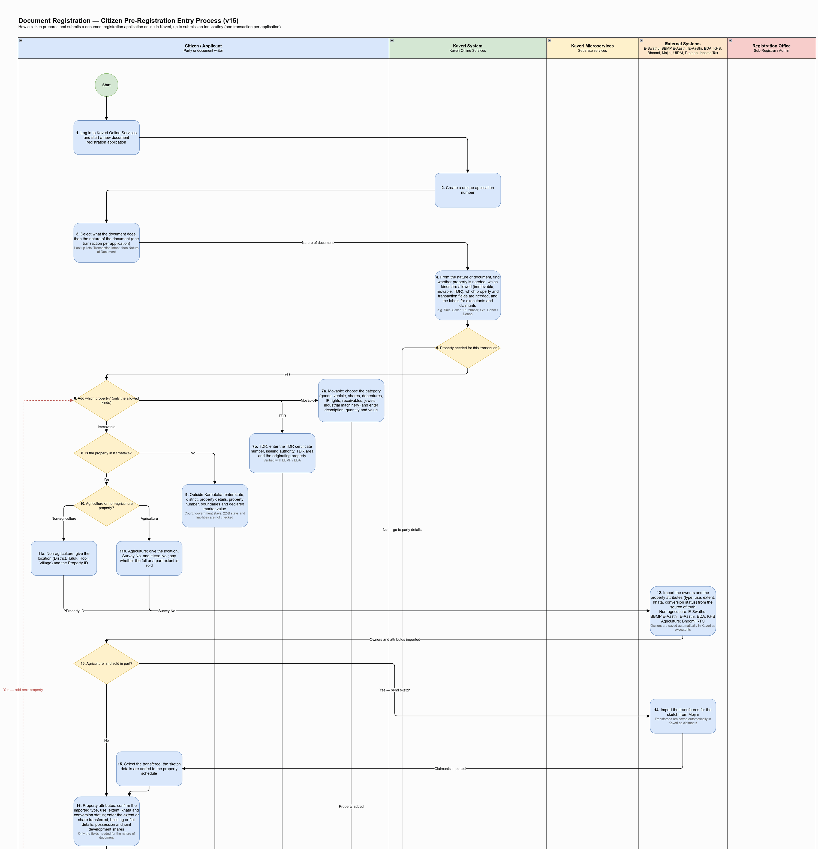
Figure: Citizen Pre-Registration Entry Process (part 1 of 4)
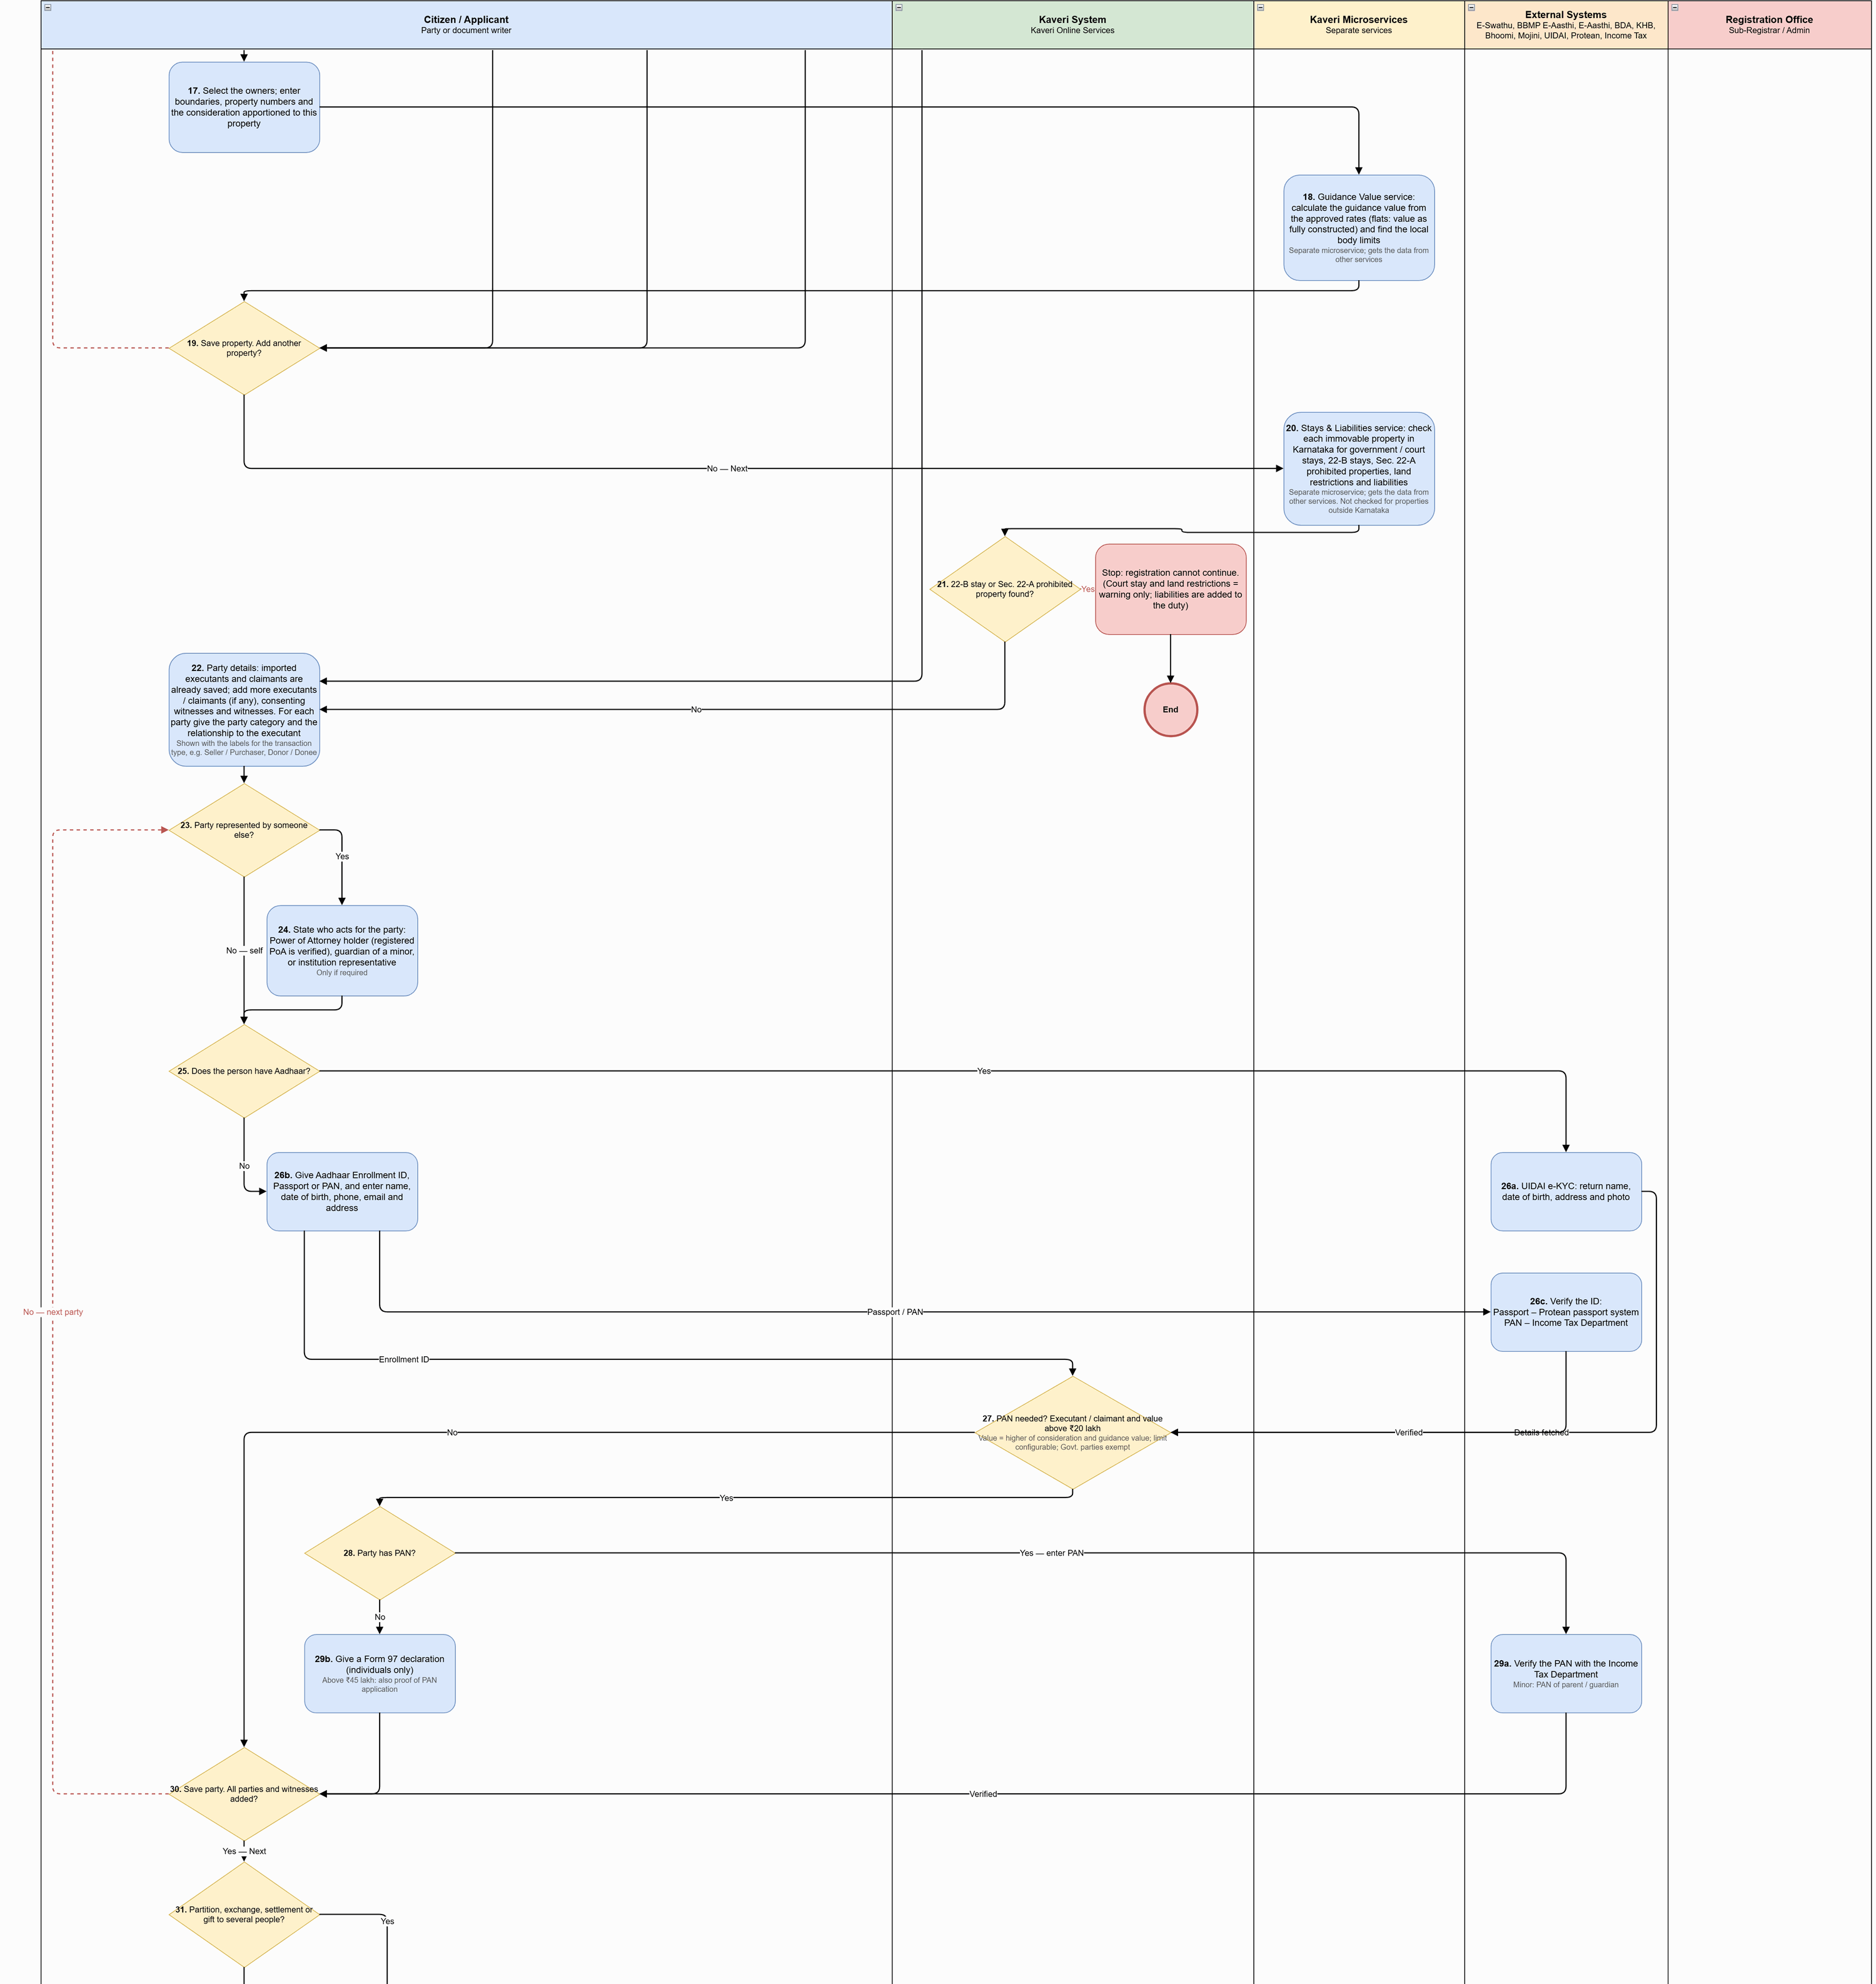
Figure: Citizen Pre-Registration Entry Process (part 2 of 4)
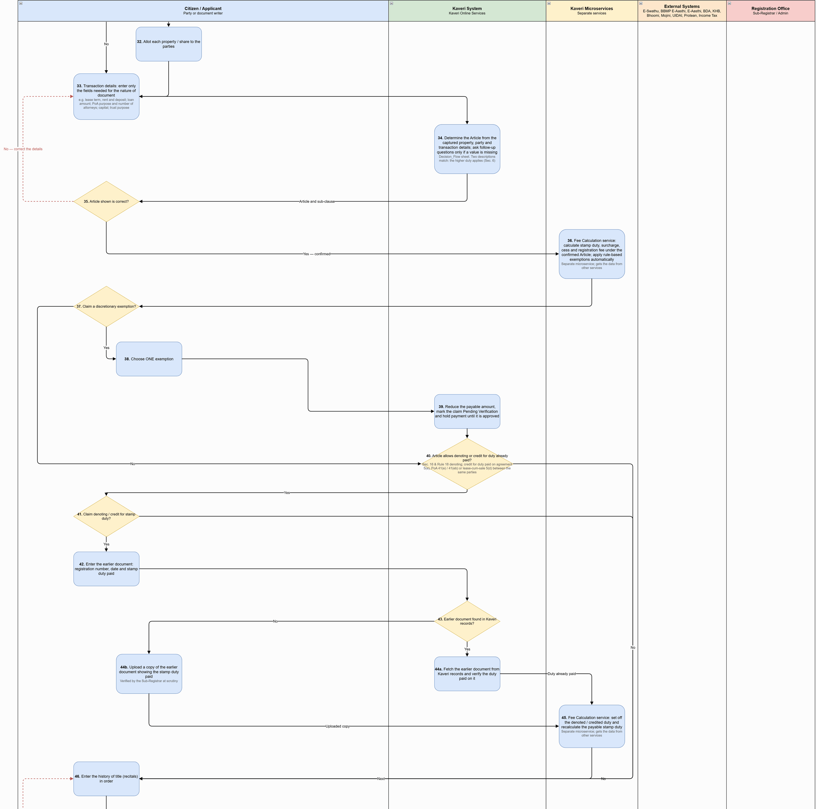
Figure: Citizen Pre-Registration Entry Process (part 3 of 4)
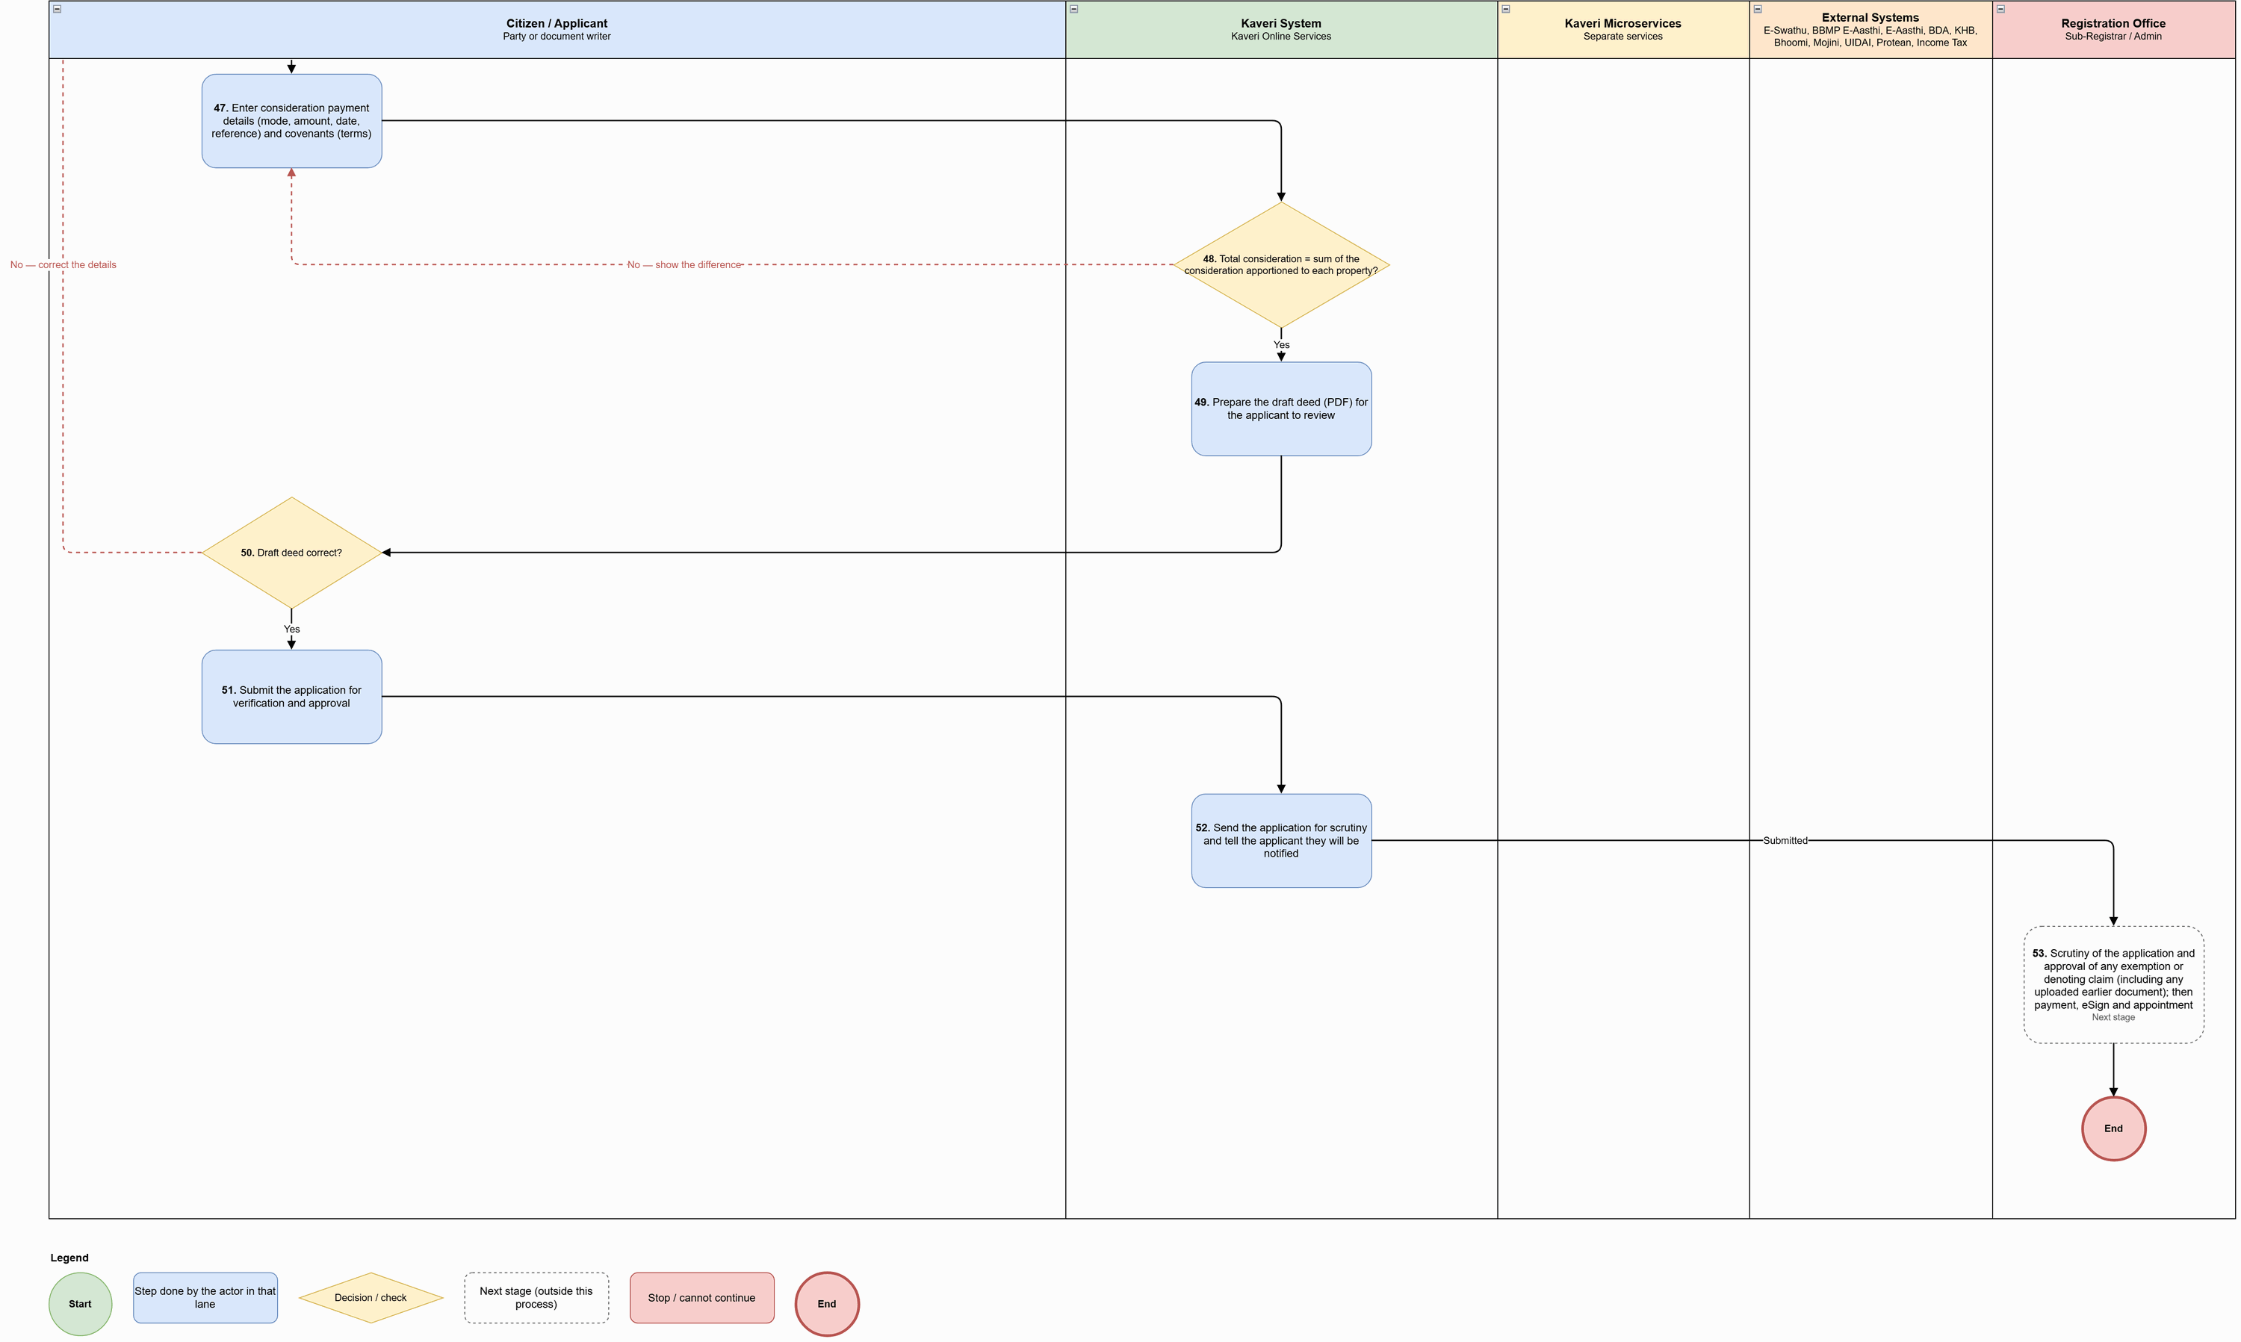
Figure: Citizen Pre-Registration Entry Process (part 4 of 4)

Process flow
Flow (citizen portal, from login to submission for scrutiny):
# | Step | Lane | Notes
1 | Log in to Kaveri Online Services and start a new document registration application | Citizen / Applicant
2 | Create a unique application number | Kaveri System
3 | Select what the document does, then the nature of the document (one transaction per application) | Citizen / Applicant | Lookup lists: Transaction Intent, then Nature of Document
4 | From the nature of document, find whether property is needed, which kinds are allowed (immovable, movable, TDR), which property and transaction fields are needed, and the labels for executants and claimants | Kaveri System | e.g. Sale: Seller / Purchaser; Gift: Donor / Donee
5 | Property needed for this transaction? | Kaveri System | Decision
6 | Add which property? (only the allowed kinds) | Citizen / Applicant | Decision
7a | Movable: choose the category (goods, vehicle, shares, debentures, IP rights, receivables, jewels, industrial machinery) and enter description, quantity and value | Citizen / Applicant
7b | TDR: enter the TDR certificate number, issuing authority, TDR area and the originating property | Citizen / Applicant | Verified with BBMP / BDA
8 | Is the property in Karnataka? | Citizen / Applicant | Decision
9 | Outside Karnataka: enter state, district, property details, property number, boundaries and declared market value | Citizen / Applicant | Court / government stays, 22-B stays and liabilities are not checked
10 | Agriculture or non-agriculture property? | Citizen / Applicant | Decision
11a | Non-agriculture: give the location (District, Taluk, Hobli, Village) and the Property ID | Citizen / Applicant
11b | Agriculture: give the location, Survey No. and Hissa No.; say whether the full or a part extent is sold | Citizen / Applicant
12 | Import the owners and the property attributes (type, use, extent, khata, conversion status) from the source of truth Non-agriculture: E‑Swathu, BBMP E‑Aasthi, E‑Aasthi, BDA, KHB Agriculture: Bhoomi RTC | External Systems | Owners are saved automatically in Kaveri as executants
13 | Agriculture land sold in part? | Citizen / Applicant | Decision
14 | Import the transferees for the sketch from Mojini | External Systems | Transferees are saved automatically in Kaveri as claimants
15 | Select the transferee; the sketch details are added to the property schedule | Citizen / Applicant
16 | Property attributes: confirm the imported type, use, extent, khata and conversion status; enter the extent or share transferred, building or flat details, possession and joint development shares | Citizen / Applicant | Only the fields needed for the nature of document
17 | Select the owners; enter boundaries, property numbers and the consideration apportioned to this property | Citizen / Applicant
18 | Guidance Value service: calculate the guidance value from the approved rates (flats: value as fully constructed) and find the local body limits | Kaveri Microservices | Separate microservice; gets the data from other services
19 | Save property. Add another property? | Citizen / Applicant | Decision
20 | Stays & Liabilities service: check each immovable property in Karnataka for government / court stays, 22-B stays, Sec. 22-A prohibited properties, land restrictions and liabilities | Kaveri Microservices | Separate microservice; gets the data from other services. Not checked for properties outside Karnataka
21 | 22-B stay or Sec. 22-A prohibited property found? | Kaveri System | Decision
22 | Party details: imported executants and claimants are already saved; add more executants / claimants (if any), consenting witnesses and witnesses. For each party give the party category and the relationship to the executant | Citizen / Applicant | Shown with the labels for the transaction type, e.g. Seller / Purchaser, Donor / Donee
23 | Party represented by someone else? | Citizen / Applicant | Decision
24 | State who acts for the party: Power of Attorney holder (registered PoA is verified), guardian of a minor, or institution representative | Citizen / Applicant | Only if required
25 | Does the person have Aadhaar? | Citizen / Applicant | Decision
26a | UIDAI e-KYC: return name, date of birth, address and photo | External Systems
26b | Give Aadhaar Enrollment ID, Passport or PAN, and enter name, date of birth, phone, email and address | Citizen / Applicant
26c | Verify the ID: Passport – Protean passport system PAN – Income Tax Department | External Systems
27 | PAN needed? Executant / claimant and value above ₹20 lakh | Kaveri System | Value = higher of consideration and guidance value; limit configurable; Govt. parties exempt
28 | Party has PAN? | Citizen / Applicant | Decision
29a | Verify the PAN with the Income Tax Department | External Systems | Minor: PAN of parent / guardian
29b | Give a Form 97 declaration (individuals only) | Citizen / Applicant | Above ₹45 lakh: also proof of PAN application
30 | Save party. All parties and witnesses added? | Citizen / Applicant | Decision
31 | Partition, exchange, settlement or gift to several people? | Citizen / Applicant | Decision
32 | Allot each property / share to the parties | Citizen / Applicant
33 | Transaction details: enter only the fields needed for the nature of document | Citizen / Applicant | e.g. lease term, rent and deposit; loan amount; PoA purpose and number of attorneys; capital; trust purpose
34 | Determine the Article from the captured property, party and transaction details; ask follow-up questions only if a value is missing | Kaveri System | Decision_Flow sheet. Two descriptions match: the higher duty applies (Sec. 6)
35 | Article shown is correct? | Citizen / Applicant | Decision
36 | Fee Calculation service: calculate stamp duty, surcharge, cess and registration fee under the confirmed Article; apply rule-based exemptions automatically | Kaveri Microservices | Separate microservice; gets the data from other services
37 | Claim a discretionary exemption? | Citizen / Applicant | Decision
38 | Choose ONE exemption | Citizen / Applicant
39 | Reduce the payable amount, mark the claim Pending Verification and hold payment until it is approved | Kaveri System
40 | Article allows denoting or credit for duty already paid? | Kaveri System | Sec. 16 & Rule 18 denoting; credit for duty paid on agreement 5(e), PoA 41(e) / 41(eb) or lease-cum-sale 5(d) between the same parties
41 | Claim denoting / credit for stamp duty? | Citizen / Applicant | Decision
42 | Enter the earlier document: registration number, date and stamp duty paid | Citizen / Applicant
43 | Earlier document found in Kaveri records? | Kaveri System | Decision
44a | Fetch the earlier document from Kaveri records and verify the duty paid on it | Kaveri System
44b | Upload a copy of the earlier document showing the stamp duty paid | Citizen / Applicant | Verified by the Sub-Registrar at scrutiny
45 | Fee Calculation service: set off the denoted / credited duty and recalculate the payable stamp duty | Kaveri Microservices | Separate microservice; gets the data from other services
46 | Enter the history of title (recitals) in order | Citizen / Applicant
47 | Enter consideration payment details (mode, amount, date, reference) and covenants (terms) | Citizen / Applicant
48 | Total consideration = sum of the consideration apportioned to each property? | Kaveri System | Decision
49 | Prepare the draft deed (PDF) for the applicant to review | Kaveri System
50 | Draft deed correct? | Citizen / Applicant | Decision
51 | Submit the application for verification and approval | Citizen / Applicant
52 | Send the application for scrutiny and tell the applicant they will be notified | Kaveri System
53 | Scrutiny of the application and approval of any exemption or denoting claim (including any uploaded earlier document); then payment, eSign and appointment | Registration Office | Next stage

Key characteristics: one transaction per application; the nature of document decides the property kinds, fields and party labels; property and owner data imported from the source of truth (owners become executants, Mojini transferees become claimants); stays and prohibited-property check before parties are added (22-B stay or Sec. 22-A prohibited property stops the application; court stays and land restrictions warn; liabilities are added to the duty); Aadhaar e-KYC or manual ID verified with Protean / Income Tax; PAN rule above ₹20 lakh with Form 97 fallback; Article determined by rules with citizen confirmation; duty and fees from the Fee Calculation service; only one discretionary exemption, held as Pending Verification; denoting / credit claim verified from Kaveri records or an uploaded copy; consideration totals checked; draft deed reviewed before submission.

Application status model
Application statuses used in the citizen pre-registration entry process:
Status | Description | Actor | Next states
Draft | Application created; data entry in progress; resumable | Citizen | Submitted – Pending Scrutiny; Stopped – Prohibited property
Stopped – Prohibited property | 22-B stay or Sec. 22-A prohibited property found; cannot continue | System | — (terminal)
Submitted – Pending Scrutiny | Submitted for verification and approval; editing locked; exemption / denoting claim held as Pending Verification | System / Sub-Registrar | Approved for Payment; Reverted for Correction; Rejected at Scrutiny

Document scrutiny by the Sub-Registrar

Channel model
Service Type | Online Activities | Office Activities | Mode
Scrutiny of the submitted application | View status and the Sub-Registrar's remarks; correct and resubmit a reverted application | Sub-Registrar opens the Pending Scrutiny list, reviews the deed, completes the checklist (common + Article checks), re-calculates guidance value and fees if needed, and approves, reverts or rejects | Back office (online application, office decision)

Process diagram
Source: ProcessDiagram/Document_Scrutiny_Process_v3.drawio (full-resolution PNG alongside).
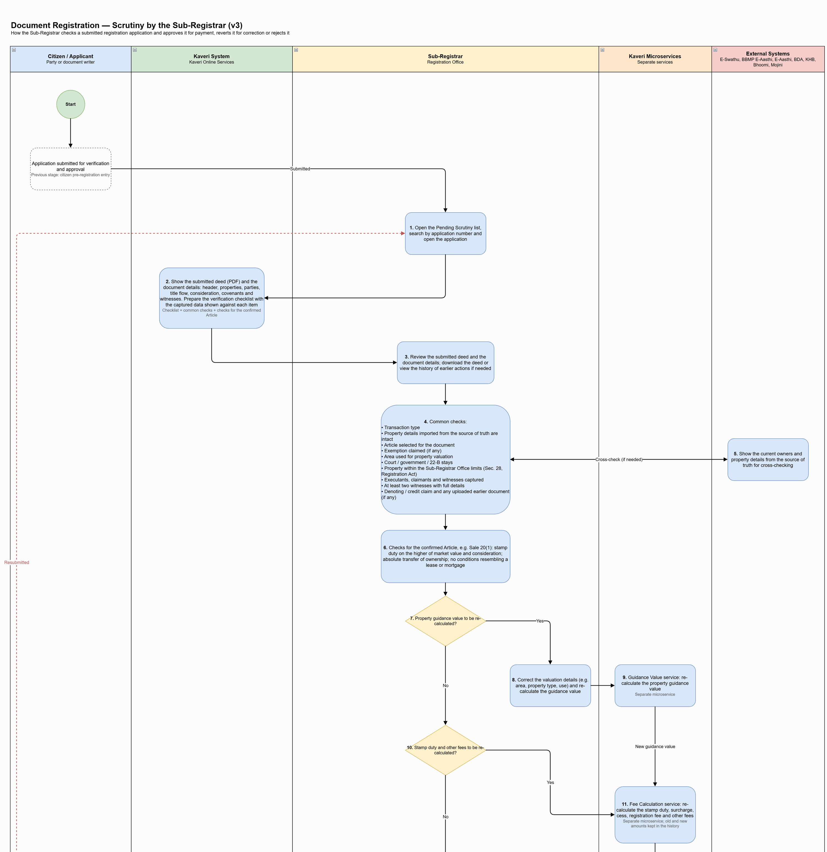
Figure: Document Scrutiny Process (part 1 of 2)
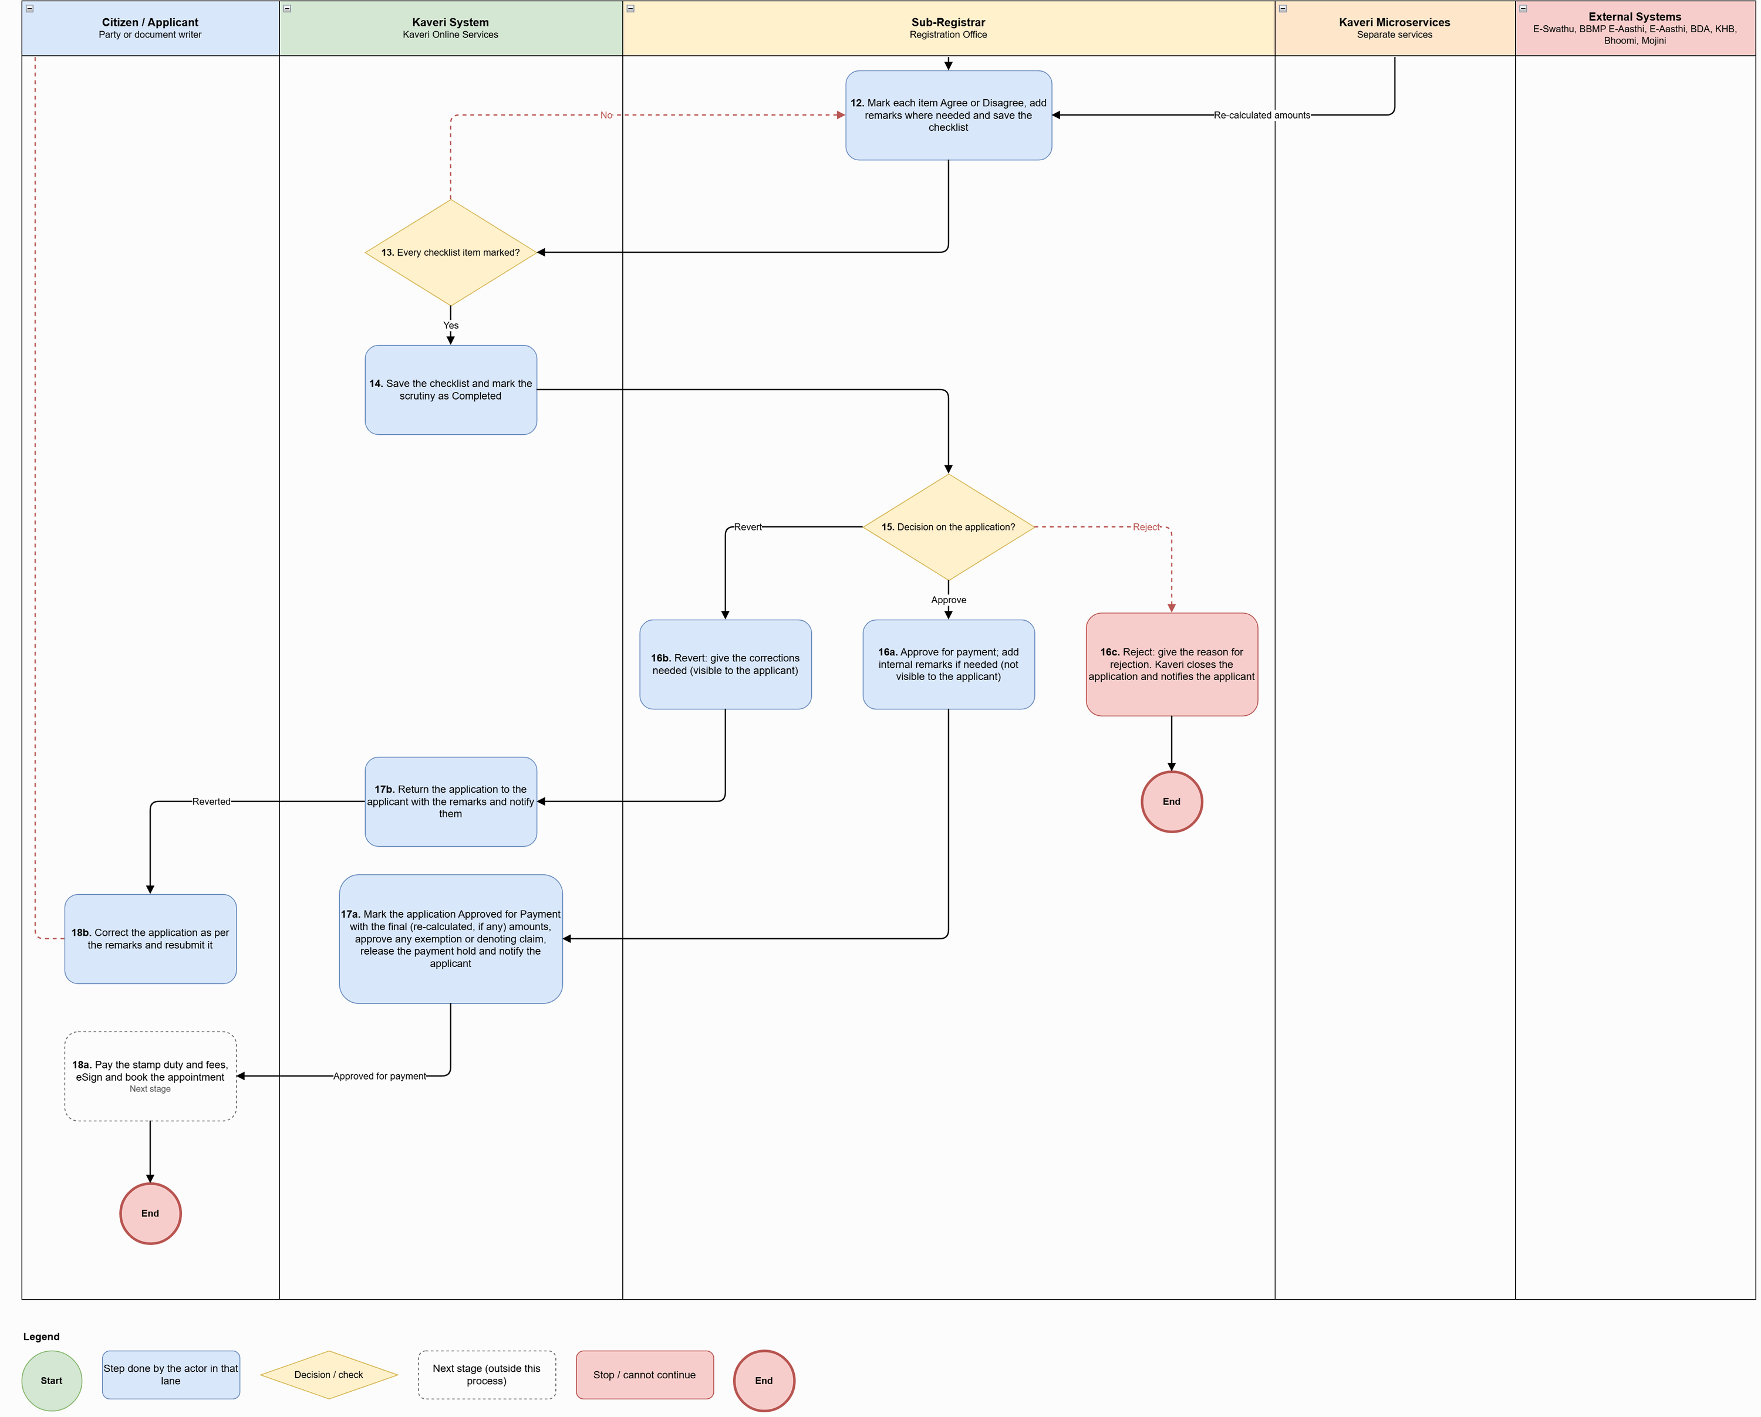
Figure: Document Scrutiny Process (part 2 of 2)

Process flow
Flow (after submission by the citizen):
# | Step | Lane | Notes
1 | Open the Pending Scrutiny list, search by application number and open the application | Sub-Registrar
2 | Show the submitted deed (PDF) and the document details: header, properties, parties, title flow, consideration, covenants and witnesses. Prepare the verification checklist with the captured data shown against each item | Kaveri System | Checklist = common checks + checks for the confirmed Article
3 | Review the submitted deed and the document details; download the deed or view the history of earlier actions if needed | Sub-Registrar
4 | Common checks: Transaction type; Property details imported from the source of truth are intact; Article selected for the document; Exemption claimed (if any); Area used for property valuation; Court / government / 22-B stays; Property within the Sub-Registrar Office limits (Sec. 28, Registration Act); Executants, claimants and witnesses captured; At least two witnesses with full details; Denoting / credit claim and any uploaded earlier document (if any) | Sub-Registrar
5 | Show the current owners and property details from the source of truth for cross-checking | External Systems
6 | Checks for the confirmed Article, e.g. Sale 20(1): stamp duty on the higher of market value and consideration; absolute transfer of ownership; no conditions resembling a lease or mortgage | Sub-Registrar
7 | Property guidance value to be re-calculated? | Sub-Registrar | Decision
8 | Correct the valuation details (e.g. area, property type, use) and re-calculate the guidance value | Sub-Registrar
9 | Guidance Value service: re-calculate the property guidance value | Kaveri Microservices | Separate microservice
10 | Stamp duty and other fees to be re-calculated? | Sub-Registrar | Decision
11 | Fee Calculation service: re-calculate the stamp duty, surcharge, cess, registration fee and other fees | Kaveri Microservices | Separate microservice; old and new amounts kept in the history
12 | Mark each item Agree or Disagree, add remarks where needed and save the checklist | Sub-Registrar
13 | Every checklist item marked? | Kaveri System | Decision
14 | Save the checklist and mark the scrutiny as Completed | Kaveri System
15 | Decision on the application? | Sub-Registrar | Decision
16a | Approve for payment; add internal remarks if needed (not visible to the applicant) | Sub-Registrar
16b | Revert: give the corrections needed (visible to the applicant) | Sub-Registrar
16c | Reject: give the reason for rejection. Kaveri closes the application and notifies the applicant | Sub-Registrar
17a | Mark the application Approved for Payment with the final (re-calculated, if any) amounts, approve any exemption or denoting claim, release the payment hold and notify the applicant | Kaveri System
17b | Return the application to the applicant with the remarks and notify them | Kaveri System
18a | Pay the stamp duty and fees, eSign and book the appointment | Citizen / Applicant | Next stage
18b | Correct the application as per the remarks and resubmit it | Citizen / Applicant

Key characteristics: scrutiny happens before payment, so defects are corrected online without a visit; checklist = common checks + checks for the confirmed Article, with captured data shown against each item; cross-check against the source of truth; guidance value and fees re-calculated by the microservices with old and new amounts kept in history; every item must be marked Agree / Disagree before a decision; revert remarks are visible to the applicant, approval remarks are internal; approval also approves any exemption or denoting claim and releases the payment hold.

Application status model
Application statuses used in the document scrutiny by the sub-registrar process:
Status | Description | Actor | Next states
Submitted – Pending Scrutiny | Submitted for verification and approval; editing locked; exemption / denoting claim held as Pending Verification | System / Sub-Registrar | Approved for Payment; Reverted for Correction; Rejected at Scrutiny
Reverted for Correction | Returned with remarks visible to the applicant | Sub-Registrar / Citizen | Submitted – Pending Scrutiny
Rejected at Scrutiny | Rejected with reason; application closed | Sub-Registrar | — (terminal)
Approved for Payment | Final amounts fixed; exemption / denoting claim approved; payment hold released | Sub-Registrar / System | Payment Pending; Paid; Partially Paid – Sec. 45-A / Sec. 33

Payment, digital signing and appointment

Channel model
Service Type | Online Activities | Office Activities | Mode
Payment, e-Sign and appointment | Pay in full or in part (gateway or challan); track signers; parties and witnesses sign by e-Sign or DSC in the portal or through a mobile link; replace a witness; book a slot | None (payments reconciled through Khajane-II) | Online

Process diagram
Source: ProcessDiagram/Citizen_Payment_eSign_Appointment_Process_v2.drawio (full-resolution PNG alongside).
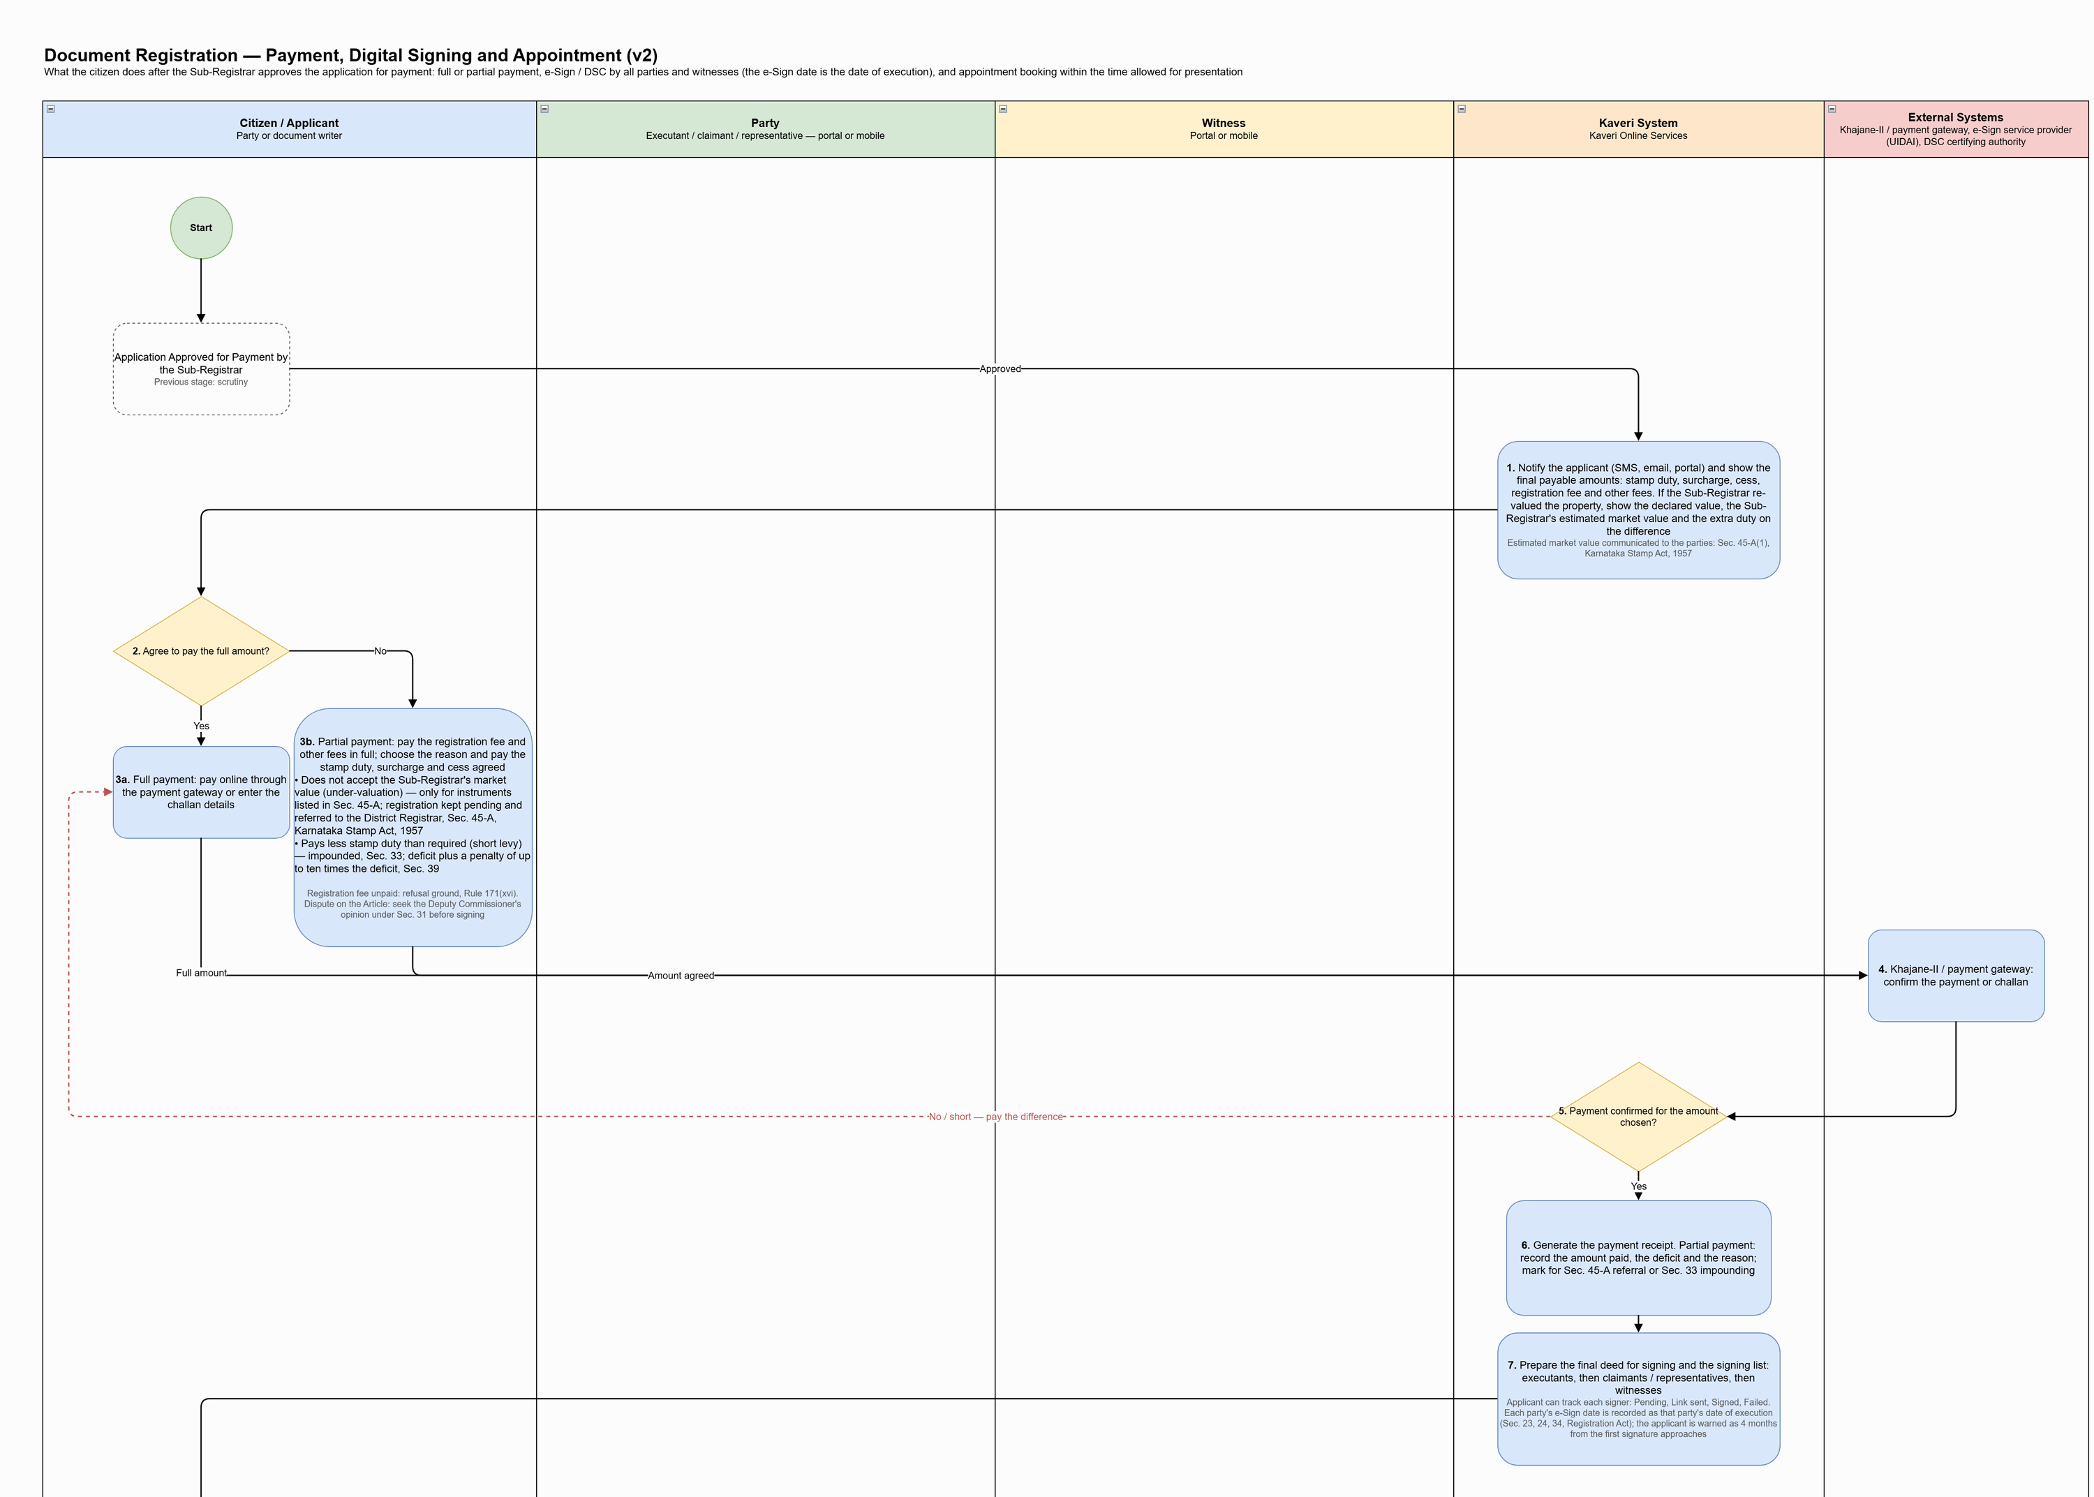
Figure: Payment, Digital Signing and Appointment Process (part 1 of 3)
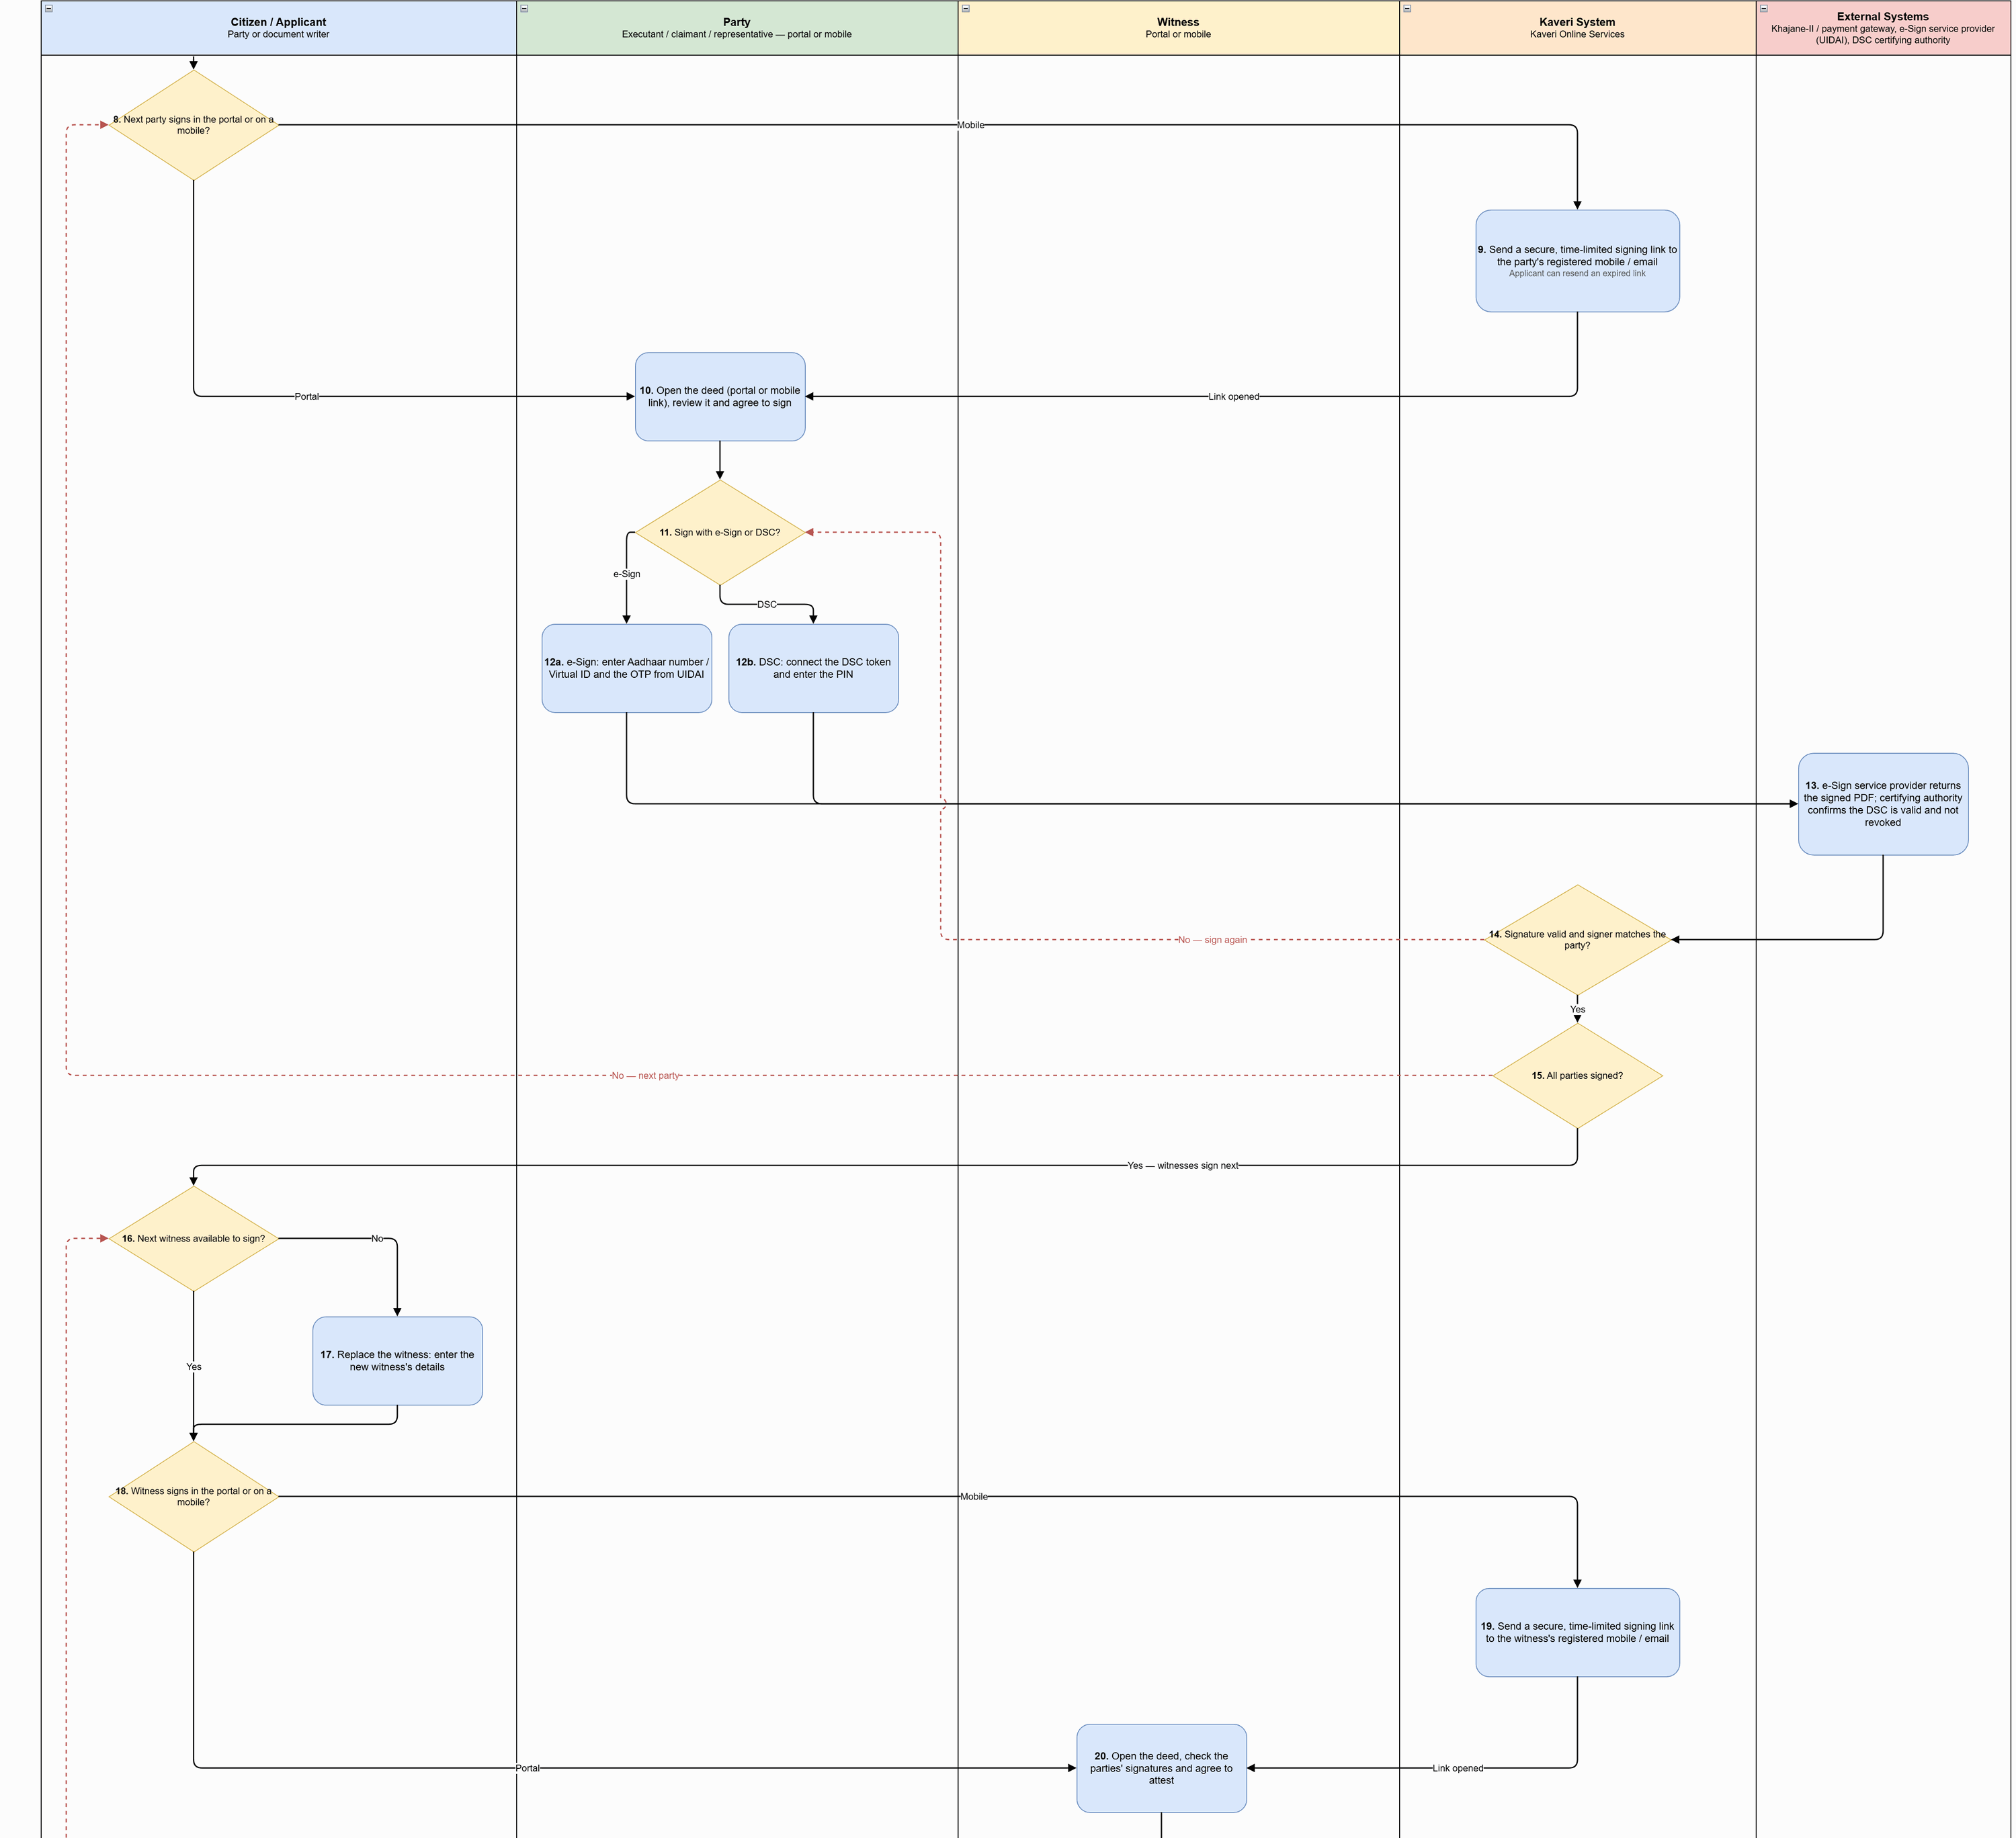
Figure: Payment, Digital Signing and Appointment Process (part 2 of 3)
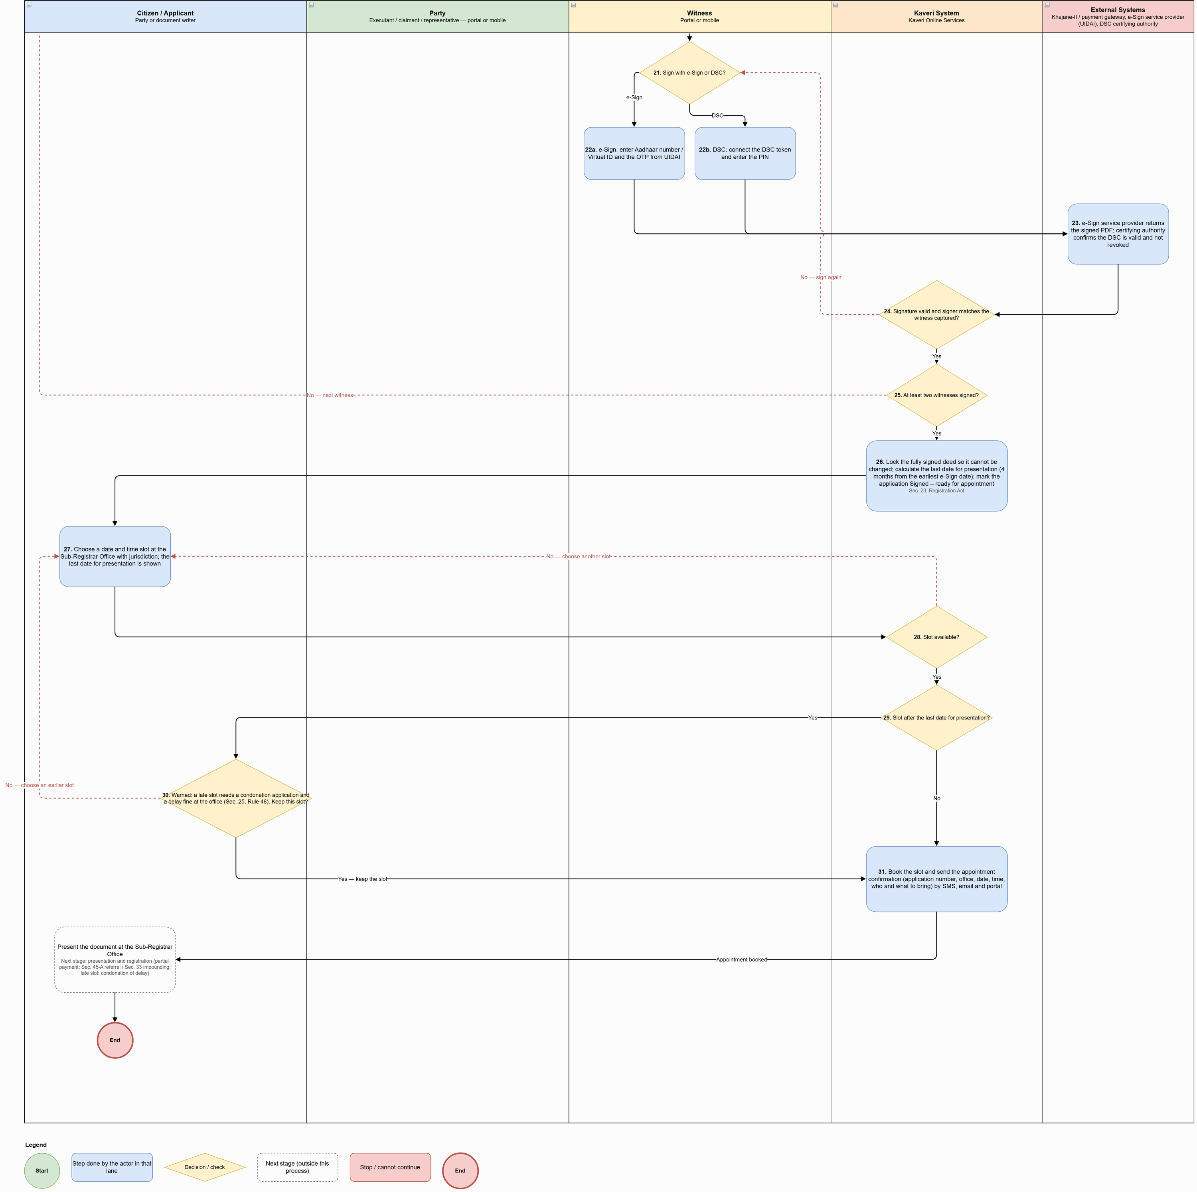
Figure: Payment, Digital Signing and Appointment Process (part 3 of 3)

Process flow
Flow (after approval for payment):
# | Step | Lane | Notes
1 | Notify the applicant (SMS, email, portal) and show the final payable amounts: stamp duty, surcharge, cess, registration fee and other fees. If the Sub-Registrar re-valued the property, show the declared value, the Sub-Registrar's estimated market value and the extra duty on the difference | Kaveri System | Estimated market value communicated to the parties: Sec. 45-A(1), Karnataka Stamp Act, 1957
2 | Agree to pay the full amount? | Citizen / Applicant | Decision
3a | Full payment: pay online through the payment gateway or enter the challan details | Citizen / Applicant
3b | Partial payment: pay the registration fee and other fees in full; choose the reason and pay the stamp duty, surcharge and cess agreed Does not accept the Sub-Registrar's market value (under-valuation) — only for instruments listed in Sec. 45-A; registration kept pending and referred to the District Registrar, Sec. 45-A, Karnataka Stamp Act, 1957; Pays less stamp duty than required (short levy) — impounded, Sec. 33; deficit plus a penalty of up to ten times the deficit, Sec. 39 | Citizen / Applicant | Registration fee unpaid: refusal ground, Rule 171(xvi). Dispute on the Article: seek the Deputy Commissioner's opinion under Sec. 31 before signing
4 | Khajane-II / payment gateway: confirm the payment or challan | External Systems
5 | Payment confirmed for the amount chosen? | Kaveri System | Decision
6 | Generate the payment receipt. Partial payment: record the amount paid, the deficit and the reason; mark for Sec. 45-A referral or Sec. 33 impounding | Kaveri System
7 | Prepare the final deed for signing and the signing list: executants, then claimants / representatives, then witnesses | Kaveri System | Applicant can track each signer: Pending, Link sent, Signed, Failed. Each party's e-Sign date is recorded as that party's date of execution (Sec. 23, 24, 34, Registration Act); the applicant is warned as 4 months from the first signature approaches
8 | Next party signs in the portal or on a mobile? | Citizen / Applicant | Decision
9 | Send a secure, time-limited signing link to the party's registered mobile / email | Kaveri System | Applicant can resend an expired link
10 | Open the deed (portal or mobile link), review it and agree to sign | Party
11 | Sign with e-Sign or DSC? | Party | Decision
12a | e-Sign: enter Aadhaar number / Virtual ID and the OTP from UIDAI | Party
12b | DSC: connect the DSC token and enter the PIN | Party
13 | e-Sign service provider returns the signed PDF; certifying authority confirms the DSC is valid and not revoked | External Systems
14 | Signature valid and signer matches the party? | Kaveri System | Decision
15 | All parties signed? | Kaveri System | Decision
16 | Next witness available to sign? | Citizen / Applicant | Decision
17 | Replace the witness: enter the new witness's details | Citizen / Applicant
18 | Witness signs in the portal or on a mobile? | Citizen / Applicant | Decision
19 | Send a secure, time-limited signing link to the witness's registered mobile / email | Kaveri System
20 | Open the deed, check the parties' signatures and agree to attest | Witness
21 | Sign with e-Sign or DSC? | Witness | Decision
22a | e-Sign: enter Aadhaar number / Virtual ID and the OTP from UIDAI | Witness
22b | DSC: connect the DSC token and enter the PIN | Witness
23 | e-Sign service provider returns the signed PDF; certifying authority confirms the DSC is valid and not revoked | External Systems
24 | Signature valid and signer matches the witness captured? | Kaveri System | Decision
25 | At least two witnesses signed? | Kaveri System | Decision
26 | Lock the fully signed deed so it cannot be changed; calculate the last date for presentation (4 months from the earliest e-Sign date); mark the application Signed – ready for appointment | Kaveri System | Sec. 23, Registration Act
27 | Choose a date and time slot at the Sub-Registrar Office with jurisdiction; the last date for presentation is shown | Citizen / Applicant
28 | Slot available? | Kaveri System | Decision
29 | Slot after the last date for presentation? | Kaveri System | Decision
30 | Warned: a late slot needs a condonation application and a delay fine at the office (Sec. 25; Rule 46). Keep this slot? | Citizen / Applicant | Decision
31 | Book the slot and send the appointment confirmation (application number, office, date, time, who and what to bring) by SMS, email and portal | Kaveri System

Key characteristics: final amounts and, if re-valued, the Sub-Registrar's estimated market value (Sec. 45-A(1)) shown before payment; registration fee always paid in full (unpaid fee is a refusal ground, Rule 171(xvi)); partial stamp duty only for an under-valuation dispute (Sec. 45-A referral) or a short levy (Sec. 33 impounding); signing order executants → claimants / representatives → witnesses with a live tracker; each e-Sign date recorded as the date of execution; at least two witnesses must sign; deed locked after signing and the last date for presentation (4 months from the earliest e-Sign) calculated; late slots allowed only after a condonation warning.

Application status model
Application statuses used in the payment, digital signing and appointment process:
Status | Description | Actor | Next states
Approved for Payment | Final amounts fixed; exemption / denoting claim approved; payment hold released | Sub-Registrar / System | Payment Pending; Paid; Partially Paid – Sec. 45-A / Sec. 33
Payment Pending | Payment initiated; awaiting confirmation from Khajane-II / gateway | System | Paid; Partially Paid – Sec. 45-A / Sec. 33; Approved for Payment
Paid | Full payment confirmed; receipt generated | System | Signing in Progress
Partially Paid – Sec. 45-A / Sec. 33 | Registration fee paid in full; stamp duty deficit and reason recorded; marked for referral or impounding | System | Signing in Progress
Signing in Progress | Signing list active; tracker shows Pending / Link sent / Signed / Failed per signer | Parties / Witnesses | Signed – Ready for Appointment
Signed – Ready for Appointment | Deed locked; last date for presentation calculated | System | Appointment Booked
Appointment Booked | Slot booked at the jurisdictional office; confirmation sent | Citizen / System | Presented; Not Presented – Defect; Registration Refused; Withdrawn

Presentation, photo & thumb capture, registration, refusal and withdrawal

Channel model
Service Type | Online Activities | Office Activities | Mode
Presentation and registration | e-Sign on own mobile through a link (Get Link); notifications of pending appearance, summons, orders and registration | Presentation checklist, presenter, admission / denial, pending appearance, summons / commission, delay check and condonation referral, identifiers, photo, thumb, e-KYC, e-Sign, endorsement, Sec. 45-A / Sec. 33 handling, DSC and registration | In person at the Sub-Registrar Office
Refusal to register | Notification; free copy of reasons | Refusal order, partial registration, Book 2, DSC, re-presentation block, refund of half the fee, return of document | In person
Withdrawal before registration | Notification; refund application (see 7.vi) | Written request, Minute Book entry with DSC, cancellation of pendings, endorsement “Withdrawn”, return of document | In person

Process diagram
Source: ProcessDiagram/Presentation_PhotoThumb_Registration_Process_v10.drawio (full-resolution PNG alongside).
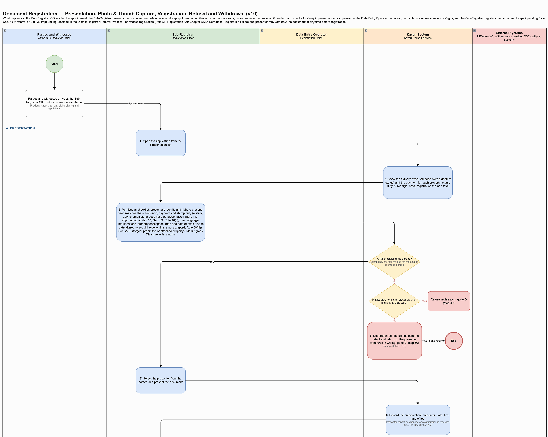
Figure: Presentation, Photo & Thumb Capture, Registration, Refusal and Withdrawal Process (part 1 of 6)
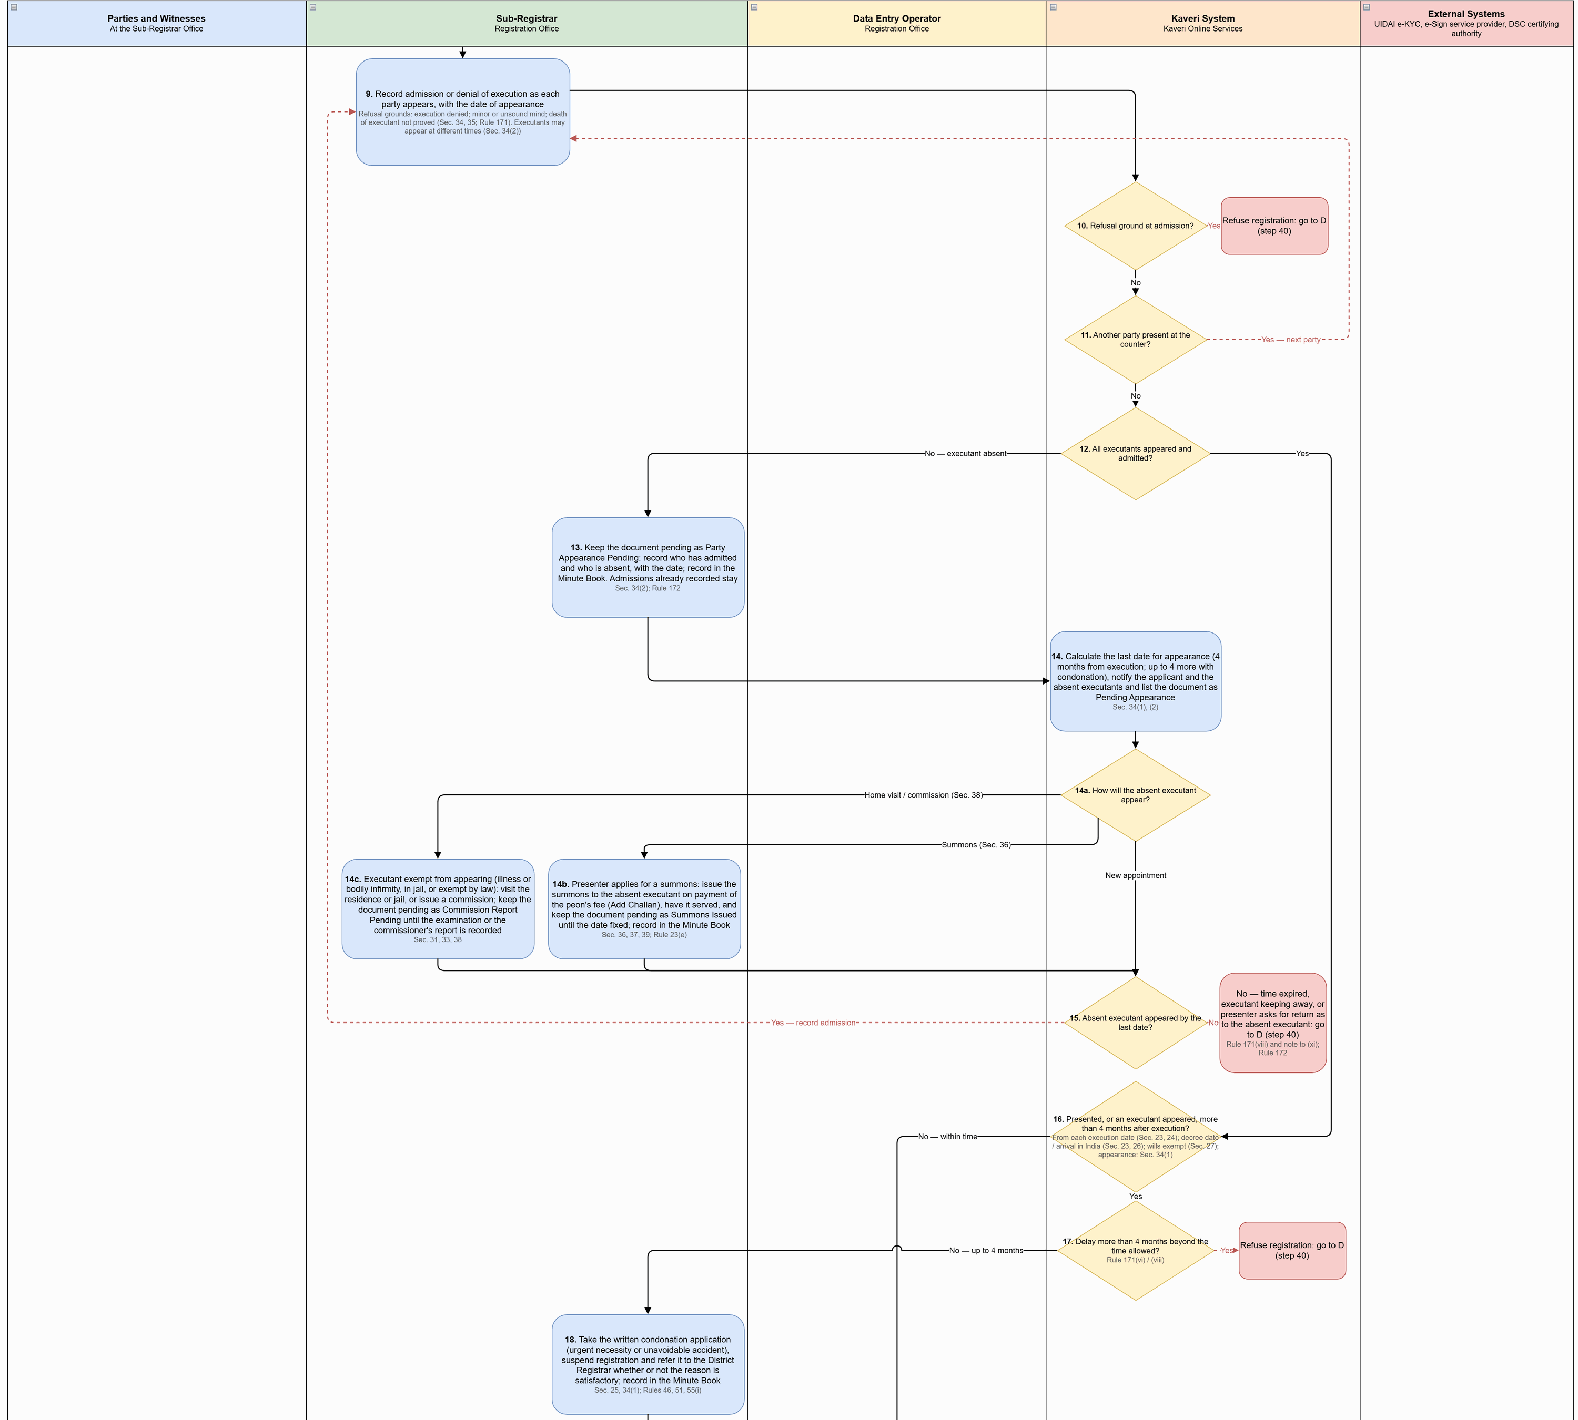
Figure: Presentation, Photo & Thumb Capture, Registration, Refusal and Withdrawal Process (part 2 of 6)
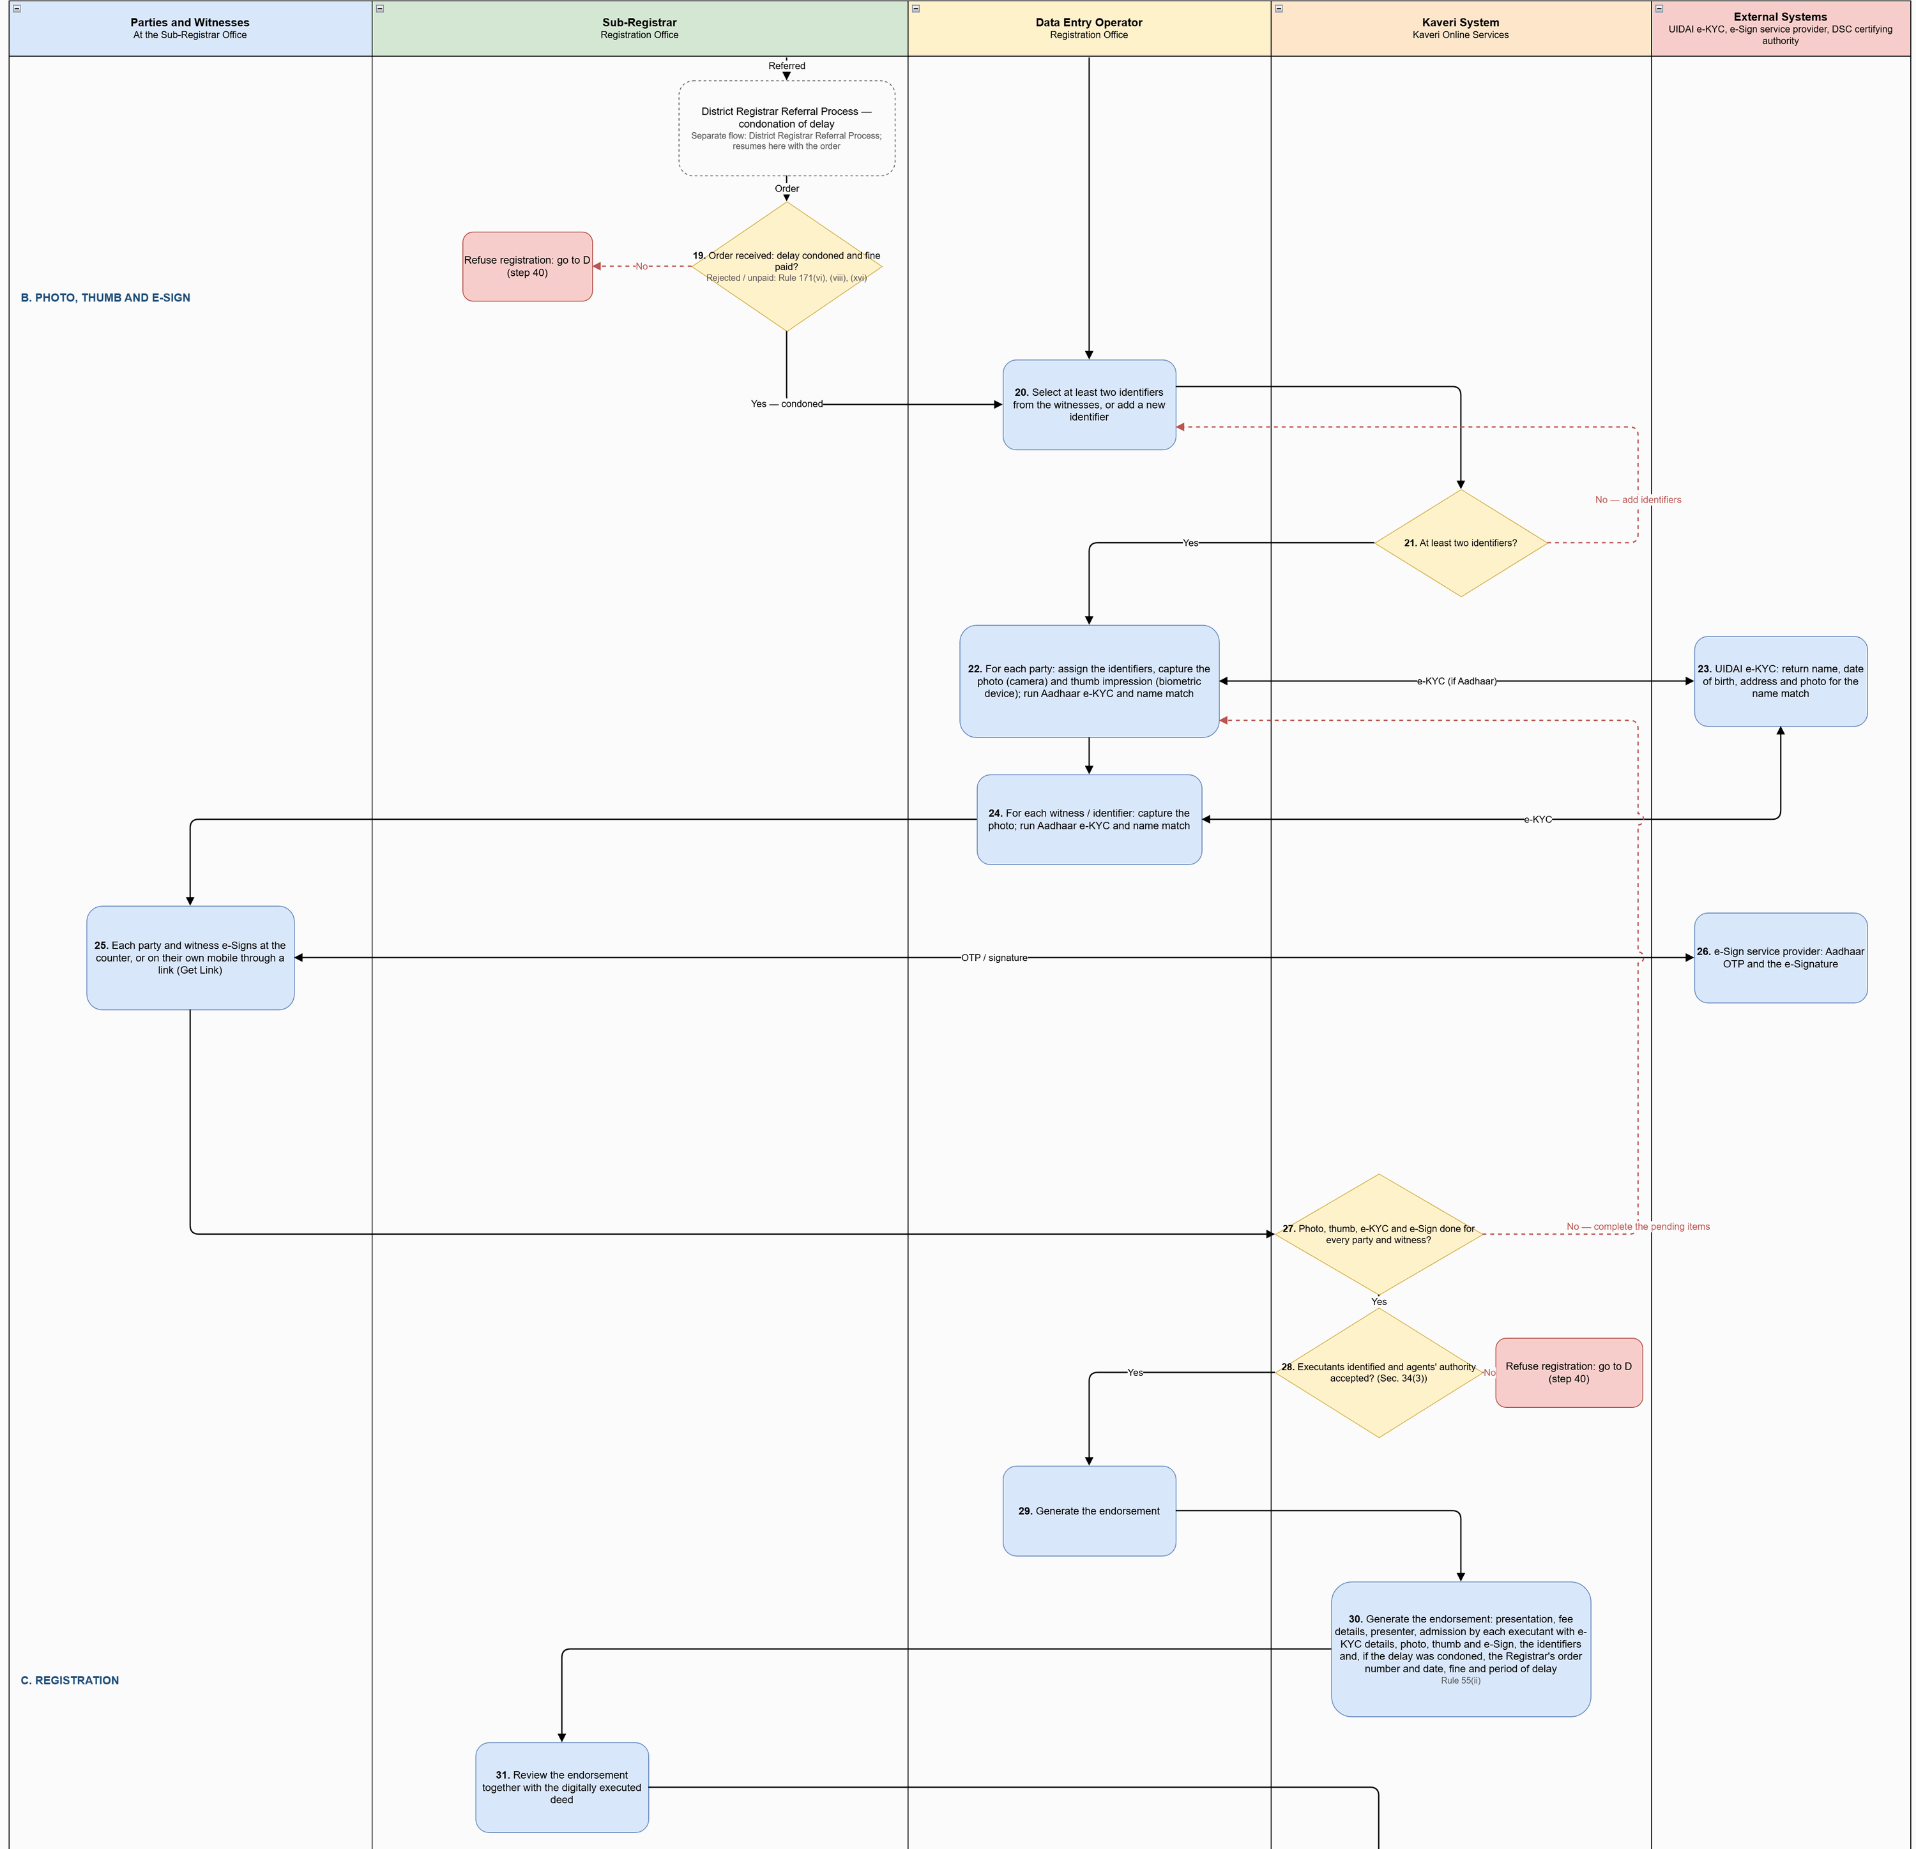
Figure: Presentation, Photo & Thumb Capture, Registration, Refusal and Withdrawal Process (part 3 of 6)
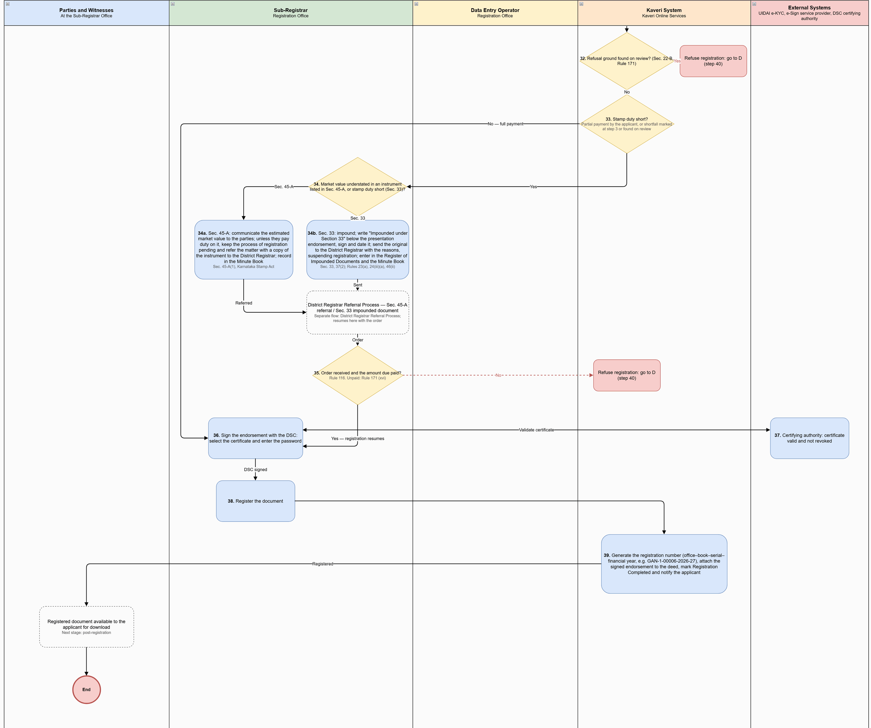
Figure: Presentation, Photo & Thumb Capture, Registration, Refusal and Withdrawal Process (part 4 of 6)
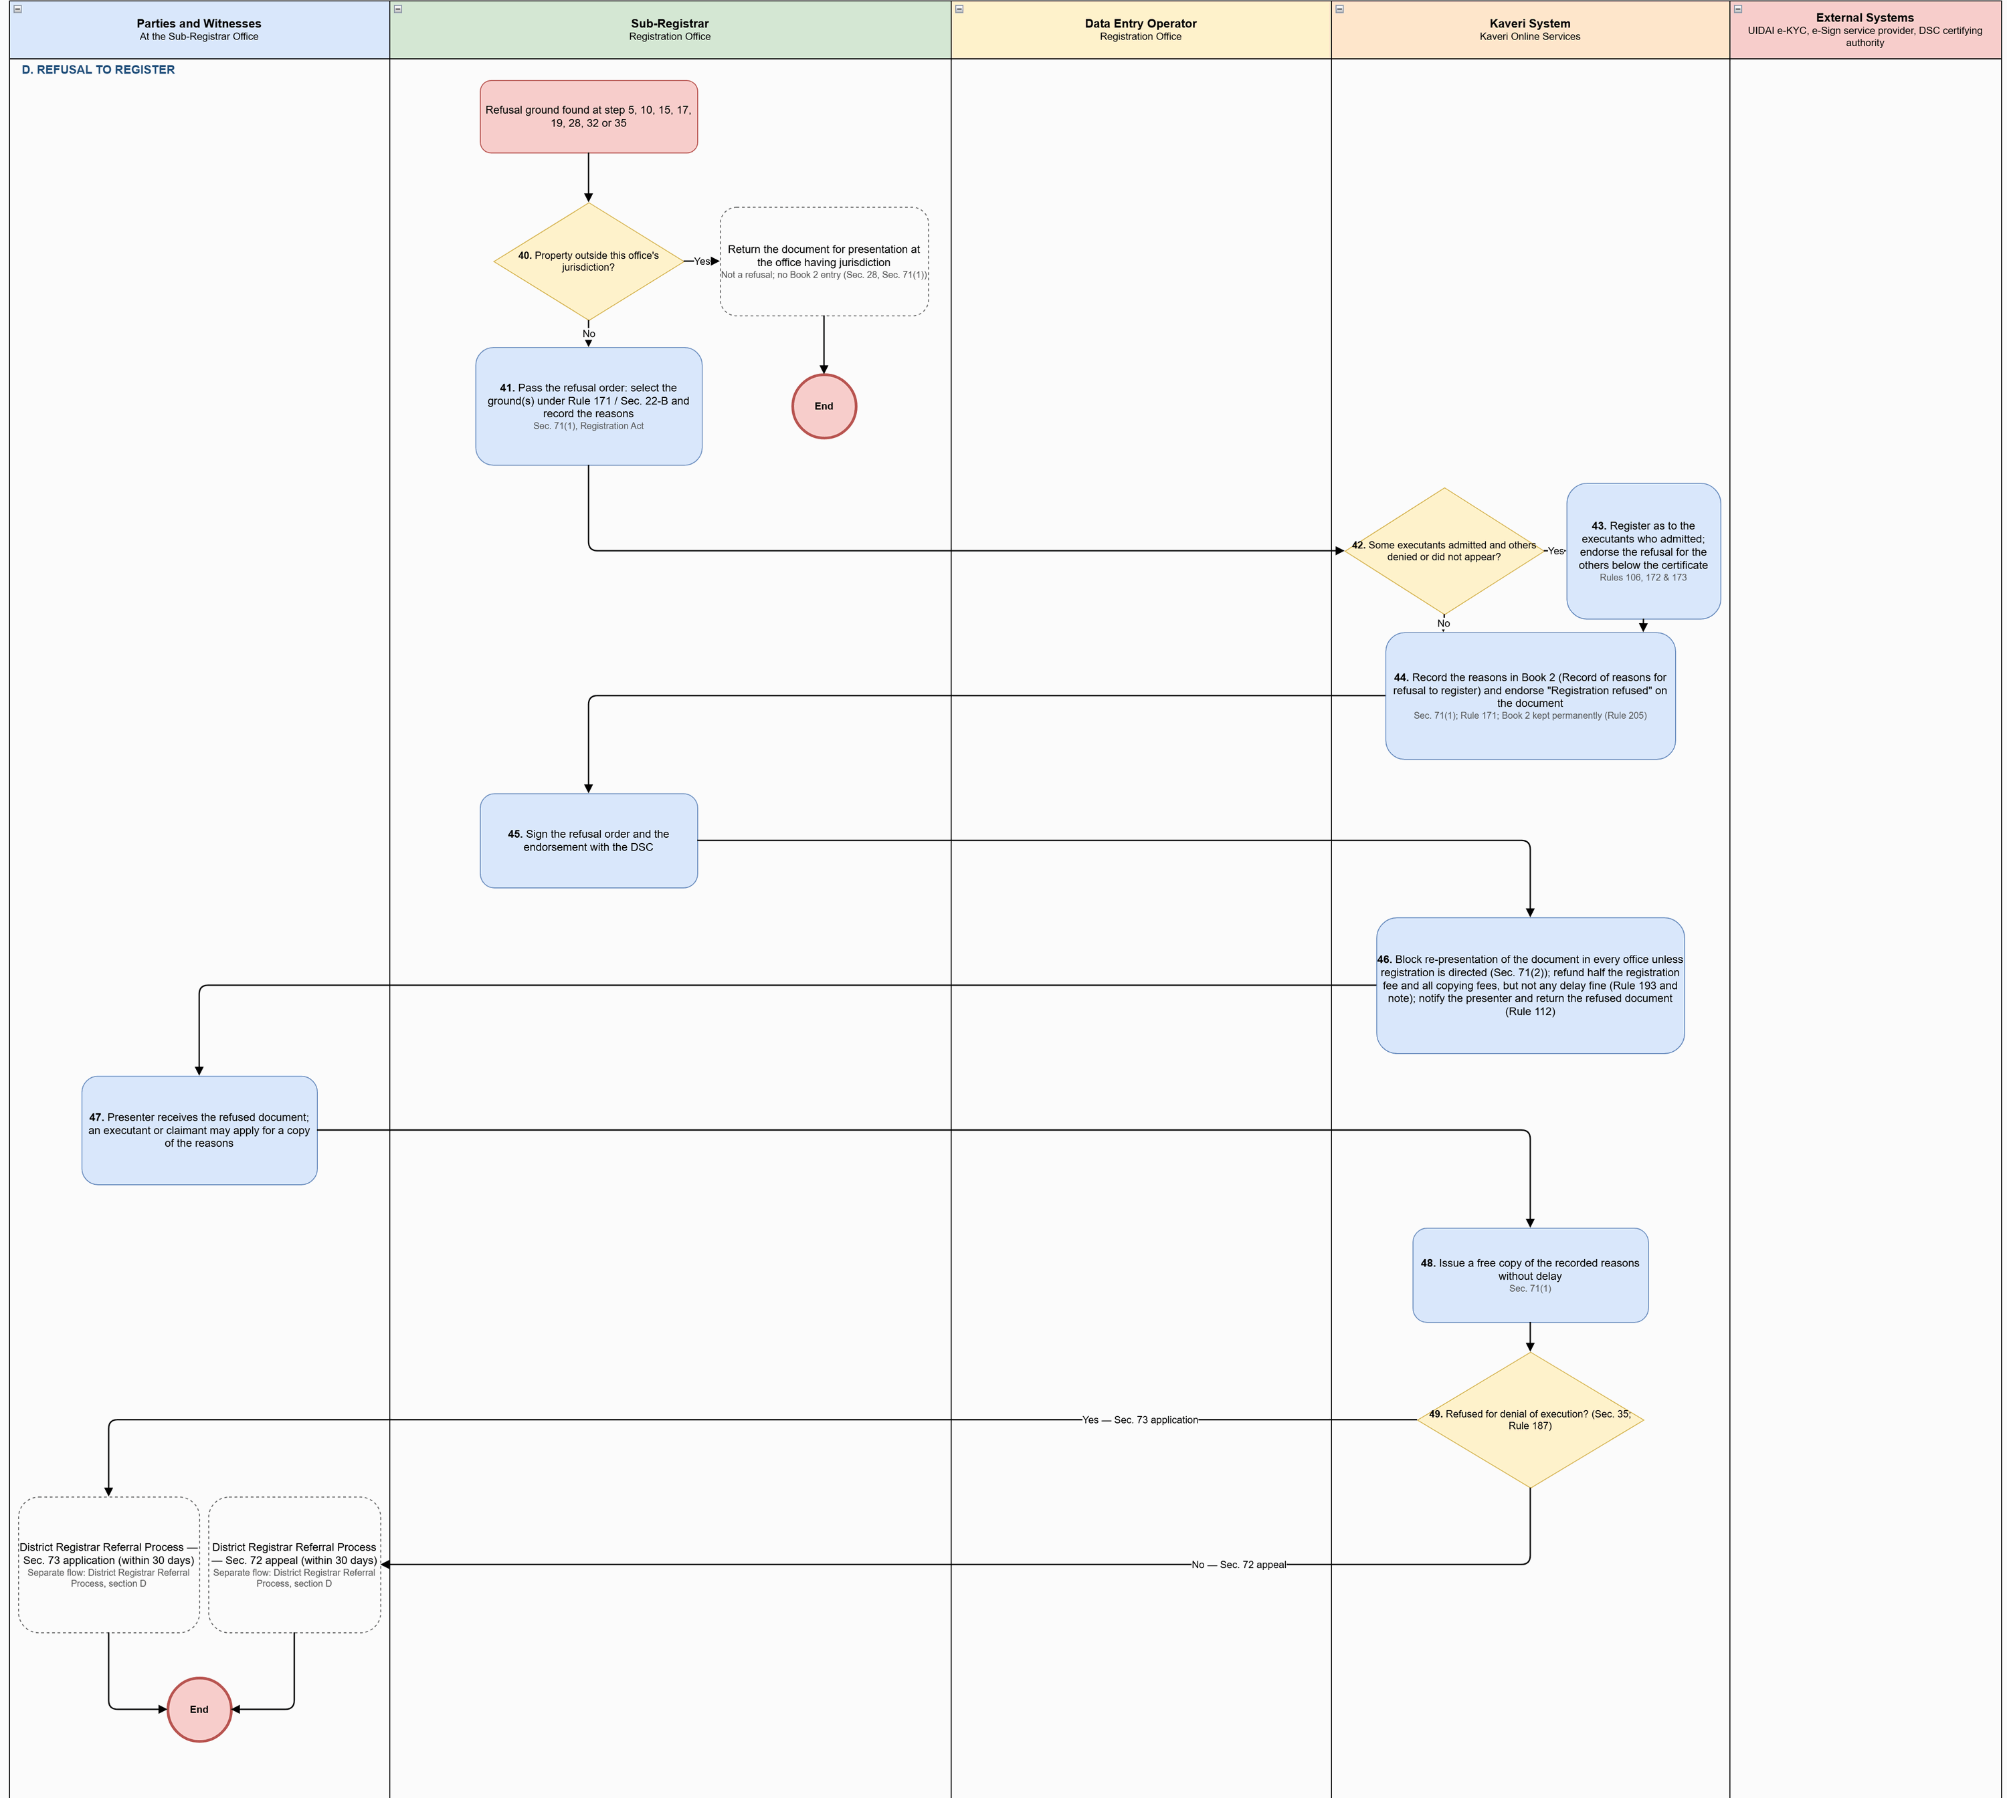
Figure: Presentation, Photo & Thumb Capture, Registration, Refusal and Withdrawal Process (part 5 of 6)
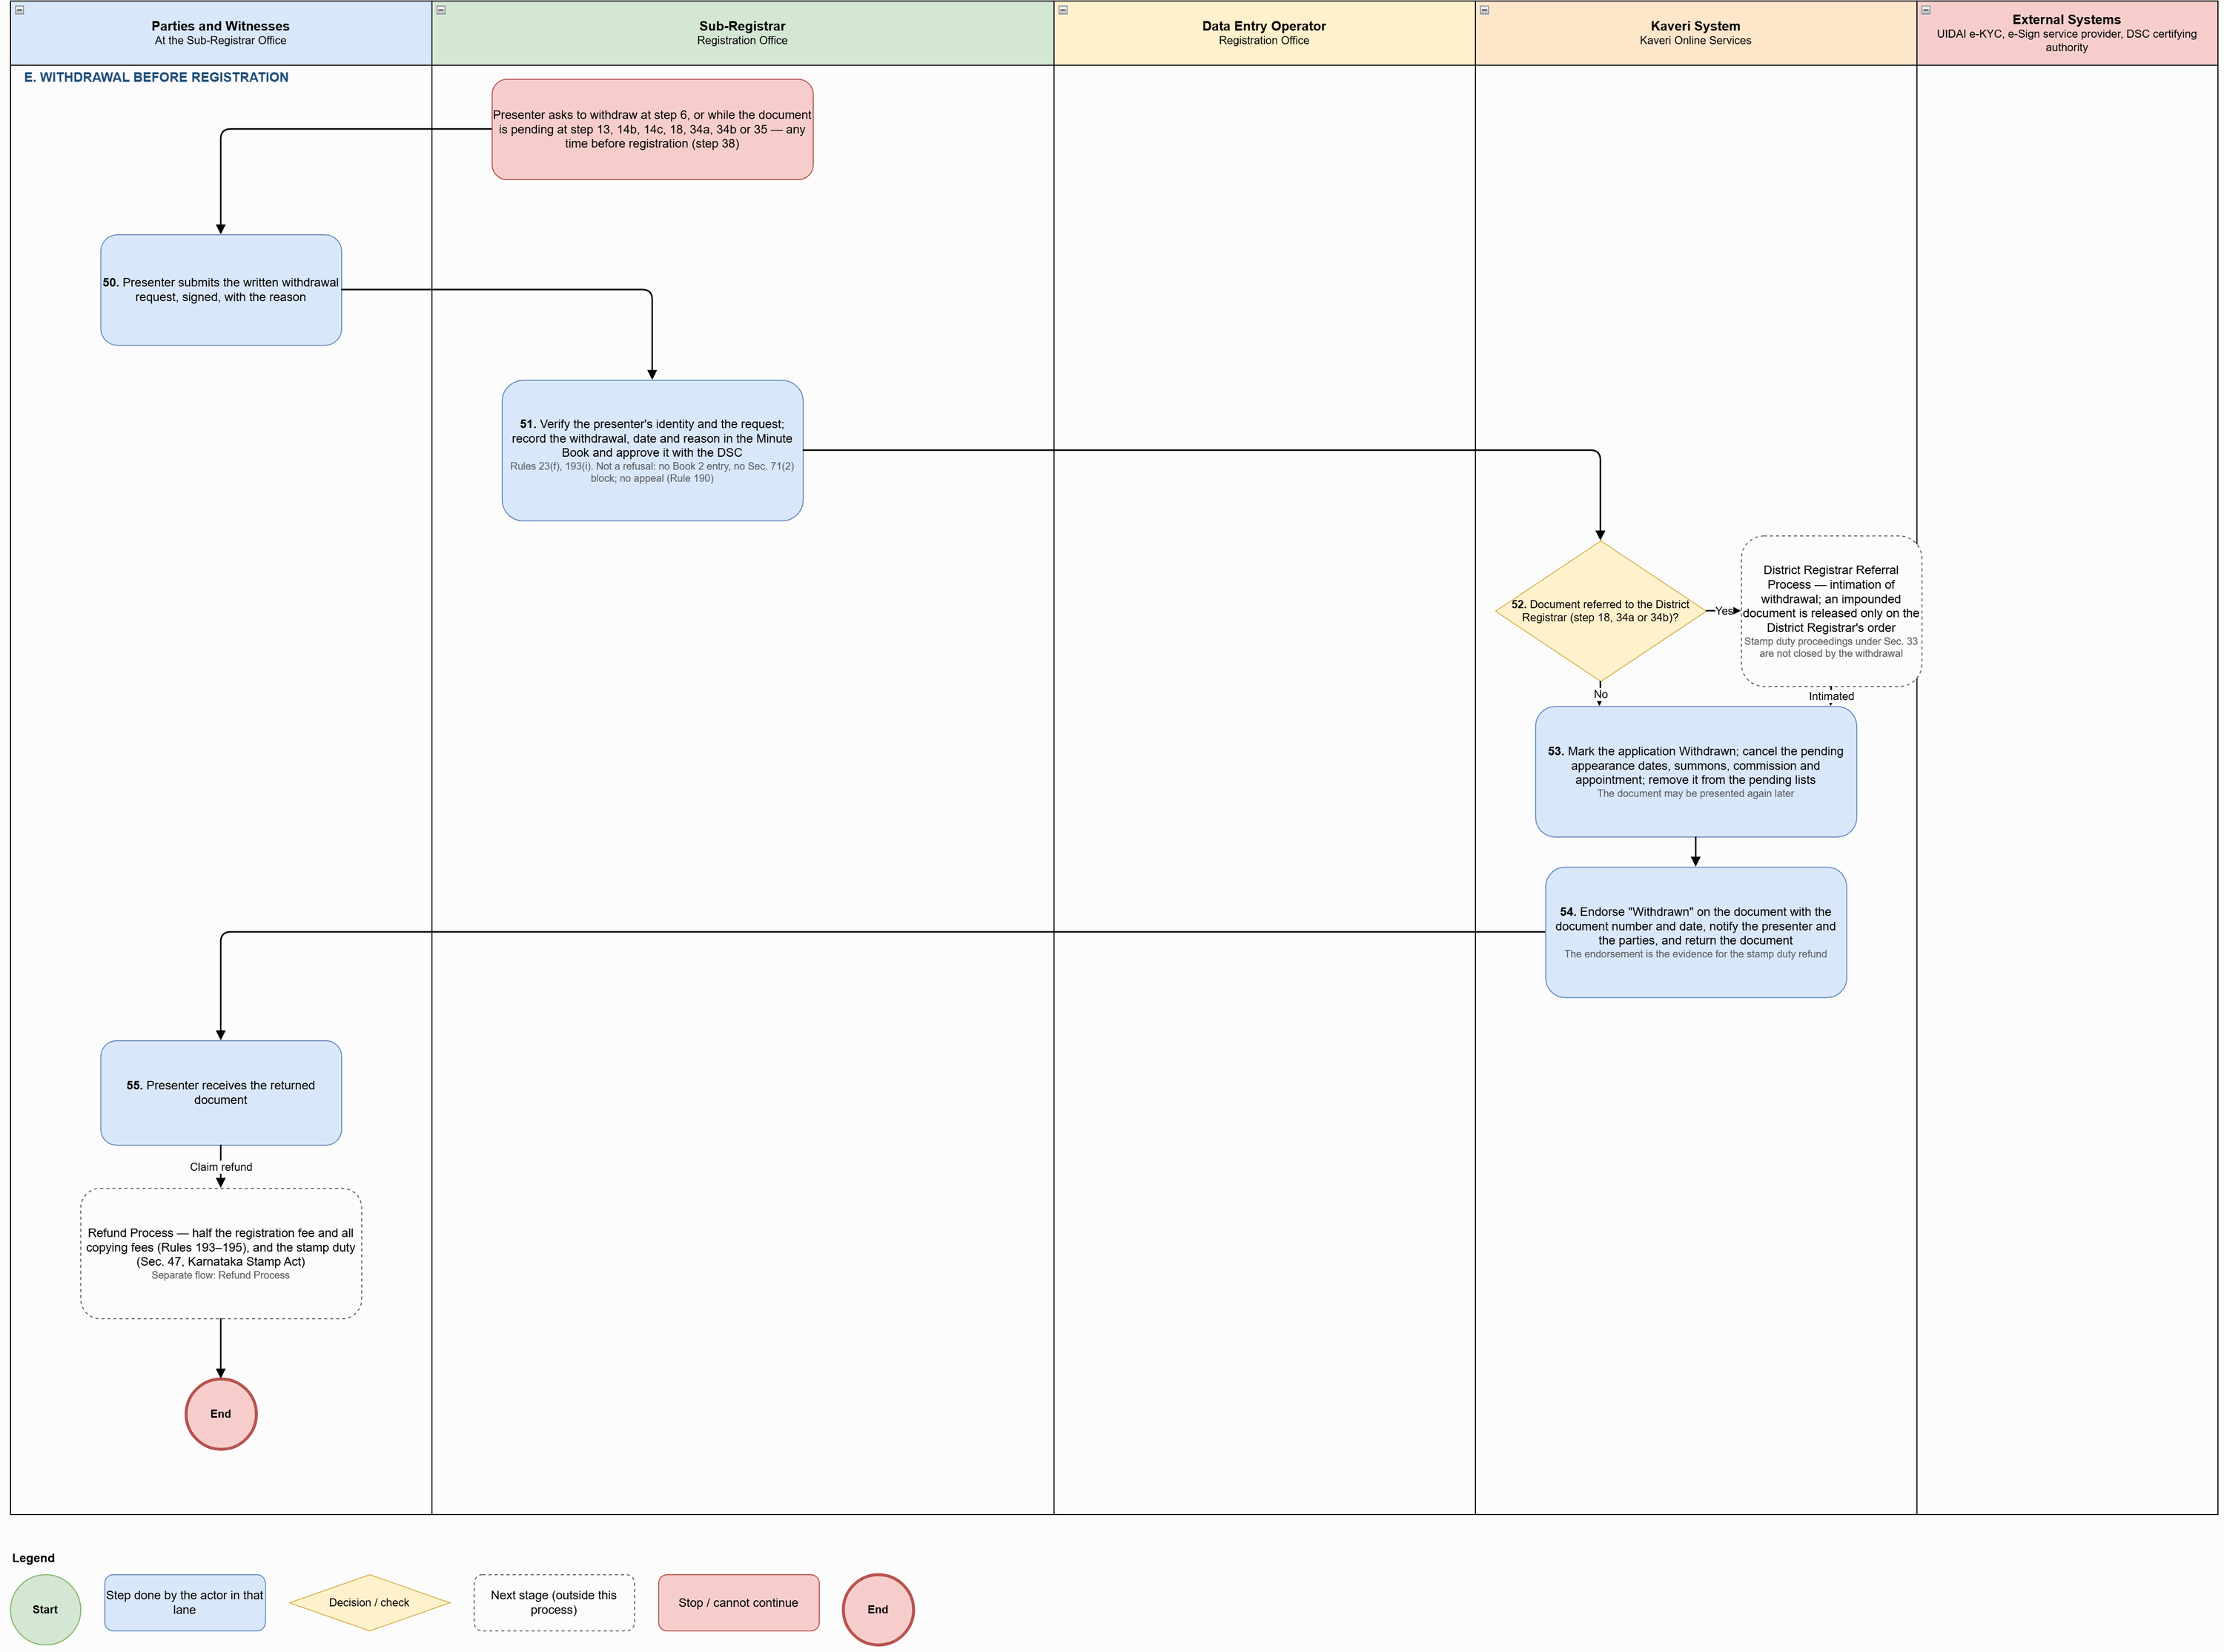
Figure: Presentation, Photo & Thumb Capture, Registration, Refusal and Withdrawal Process (part 6 of 6)

Process flow
Flow (at the Sub-Registrar Office after the appointment), by section of the diagram:

A. Presentation
# | Step | Lane | Notes
1 | Open the application from the Presentation list | Sub-Registrar
2 | Show the digitally executed deed (with signature status) and the payment for each property: stamp duty, surcharge, cess, registration fee and total | Kaveri System
3 | Verification checklist: presenter's identity and right to present; deed matches the submission; payment and stamp duty (a stamp duty shortfall alone does not stop presentation: mark it for impounding at step 34, Sec. 33; Rule 46(ii), (iii)); language, interlineations, property description, map and date of execution (a date altered to avoid the delay fine is not accepted, Rule 50(iii)); Sec. 22-B (forged, prohibited or attached property). Mark Agree / Disagree with remarks | Sub-Registrar
4 | All checklist items agreed? | Kaveri System | Stamp duty shortfall marked for impounding counts as agreed
5 | Disagree item is a refusal ground? (Rule 171, Sec. 22-B) | Kaveri System | Decision
6 | Not presented: the parties cure the defect and return, or the presenter withdraws in writing: go to E (step 50) | Kaveri System | No appeal (Rule 190)
7 | Select the presenter from the parties and present the document | Sub-Registrar
8 | Record the presentation: presenter, date, time and office | Kaveri System | Presenter cannot be changed once admission is recorded (Sec. 32, Registration Act)
9 | Record admission or denial of execution as each party appears, with the date of appearance | Sub-Registrar | Refusal grounds: execution denied; minor or unsound mind; death of executant not proved (Sec. 34, 35; Rule 171). Executants may appear at different times (Sec. 34(2))
10 | Refusal ground at admission? | Kaveri System | Decision
11 | Another party present at the counter? | Kaveri System | Decision
12 | All executants appeared and admitted? | Kaveri System | Decision
13 | Keep the document pending as Party Appearance Pending: record who has admitted and who is absent, with the date; record in the Minute Book. Admissions already recorded stay | Sub-Registrar | Sec. 34(2); Rule 172
14 | Calculate the last date for appearance (4 months from execution; up to 4 more with condonation), notify the applicant and the absent executants and list the document as Pending Appearance | Kaveri System | Sec. 34(1), (2)
14a | How will the absent executant appear? | Kaveri System | Decision
14b | Presenter applies for a summons: issue the summons to the absent executant on payment of the peon's fee (Add Challan), have it served, and keep the document pending as Summons Issued until the date fixed; record in the Minute Book | Sub-Registrar | Sec. 36, 37, 39; Rule 23(e)
14c | Executant exempt from appearing (illness or bodily infirmity, in jail, or exempt by law): visit the residence or jail, or issue a commission; keep the document pending as Commission Report Pending until the examination or the commissioner's report is recorded | Sub-Registrar | Sec. 31, 33, 38
15 | Absent executant appeared by the last date? | Kaveri System | Decision
16 | Presented, or an executant appeared, more than 4 months after execution? | Kaveri System | From each execution date (Sec. 23, 24); decree date / arrival in India (Sec. 23, 26); wills exempt (Sec. 27); appearance: Sec. 34(1)
17 | Delay more than 4 months beyond the time allowed? | Kaveri System | Rule 171(vi) / (viii)
18 | Take the written condonation application (urgent necessity or unavoidable accident), suspend registration and refer it to the District Registrar whether or not the reason is satisfactory; record in the Minute Book | Sub-Registrar | Sec. 25, 34(1); Rules 46, 51, 55(i)
19 | Order received: delay condoned and fine paid? | Sub-Registrar | Rejected / unpaid: Rule 171(vi), (viii), (xvi)

B. Photo, thumb and e-Sign
# | Step | Lane | Notes
20 | Select at least two identifiers from the witnesses, or add a new identifier | Data Entry Operator
21 | At least two identifiers? | Kaveri System | Decision
22 | For each party: assign the identifiers, capture the photo (camera) and thumb impression (biometric device); run Aadhaar e-KYC and name match | Data Entry Operator
23 | UIDAI e-KYC: return name, date of birth, address and photo for the name match | External Systems
24 | For each witness / identifier: capture the photo; run Aadhaar e-KYC and name match | Data Entry Operator
25 | Each party and witness e-Signs at the counter, or on their own mobile through a link (Get Link) | Parties and Witnesses
26 | e-Sign service provider: Aadhaar OTP and the e-Signature | External Systems
27 | Photo, thumb, e-KYC and e-Sign done for every party and witness? | Kaveri System | Decision
28 | Executants identified and agents' authority accepted? (Sec. 34(3)) | Kaveri System | Decision
29 | Generate the endorsement | Data Entry Operator
30 | Generate the endorsement: presentation, fee details, presenter, admission by each executant with e-KYC details, photo, thumb and e-Sign, the identifiers and, if the delay was condoned, the Registrar's order number and date, fine and period of delay | Kaveri System | Rule 55(ii)

C. Registration
# | Step | Lane | Notes
31 | Review the endorsement together with the digitally executed deed | Sub-Registrar
32 | Refusal ground found on review? (Sec. 22-B, Rule 171) | Kaveri System | Decision
33 | Stamp duty short? | Kaveri System | Partial payment by the applicant, or shortfall marked at step 3 or found on review
34 | Market value understated in an instrument listed in Sec. 45-A, or stamp duty short (Sec. 33)? | Sub-Registrar | Decision
34a | Sec. 45-A: communicate the estimated market value to the parties; unless they pay duty on it, keep the process of registration pending and refer the matter with a copy of the instrument to the District Registrar; record in the Minute Book | Sub-Registrar | Sec. 45-A(1), Karnataka Stamp Act
34b | Sec. 33: impound; write "Impounded under Section 33" below the presentation endorsement, sign and date it; send the original to the District Registrar with the reasons, suspending registration; enter in the Register of Impounded Documents and the Minute Book | Sub-Registrar | Sec. 33, 37(2); Rules 23(a), 24(iii)(a), 46(ii)
35 | Order received and the amount due paid? | Sub-Registrar | Rule 116. Unpaid: Rule 171 (xvi)
36 | Sign the endorsement with the DSC: select the certificate and enter the password | Sub-Registrar
37 | Certifying authority: certificate valid and not revoked | External Systems
38 | Register the document | Sub-Registrar
39 | Generate the registration number (office–book–serial–financial year, e.g. GAN-1-00006-2026-27), attach the signed endorsement to the deed, mark Registration Completed and notify the applicant | Kaveri System

D. Refusal to register
# | Step | Lane | Notes
40 | Property outside this office's jurisdiction? | Sub-Registrar | Decision
41 | Pass the refusal order: select the ground(s) under Rule 171 / Sec. 22-B and record the reasons | Sub-Registrar | Sec. 71(1), Registration Act
42 | Some executants admitted and others denied or did not appear? | Kaveri System | Decision
43 | Register as to the executants who admitted; endorse the refusal for the others below the certificate | Kaveri System | Rules 106, 172 & 173
44 | Record the reasons in Book 2 (Record of reasons for refusal to register) and endorse "Registration refused" on the document | Kaveri System | Sec. 71(1); Rule 171; Book 2 kept permanently (Rule 205)
45 | Sign the refusal order and the endorsement with the DSC | Sub-Registrar
46 | Block re-presentation of the document in every office unless registration is directed (Sec. 71(2)); refund half the registration fee and all copying fees, but not any delay fine (Rule 193 and note); notify the presenter and return the refused document (Rule 112) | Kaveri System
47 | Presenter receives the refused document; an executant or claimant may apply for a copy of the reasons | Parties and Witnesses
48 | Issue a free copy of the recorded reasons without delay | Kaveri System | Sec. 71(1)
49 | Refused for denial of execution? (Sec. 35; Rule 187) | Kaveri System | Decision

E. Withdrawal before registration
# | Step | Lane | Notes
50 | Presenter submits the written withdrawal request, signed, with the reason | Parties and Witnesses
51 | Verify the presenter's identity and the request; record the withdrawal, date and reason in the Minute Book and approve it with the DSC | Sub-Registrar | Rules 23(f), 193(i). Not a refusal: no Book 2 entry, no Sec. 71(2) block; no appeal (Rule 190)
52 | Document referred to the District Registrar (step 18, 34a or 34b)? | Kaveri System | Decision
53 | Mark the application Withdrawn; cancel the pending appearance dates, summons, commission and appointment; remove it from the pending lists | Kaveri System | The document may be presented again later
54 | Endorse "Withdrawn" on the document with the document number and date, notify the presenter and the parties, and return the document | Kaveri System | The endorsement is the evidence for the stamp duty refund
55 | Presenter receives the returned document | Parties and Witnesses

Key characteristics: a stamp duty shortfall alone does not stop presentation — it is marked for impounding; refusal grounds go to D, curable defects allow cure or withdrawal (no appeal, Rule 190); the presenter is fixed once admission is recorded (Sec. 32); executants may appear at different times, with the document kept pending (Sec. 34(2); Rule 172) and summons or commission available; delay up to a further 4 months is referred to the District Registrar for condonation, beyond that it is refused; at least two identifiers; photo, thumb, e-KYC name match and e-Sign for every party and witness; endorsement generated with condonation details (Rule 55(ii)); Sec. 45-A and Sec. 33 cases decided in the District Registrar Referral Process before registration; registration number office–book–serial–financial year; refusal recorded in Book 2 with a re-presentation block; withdrawal is not a refusal and leads to the Refund Process.

Application status model
Application statuses used in the presentation, photo & thumb capture, registration, refusal and withdrawal process:
Status | Description | Actor | Next states
Appointment Booked | Slot booked at the jurisdictional office; confirmation sent | Citizen / System | Presented; Not Presented – Defect; Registration Refused; Withdrawn
Presented | Presentation recorded (presenter, date, time, office) | Sub-Registrar / System | Party Appearance Pending; Pending with District Registrar; Registration Completed; Registration Refused; Withdrawn
Not Presented – Defect | Checklist disagreement that is not a refusal ground; parties may cure and return | Sub-Registrar | Appointment Booked; Withdrawn
Party Appearance Pending | Some executants have not appeared; last date for appearance tracked | Sub-Registrar / System | Summons Issued; Commission Report Pending; Presented; Registration Refused; Withdrawn
Summons Issued | Summons issued on payment of the peon's fee; pending until the date fixed | Sub-Registrar | Party Appearance Pending; Presented; Registration Refused
Commission Report Pending | Home / jail visit or commission issued; awaiting examination or report | Sub-Registrar | Party Appearance Pending; Presented; Registration Refused
Pending with District Registrar | Condonation, Sec. 45-A reference or Sec. 33 impounded instrument with the District Registrar | District Registrar | Hearing Scheduled; Order Passed – Payment Due; Returned to Sub-Registrar
Registration Completed | Registered with DSC; registration number generated; document issued | Sub-Registrar / System | — (post-registration services)
Partially Registered | Registered as to executants who admitted; refused for the others (Rules 106, 172, 173) | Sub-Registrar | Appeal Pending with District Registrar
Registration Refused | Refusal order and Book 2 entry signed with DSC; re-presentation blocked; half fee refunded | Sub-Registrar | Appeal Pending with District Registrar
Withdrawn | Withdrawal recorded in the Minute Book; pendings cancelled; document returned | Sub-Registrar / System | Refund Applied

District Registrar referral, appeals and applications

Channel model
Service Type | Online Activities | Office Activities | Mode
Referral by the Sub-Registrar (condonation, Sec. 45-A, Sec. 33) | Notifications; view orders; pay the amount due through Add Challan | District Registrar examines the case, hears the parties where required, passes the order with DSC, endorses payment and returns the document to the Sub-Registrar | Back office with hearings in person
Appeal / application against refusal (Sec. 72, 73) | Notifications of hearing and orders; process fee payment | Filed in person or through an agent with an authenticated power of attorney within 30 days; admissibility, hearing, enquiry and order | In person

Process diagram
Source: ProcessDiagram/District_Registrar_Referral_Process_v3.drawio (full-resolution PNG alongside).
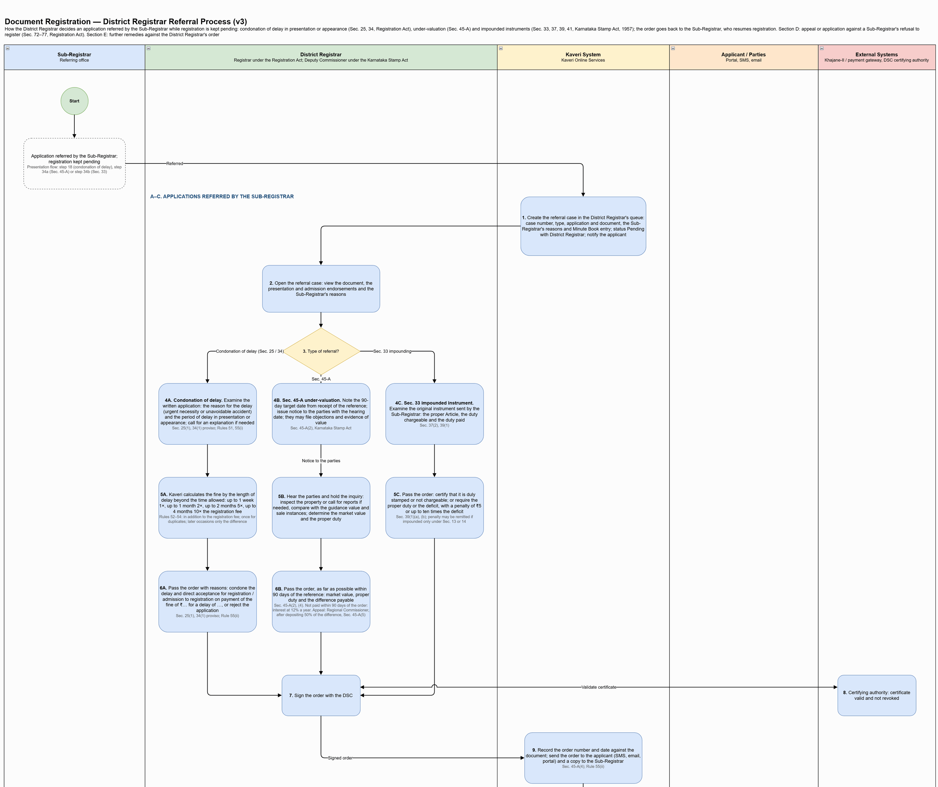
Figure: District Registrar Referral Process (part 1 of 3)
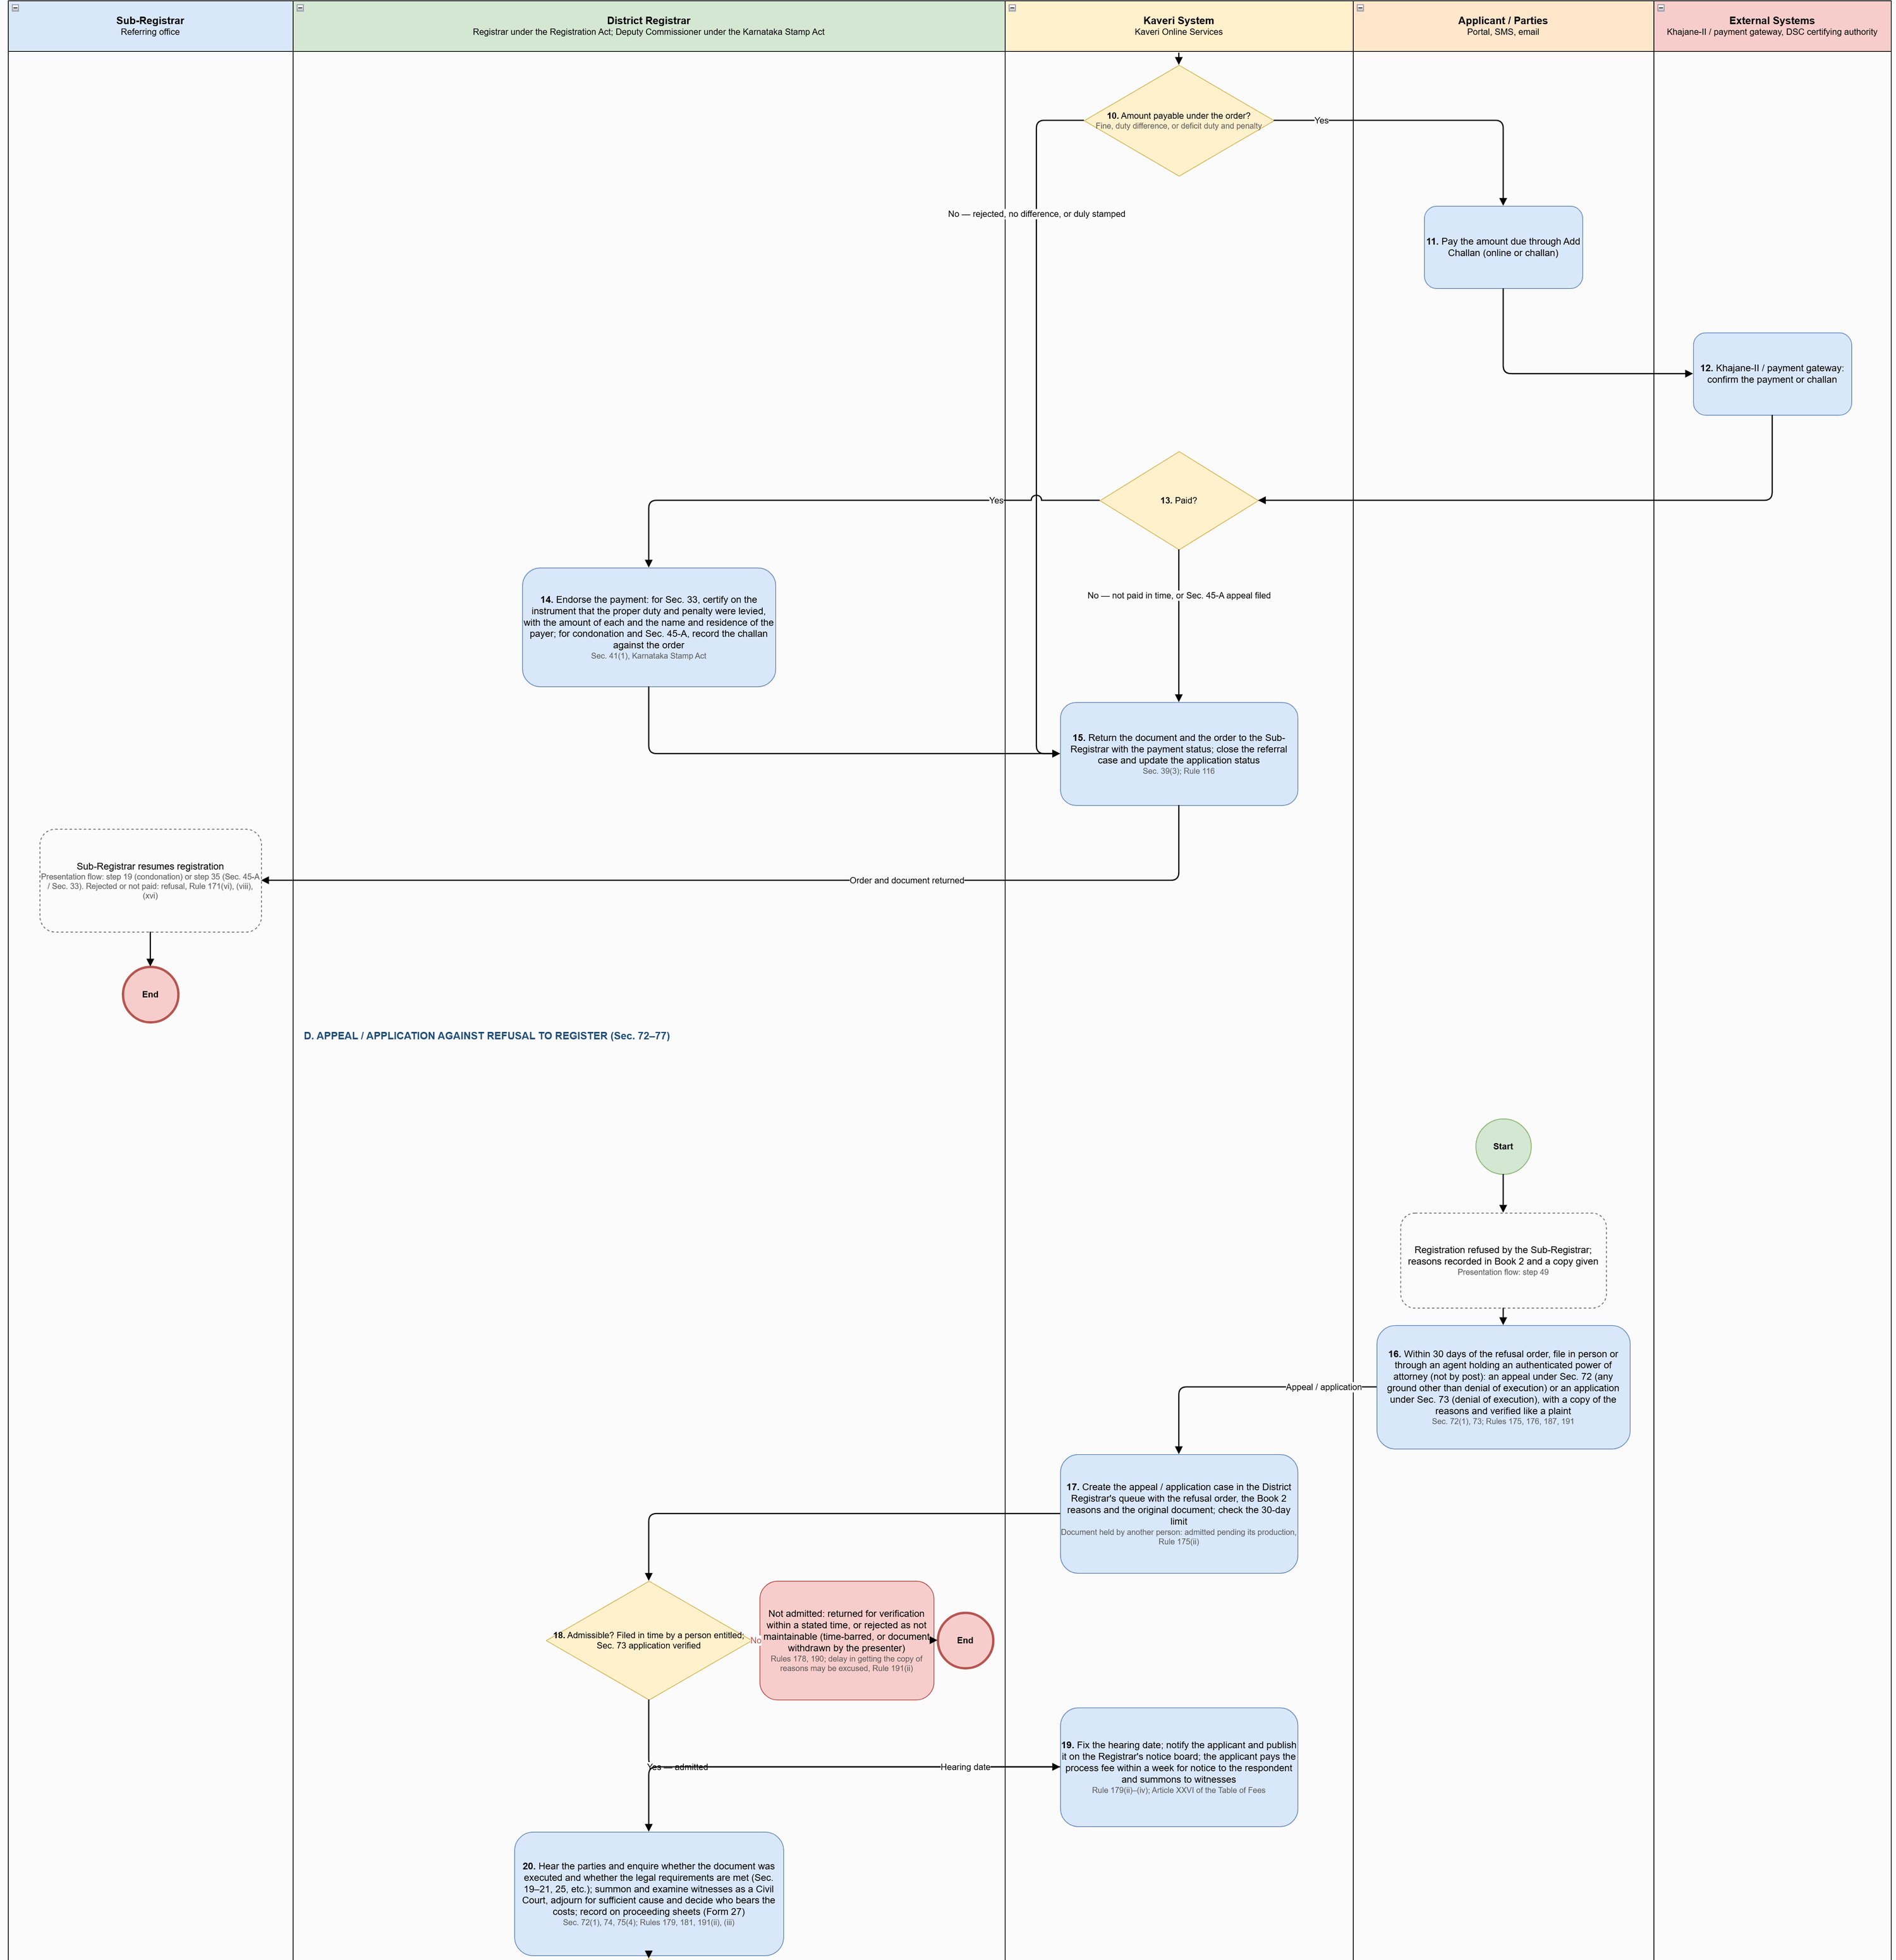
Figure: District Registrar Referral Process (part 2 of 3)
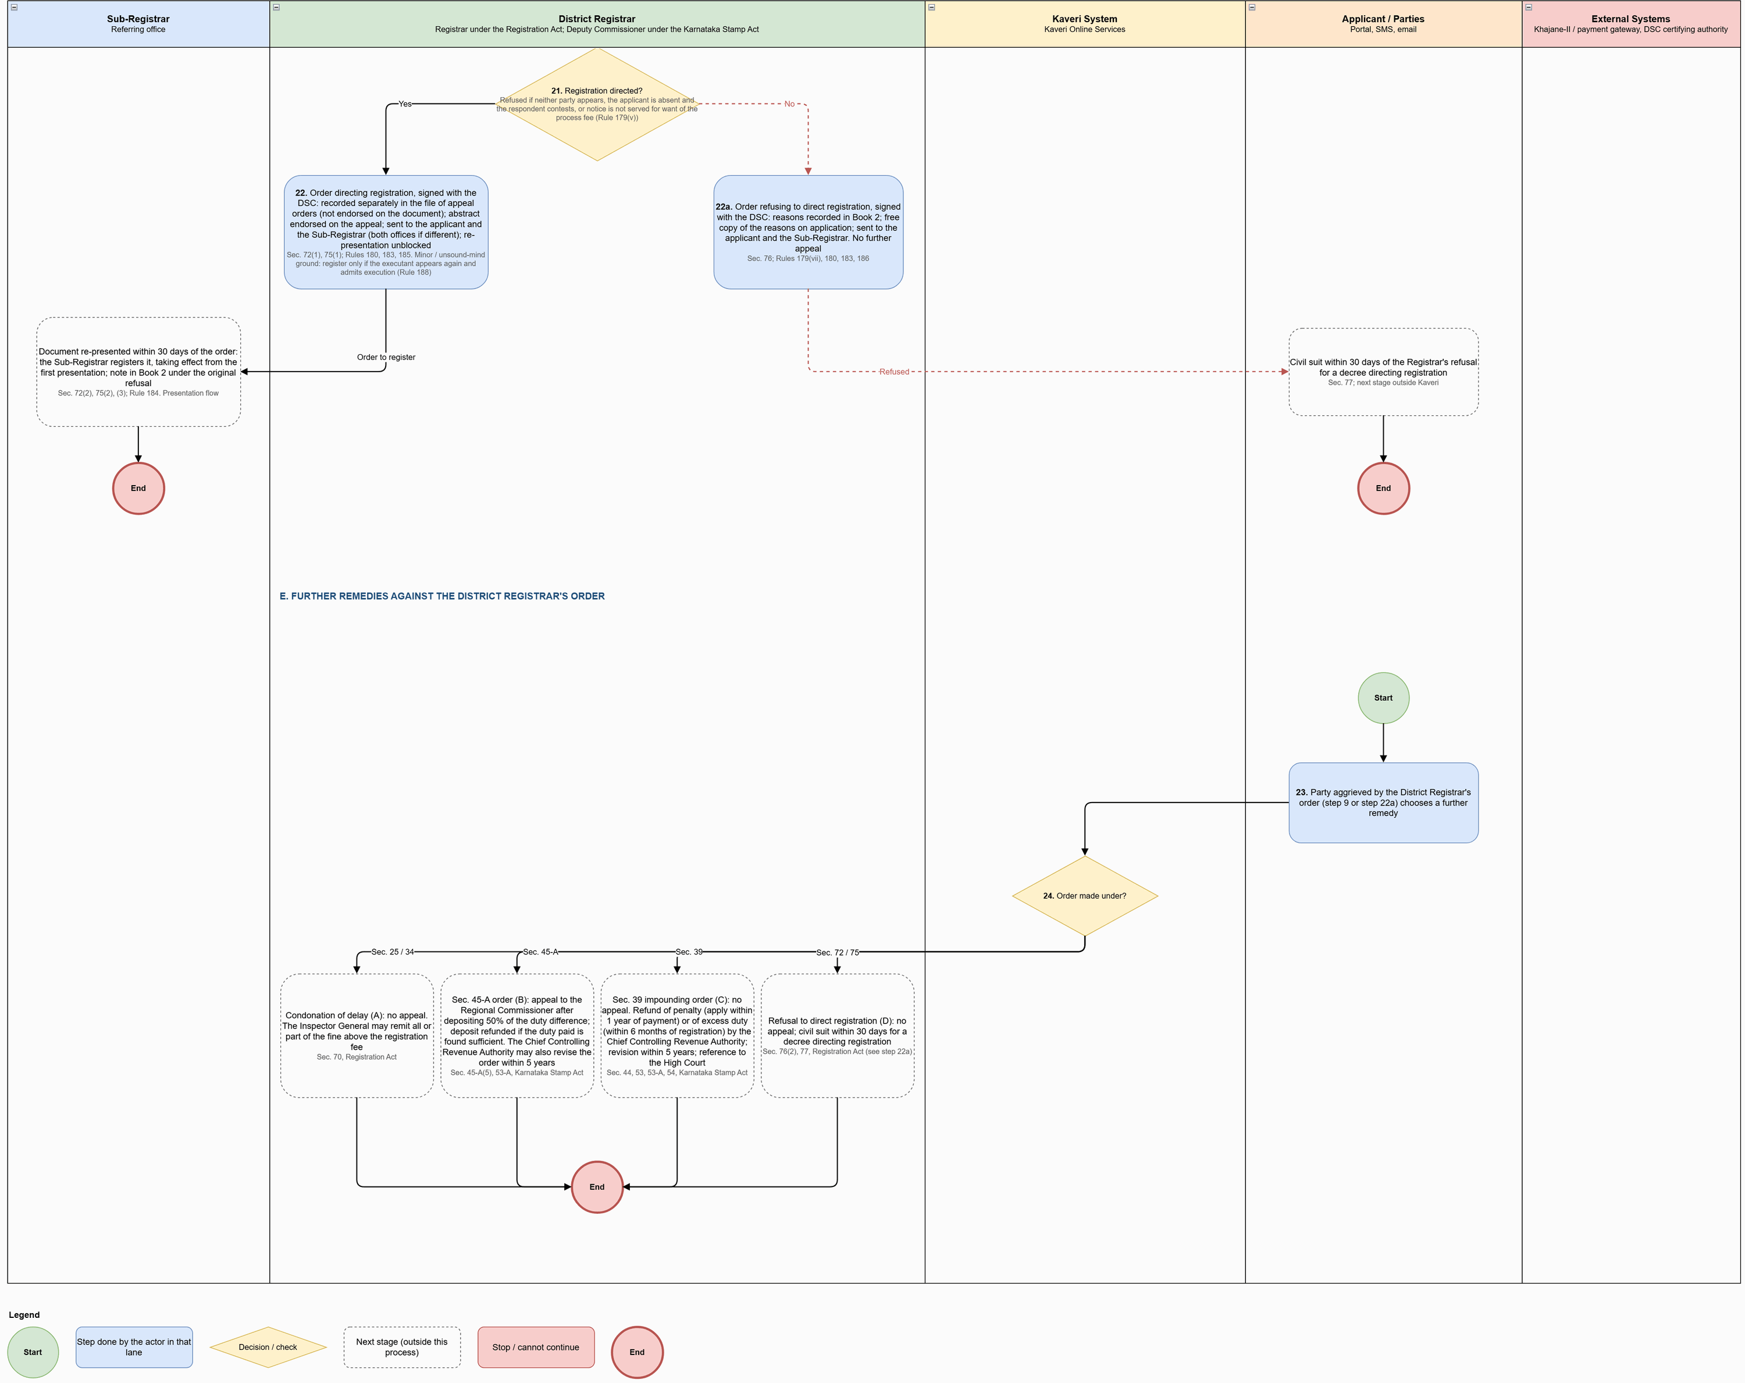
Figure: District Registrar Referral Process (part 3 of 3)

Process flow
Flow (District Registrar's queue), by section of the diagram:

A–C. Applications referred by the Sub-Registrar
# | Step | Lane | Notes
1 | Create the referral case in the District Registrar's queue: case number, type, application and document, the Sub-Registrar's reasons and Minute Book entry; status Pending with District Registrar; notify the applicant | Kaveri System
2 | Open the referral case: view the document, the presentation and admission endorsements and the Sub-Registrar's reasons | District Registrar
3 | Type of referral? | District Registrar | Decision
4A | Condonation of delay. Examine the written application: the reason for the delay (urgent necessity or unavoidable accident) and the period of delay in presentation or appearance; call for an explanation if needed | District Registrar | Sec. 25(1), 34(1) proviso; Rules 51, 55(i)
5A | Kaveri calculates the fine by the length of delay beyond the time allowed: up to 1 week 1×, up to 1 month 2×, up to 2 months 5×, up to 4 months 10× the registration fee | District Registrar | Rules 52–54: in addition to the registration fee; once for duplicates; later occasions only the difference
6A | Pass the order with reasons: condone the delay and direct acceptance for registration / admission to registration on payment of the fine of ₹… for a delay of …, or reject the application | District Registrar | Sec. 25(1), 34(1) proviso; Rule 55(ii)
4B | Sec. 45-A under-valuation. Note the 90-day target date from receipt of the reference; issue notice to the parties with the hearing date; they may file objections and evidence of value | District Registrar | Sec. 45-A(2), Karnataka Stamp Act
5B | Hear the parties and hold the inquiry: inspect the property or call for reports if needed, compare with the guidance value and sale instances; determine the market value and the proper duty | District Registrar
6B | Pass the order, as far as possible within 90 days of the reference: market value, proper duty and the difference payable | District Registrar | Sec. 45-A(2), (4). Not paid within 90 days of the order: interest at 12% a year. Appeal: Regional Commissioner, after depositing 50% of the difference, Sec. 45-A(5)
4C | Sec. 33 impounded instrument. Examine the original instrument sent by the Sub-Registrar: the proper Article, the duty chargeable and the duty paid | District Registrar | Sec. 37(2), 39(1)
5C | Pass the order: certify that it is duly stamped or not chargeable; or require the proper duty or the deficit, with a penalty of ₹5 or up to ten times the deficit | District Registrar | Sec. 39(1)(a), (b); penalty may be remitted if impounded only under Sec. 13 or 14
7 | Sign the order with the DSC | District Registrar
8 | Certifying authority: certificate valid and not revoked | External Systems
9 | Record the order number and date against the document; send the order to the applicant (SMS, email, portal) and a copy to the Sub-Registrar | Kaveri System | Sec. 45-A(4); Rule 55(ii)
10 | Amount payable under the order? | Kaveri System | Fine, duty difference, or deficit duty and penalty
11 | Pay the amount due through Add Challan (online or challan) | Applicant / Parties
12 | Khajane-II / payment gateway: confirm the payment or challan | External Systems
13 | Paid? | Kaveri System | Decision
14 | Endorse the payment: for Sec. 33, certify on the instrument that the proper duty and penalty were levied, with the amount of each and the name and residence of the payer; for condonation and Sec. 45-A, record the challan against the order | District Registrar | Sec. 41(1), Karnataka Stamp Act
15 | Return the document and the order to the Sub-Registrar with the payment status; close the referral case and update the application status | Kaveri System | Sec. 39(3); Rule 116

D. Appeal / application against refusal to register (Sec. 72–77)
# | Step | Lane | Notes
16 | Within 30 days of the refusal order, file in person or through an agent holding an authenticated power of attorney (not by post): an appeal under Sec. 72 (any ground other than denial of execution) or an application under Sec. 73 (denial of execution), with a copy of the reasons and verified like a plaint | Applicant / Parties | Sec. 72(1), 73; Rules 175, 176, 187, 191
17 | Create the appeal / application case in the District Registrar's queue with the refusal order, the Book 2 reasons and the original document; check the 30-day limit | Kaveri System | Document held by another person: admitted pending its production, Rule 175(ii)
18 | Admissible? Filed in time by a person entitled; Sec. 73 application verified | District Registrar | Decision
19 | Fix the hearing date; notify the applicant and publish it on the Registrar's notice board; the applicant pays the process fee within a week for notice to the respondent and summons to witnesses | Kaveri System | Rule 179(ii)–(iv); Article XXVI of the Table of Fees
20 | Hear the parties and enquire whether the document was executed and whether the legal requirements are met (Sec. 19–21, 25, etc.); summon and examine witnesses as a Civil Court, adjourn for sufficient cause and decide who bears the costs; record on proceeding sheets (Form 27) | District Registrar | Sec. 72(1), 74, 75(4); Rules 179, 181, 191(ii), (iii)
21 | Registration directed? | District Registrar | Refused if neither party appears, the applicant is absent and the respondent contests, or notice is not served for want of the process fee (Rule 179(v))
22 | Order directing registration, signed with the DSC: recorded separately in the file of appeal orders (not endorsed on the document); abstract endorsed on the appeal; sent to the applicant and the Sub-Registrar (both offices if different); re-presentation unblocked | District Registrar | Sec. 72(1), 75(1); Rules 180, 183, 185. Minor / unsound-mind ground: register only if the executant appears again and admits execution (Rule 188)
22a | Order refusing to direct registration, signed with the DSC: reasons recorded in Book 2; free copy of the reasons on application; sent to the applicant and the Sub-Registrar. No further appeal | District Registrar | Sec. 76; Rules 179(vii), 180, 183, 186

E. Further remedies against the District Registrar's order
# | Step | Lane | Notes
23 | Party aggrieved by the District Registrar's order (step 9 or step 22a) chooses a further remedy | Applicant / Parties
24 | Order made under? | Kaveri System | Decision
24A | Condonation of delay (A): no appeal. The Inspector General may remit all or part of the fine above the registration fee | District Registrar | Sec. 70, Registration Act
24B | Sec. 45-A order (B): appeal to the Regional Commissioner after depositing 50% of the duty difference; deposit refunded if the duty paid is found sufficient. The Chief Controlling Revenue Authority may also revise the order within 5 years | District Registrar | Sec. 45-A(5), 53-A, Karnataka Stamp Act
24C | Sec. 39 impounding order (C): no appeal. Refund of penalty (apply within 1 year of payment) or of excess duty (within 6 months of registration) by the Chief Controlling Revenue Authority; revision within 5 years; reference to the High Court | District Registrar | Sec. 44, 53, 53-A, 54, Karnataka Stamp Act
24D | Refusal to direct registration (D): no appeal; civil suit within 30 days for a decree directing registration | District Registrar | Sec. 76(2), 77, Registration Act (see step 22a)

Key characteristics: one referral case per reference, with the Sub-Registrar's reasons and Minute Book entry; condonation fine calculated by the system on the Rule 52–54 slab; Sec. 45-A references tracked against the 90-day target with interest at 12% where the order is not paid within 90 days; Sec. 33 orders certify the instrument or levy deficit duty with penalty; all orders signed with DSC and sent to the applicant and the Sub-Registrar; payment endorsed (Sec. 41(1)) and the document returned (Sec. 39(3); Rule 116); appeals and applications checked for the 30-day limit and entitlement, heard on proceeding sheets (Form 27), and decided by an order directing registration (re-presentation unblocked) or refusing it (Book 2; civil suit under Sec. 77).

Application status model
Application statuses used in the district registrar referral, appeals and applications process:
Status | Description | Actor | Next states
Pending with District Registrar | Condonation, Sec. 45-A reference or Sec. 33 impounded instrument with the District Registrar | District Registrar | Hearing Scheduled; Order Passed – Payment Due; Returned to Sub-Registrar
Hearing Scheduled | Notice issued and hearing date fixed | District Registrar | Order Passed – Payment Due; Returned to Sub-Registrar; Registration Directed; Appeal Refused
Order Passed – Payment Due | Order signed with DSC; fine, duty difference or deficit and penalty payable | Applicant | Returned to Sub-Registrar
Returned to Sub-Registrar | Order and payment status returned; registration resumes or is refused | System | Presented; Registration Refused
Appeal Pending with District Registrar | Sec. 72 appeal or Sec. 73 application filed within 30 days | Applicant / District Registrar | Hearing Scheduled; Registration Directed; Appeal Refused
Registration Directed | Order directing registration; re-presentation unblocked (within 30 days) | District Registrar | Appointment Booked; Presented
Appeal Refused | Order refusing to direct registration; reasons in Book 2; civil suit under Sec. 77 | District Registrar | — (terminal in Kaveri)

Refund of fees and stamp duty on withdrawal

Channel model
Service Type | Online Activities | Office Activities | Mode
Registration fee and copying fee refund | Refund application pre-filled from the withdrawal, with bank account; tracking and notification | Sub-Registrar verifies and enters in Form 28; District Registrar (≤ 3 years) or Inspector General (≤ 5 years) sanctions; refund bill to Khajane-II | Online application, office sanction
Stamp duty refund (e-stamp certificate) | Form 4 application with the e-stamp certificate and the withdrawn document | Deputy Commissioner of Stamps verifies time limit and Sec. 47(c) grounds, cancels and locks the certificate, allows duty less 20 paise per rupee and pays by treasury cheque | Online application, office decision

Process diagram
Source: ProcessDiagram/Refund_Process_v1.drawio (full-resolution PNG alongside).
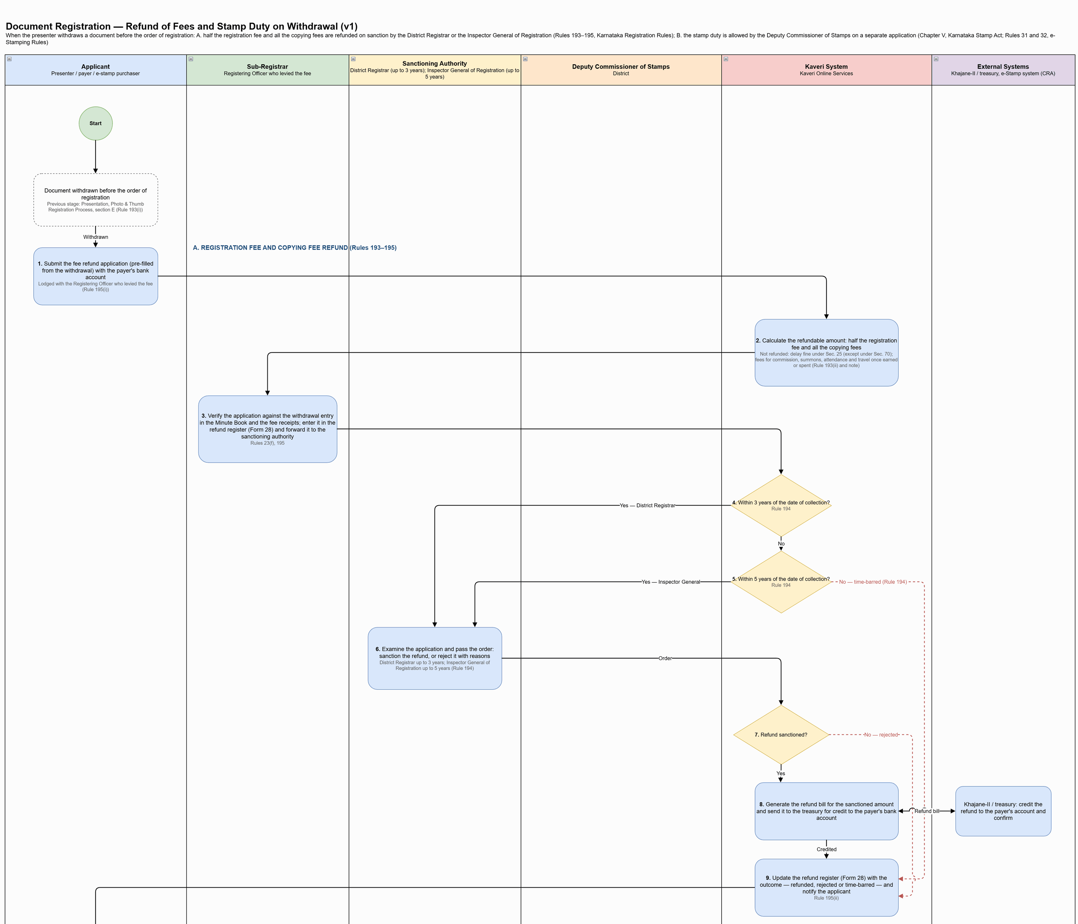
Figure: Refund of Fees and Stamp Duty on Withdrawal (part 1 of 2)
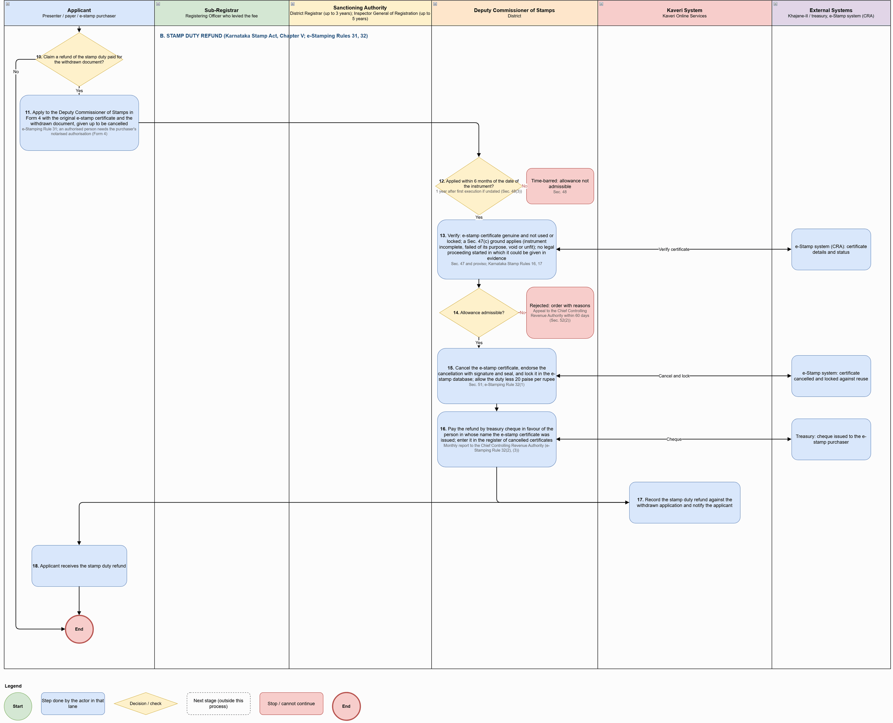
Figure: Refund of Fees and Stamp Duty on Withdrawal (part 2 of 2)

Process flow
Flow (after withdrawal), by section of the diagram:

A. Registration fee and copying fee refund (Rules 193–195)
# | Step | Lane | Notes
1 | Submit the fee refund application (pre-filled from the withdrawal) with the payer's bank account | Applicant | Lodged with the Registering Officer who levied the fee (Rule 195(i))
2 | Calculate the refundable amount: half the registration fee and all the copying fees | Kaveri System | Not refunded: delay fine under Sec. 25 (except under Sec. 70); fees for commission, summons, attendance and travel once earned or spent (Rule 193(ii) and note)
3 | Verify the application against the withdrawal entry in the Minute Book and the fee receipts; enter it in the refund register (Form 28) and forward it to the sanctioning authority | Sub-Registrar | Rules 23(f), 195
4 | Within 3 years of the date of collection? | Kaveri System | Rule 194
5 | Within 5 years of the date of collection? | Kaveri System | Rule 194
6 | Examine the application and pass the order: sanction the refund, or reject it with reasons | Sanctioning Authority | District Registrar up to 3 years; Inspector General of Registration up to 5 years (Rule 194)
7 | Refund sanctioned? | Kaveri System | Decision
8 | Generate the refund bill for the sanctioned amount and send it to the treasury for credit to the payer's bank account | Kaveri System
9 | Update the refund register (Form 28) with the outcome — refunded, rejected or time-barred — and notify the applicant | Kaveri System | Rule 195(ii)

B. Stamp duty refund (Karnataka Stamp Act, Chapter v; e-Stamping Rules 31, 32)
# | Step | Lane | Notes
10 | Claim a refund of the stamp duty paid for the withdrawn document? | Applicant | Decision
11 | Apply to the Deputy Commissioner of Stamps in Form 4 with the original e-stamp certificate and the withdrawn document, given up to be cancelled | Applicant | e-Stamping Rule 31; an authorised person needs the purchaser's notarised authorisation (Form 4)
12 | Applied within 6 months of the date of the instrument? | Deputy Commissioner of Stamps | 1 year after first execution if undated (Sec. 48(3))
13 | Verify: e-stamp certificate genuine and not used or locked; a Sec. 47(c) ground applies (instrument incomplete, failed of its purpose, void or unfit); no legal proceeding started in which it could be given in evidence | Deputy Commissioner of Stamps | Sec. 47 and proviso; Karnataka Stamp Rules 16, 17
14 | Allowance admissible? | Deputy Commissioner of Stamps | Decision
15 | Cancel the e-stamp certificate, endorse the cancellation with signature and seal, and lock it in the e-stamp database; allow the duty less 20 paise per rupee | Deputy Commissioner of Stamps | Sec. 51; e-Stamping Rule 32(1)
16 | Pay the refund by treasury cheque in favour of the person in whose name the e-stamp certificate was issued; enter it in the register of cancelled certificates | Deputy Commissioner of Stamps | Monthly report to the Chief Controlling Revenue Authority (e-Stamping Rule 32(2), (3))
17 | Record the stamp duty refund against the withdrawn application and notify the applicant | Kaveri System
18 | Applicant receives the stamp duty refund | Applicant

Key characteristics: refundable fee is half the registration fee plus all copying fees (delay fine and earned process fees are not refunded, Rule 193(ii)); limitation and the sanctioning authority decided by the date of collection (Rule 194); refund register Form 28 updated with every outcome; stamp duty refund only within 6 months of the instrument (1 year if undated, Sec. 48); e-stamp certificate checked as genuine, unused and unlocked and then cancelled and locked; allowance less 20 paise per rupee (Sec. 51; e-Stamping Rule 32(1)); refund recorded against the withdrawn application.

Application status model
Application statuses used in the refund of fees and stamp duty on withdrawal process:
Status | Description | Actor | Next states
Withdrawn | Withdrawal recorded in the Minute Book; pendings cancelled; document returned | Sub-Registrar / System | Refund Applied
Refund Applied | Fee refund application or Form 4 stamp duty refund application submitted | Applicant | Refund Under Verification
Refund Under Verification | Sub-Registrar / Deputy Commissioner of Stamps verifying; limitation checked | Officer | Refund Sanctioned; Refund Rejected; Refund Time-barred
Refund Sanctioned | Sanctioned by the District Registrar / Inspector General or allowed by the Deputy Commissioner | Officer | Refunded
Refunded | Refund bill / treasury cheque issued; register updated | System | — (terminal)
Refund Rejected | Rejected with reasons; appeal information shown | Officer | — (terminal)
Refund Time-barred | Outside the limitation period (Rule 194; Sec. 48) | System | — (terminal)

Application status model (end-to-end)
Consolidated status model across the six processes. Every change of status is audited (NFR-DOC-AUD-001) and notified to the applicant (FR-DOC-NTF-001).
Status | Description | Actor | Next states
Draft | Application created; data entry in progress; resumable | Citizen | Submitted – Pending Scrutiny; Stopped – Prohibited property
Stopped – Prohibited property | 22-B stay or Sec. 22-A prohibited property found; cannot continue | System | — (terminal)
Submitted – Pending Scrutiny | Submitted for verification and approval; editing locked; exemption / denoting claim held as Pending Verification | System / Sub-Registrar | Approved for Payment; Reverted for Correction; Rejected at Scrutiny
Reverted for Correction | Returned with remarks visible to the applicant | Sub-Registrar / Citizen | Submitted – Pending Scrutiny
Rejected at Scrutiny | Rejected with reason; application closed | Sub-Registrar | — (terminal)
Approved for Payment | Final amounts fixed; exemption / denoting claim approved; payment hold released | Sub-Registrar / System | Payment Pending; Paid; Partially Paid – Sec. 45-A / Sec. 33
Payment Pending | Payment initiated; awaiting confirmation from Khajane-II / gateway | System | Paid; Partially Paid – Sec. 45-A / Sec. 33; Approved for Payment
Paid | Full payment confirmed; receipt generated | System | Signing in Progress
Partially Paid – Sec. 45-A / Sec. 33 | Registration fee paid in full; stamp duty deficit and reason recorded; marked for referral or impounding | System | Signing in Progress
Signing in Progress | Signing list active; tracker shows Pending / Link sent / Signed / Failed per signer | Parties / Witnesses | Signed – Ready for Appointment
Signed – Ready for Appointment | Deed locked; last date for presentation calculated | System | Appointment Booked
Appointment Booked | Slot booked at the jurisdictional office; confirmation sent | Citizen / System | Presented; Not Presented – Defect; Registration Refused; Withdrawn
Not Presented – Defect | Checklist disagreement that is not a refusal ground; parties may cure and return | Sub-Registrar | Appointment Booked; Withdrawn
Presented | Presentation recorded (presenter, date, time, office) | Sub-Registrar / System | Party Appearance Pending; Pending with District Registrar; Registration Completed; Registration Refused; Withdrawn
Party Appearance Pending | Some executants have not appeared; last date for appearance tracked | Sub-Registrar / System | Summons Issued; Commission Report Pending; Presented; Registration Refused; Withdrawn
Summons Issued | Summons issued on payment of the peon's fee; pending until the date fixed | Sub-Registrar | Party Appearance Pending; Presented; Registration Refused
Commission Report Pending | Home / jail visit or commission issued; awaiting examination or report | Sub-Registrar | Party Appearance Pending; Presented; Registration Refused
Pending with District Registrar | Condonation, Sec. 45-A reference or Sec. 33 impounded instrument with the District Registrar | District Registrar | Hearing Scheduled; Order Passed – Payment Due; Returned to Sub-Registrar
Hearing Scheduled | Notice issued and hearing date fixed | District Registrar | Order Passed – Payment Due; Returned to Sub-Registrar; Registration Directed; Appeal Refused
Order Passed – Payment Due | Order signed with DSC; fine, duty difference or deficit and penalty payable | Applicant | Returned to Sub-Registrar
Returned to Sub-Registrar | Order and payment status returned; registration resumes or is refused | System | Presented; Registration Refused
Registration Completed | Registered with DSC; registration number generated; document issued | Sub-Registrar / System | — (post-registration services)
Partially Registered | Registered as to executants who admitted; refused for the others (Rules 106, 172, 173) | Sub-Registrar | Appeal Pending with District Registrar
Registration Refused | Refusal order and Book 2 entry signed with DSC; re-presentation blocked; half fee refunded | Sub-Registrar | Appeal Pending with District Registrar
Appeal Pending with District Registrar | Sec. 72 appeal or Sec. 73 application filed within 30 days | Applicant / District Registrar | Hearing Scheduled; Registration Directed; Appeal Refused
Registration Directed | Order directing registration; re-presentation unblocked (within 30 days) | District Registrar | Appointment Booked; Presented
Appeal Refused | Order refusing to direct registration; reasons in Book 2; civil suit under Sec. 77 | District Registrar | — (terminal in Kaveri)
Withdrawn | Withdrawal recorded in the Minute Book; pendings cancelled; document returned | Sub-Registrar / System | Refund Applied
Refund Applied | Fee refund application or Form 4 stamp duty refund application submitted | Applicant | Refund Under Verification
Refund Under Verification | Sub-Registrar / Deputy Commissioner of Stamps verifying; limitation checked | Officer | Refund Sanctioned; Refund Rejected; Refund Time-barred
Refund Sanctioned | Sanctioned by the District Registrar / Inspector General or allowed by the Deputy Commissioner | Officer | Refunded
Refunded | Refund bill / treasury cheque issued; register updated | System | — (terminal)
Refund Rejected | Rejected with reasons; appeal information shown | Officer | — (terminal)
Refund Time-barred | Outside the limitation period (Rule 194; Sec. 48) | System | — (terminal)

What is new in Kaveri 3.0
# | Capability | What is new in Kaveri 3.0
1 | Rule-based Article determination | The Article is derived from intent, nature and captured details using the Decision_Flow; Sec. 6 highest-duty rule applied; citizen only confirms.
2 | Source-of-truth property import | Owners and attributes imported from E-Swathu, BBMP E-Aasthi, E-Aasthi, BDA, KHB and Bhoomi; Mojini transferees for part sales; owners auto-added as executants.
3 | Early stays and prohibited-property check | Stays & Liabilities microservice runs before parties are added; 22-B stays and Sec. 22-A properties stop the application at entry.
4 | Microservice-based valuation and fees | Guidance Value and Fee Calculation services, re-callable by the Sub-Registrar at scrutiny with history of old and new amounts.
5 | Online scrutiny before payment | Sub-Registrar checklist with captured data against each item; revert for correction online; approve / reject with remarks.
6 | Partial payment with statutory routing | Registration fee always in full; stamp duty deficit routed to Sec. 45-A referral or Sec. 33 impounding.
7 | Digital execution with tracker | e-Sign / DSC by every party and witness, in the portal or through time-limited mobile links; each e-Sign date recorded as the date of execution.
8 | Deadline-aware appointments | Last date for presentation computed from the earliest e-Sign; late slots need explicit acknowledgement of the condonation requirement.
9 | Electronic Minute Book and pending registers | Party Appearance Pending, summons, commission, referrals, impounding and withdrawal recorded electronically and signed with DSC.
10 | System-calculated delay and fines | Delay against Sec. 23–27 and 34 calculated automatically; condonation fine computed on the Rule 52–54 slab.
11 | District Registrar case management | Referral, appeal and application cases with hearing dates, 90-day target for Sec. 45-A, DSC-signed orders and payment endorsement.
12 | Refusal controls | Refusal grounds under Rule 171 / Sec. 22-B, partial registration, Book 2, free copy of reasons and a state-wide re-presentation block.
13 | Withdrawal and refunds | Withdrawal endorsement as evidence; fee refund with Rule 194 limitation and Form 28; e-stamp refund with Sec. 48 limit and certificate locking.
14 | End-to-end status tracking | Unified status model across all six processes with notifications at each change.

Rectified As-Is pain points
Sr.No | Pain Point (As-Is) | How rectified in Kaveri 3.0
1 | Article chosen manually | Article determined by rules with citizen confirmation and Sub-Registrar Article checks at scrutiny
2 | Property data keyed manually | Imported read-only from the source of truth with source and timestamp
3 | Late detection of prohibited properties | Checked at entry; application stopped before fees are paid
4 | Manual duty and fee calculation | Fee Calculation service with automatic exemptions and denoting set-off
5 | Scrutiny on appointment day | Scrutiny before payment; online revert and resubmission
6 | Identity and PAN checks on paper | Aadhaar e-KYC or Protean / Income Tax verification; PAN rule and Form 97 enforced
7 | Time limits tracked by hand | Last dates for presentation and appearance calculated and enforced; delay fine slab automated
8 | Paper Minute Book | Electronic Minute Book entries signed with DSC
9 | Referrals without tracking | District Registrar case queue with targets and status
10 | Refused documents re-presented | State-wide block on re-presentation unless registration is directed
11 | Refunds without limitation checks | Rule 194 and Sec. 48 limits checked; e-stamp certificate locked on refund
12 | Appointments ignore deadlines | Slot booking shows the last date and warns for late slots
13 | Limited status visibility | Status tracker and notifications at every change

Functional requirements

Citizen pre-registration entry
(Ref: 7.i; Registration Act Sec. 17, 21, 22, 22-A, 22-B, 32, 33; Stamp Act Sec. 3–6, 16, 45-A, 45-B)

Application start and transaction selection
Req ID | Requirement | Priority | Acceptance criteria
FR-DOC-PRE-001 | An authenticated citizen or document writer shall start a new document registration application; the system shall create a unique application number. | Must | Number shown on screen and dashboard; draft saved and resumable
FR-DOC-PRE-002 | The citizen shall select the Transaction Intent and then the Nature of Document from the masters (3.v); only one nature per application. | Must | Nature list filtered by intent; second nature not allowed (GR-01)
FR-DOC-PRE-003 | From the nature of document, the system shall derive whether property is needed, the allowed property kinds, the property and transaction fields needed, and the executant / claimant labels. | Must | Labels such as Seller / Purchaser shown; fields not needed are hidden; driven by configurable masters

Property capture and source-of-truth import
Req ID | Requirement | Priority | Acceptance criteria
FR-DOC-PRE-004 | The citizen shall add only the allowed property kinds: immovable, movable (category, description, quantity, value) or TDR. | Must | Kinds not allowed for the nature are not offered
FR-DOC-PRE-005 | For TDR the system shall capture certificate number, issuing authority, TDR area and originating property, and verify the certificate with BBMP / BDA. | Must | Unverified TDR cannot be saved
FR-DOC-PRE-006 | For property outside Karnataka the system shall capture state, district, property details, number, boundaries and declared market value, and skip the stays and liabilities checks. | Must | Outside-Karnataka flag stored; stays service not called
FR-DOC-PRE-007 | For non-agricultural property the citizen shall give location and Property ID; the system shall import owners and attributes (type, use, extent, khata, conversion status) from E-Swathu, BBMP E-Aasthi, E-Aasthi, BDA or KHB, and save the owners as executants. | Must | Imported fields read-only; source system and timestamp stored; owners listed as executants
FR-DOC-PRE-008 | For agricultural property the citizen shall give location, Survey No., Hissa No. and full / part extent; the system shall import from Bhoomi RTC and, for part sale, import transferees from Mojini, save them as claimants and add the sketch details to the schedule. | Must | Part sale cannot proceed without a Mojini sketch selection
FR-DOC-PRE-009 | The citizen shall confirm imported attributes and enter only the fields needed for the nature: extent / share transferred, building or flat details, possession and joint development shares. | Must | Field set matches the nature configuration
FR-DOC-PRE-010 | The citizen shall select owners and enter boundaries, property numbers and the consideration apportioned to each property; several properties may be added. | Must | At least one owner selected; apportioned amount mandatory where consideration applies

Guidance value, stays and liabilities
Req ID | Requirement | Priority | Acceptance criteria
FR-DOC-PRE-011 | For each property the system shall call the Guidance Value service (approved rates; flats valued as fully constructed) and obtain the local body limits. | Must | GV stored with rate reference and version; LL-1/2/3 stored
FR-DOC-PRE-012 | After properties are saved, the system shall call the Stays & Liabilities service for every immovable property in Karnataka. | Must | Result stored per property with check timestamp
FR-DOC-PRE-013 | Where a 22-B stay or a Sec. 22-A prohibited property is found, the system shall stop the application with a bilingual message. | Must | Status Stopped – Prohibited property; no further step allowed
FR-DOC-PRE-014 | Court / government stays and land restrictions shall be shown as warnings and carried to scrutiny; liabilities shall be added to the duty calculation. | Must | Warnings visible to the Sub-Registrar in the checklist; liabilities passed to the Fee Calculation service

Parties, representatives and witnesses
Req ID | Requirement | Priority | Acceptance criteria
FR-DOC-PRE-015 | The citizen shall add further executants and claimants, consenting witnesses and witnesses, with party category and relationship to the executant, shown with the transaction labels. | Must | Relationship captured from the Relationship master
FR-DOC-PRE-016 | Where a party is represented, the citizen shall state the representative: PoA holder (registered PoA verified in Kaveri records), guardian of a minor, or institution representative. | Must | Unverified PoA blocks submission
FR-DOC-PRE-017 | Identity shall be verified by Aadhaar e-KYC (name, date of birth, address, photo) or, without Aadhaar, by Enrollment ID, Passport (Protean) or PAN (Income Tax Department) with manual details. | Must | Verification result and reference stored per party
FR-DOC-PRE-018 | PAN shall be required for an executant / claimant where the value (higher of consideration and guidance value) exceeds ₹20 lakh (configurable; Government parties exempt); PAN verified with the Income Tax Department; minor uses the parent's / guardian's PAN; without PAN an individual gives a Form 97 declaration, and above ₹45 lakh also proof of PAN application. | Must | Thresholds configurable; submission blocked until PAN or Form 97 (and proof where needed) is provided
FR-DOC-PRE-019 | For partition, exchange, settlement or gift to several persons, the citizen shall allot each property / share to the parties. | Must | Allotment totals equal 100% of each property

Transaction details, Article and fees
Req ID | Requirement | Priority | Acceptance criteria
FR-DOC-PRE-020 | The citizen shall enter only the transaction fields needed for the nature (e.g. lease term, rent, deposit; loan amount; PoA purpose and number of attorneys; capital; trust purpose). | Must | Fields per Article_Input_Matrix
FR-DOC-PRE-021 | The system shall determine the Article from the captured details using the Decision_Flow, asking follow-up questions only for missing values, applying Sec. 6 (highest duty) where two descriptions match; the citizen shall confirm the Article. | Must | Article and sub-clause shown with the reason; worked examples pass in UAT
FR-DOC-PRE-022 | The system shall call the Fee Calculation service to compute stamp duty, surcharge, cess and registration fee under the confirmed Article, applying rule-based exemptions automatically. | Must | Breakdown per head and per property shown; rounding per GR-06; caps per GR-07
FR-DOC-PRE-023 | The citizen may claim one discretionary exemption; the system shall reduce the payable amount, mark the claim Pending Verification and hold payment until the Sub-Registrar approves it. | Must | Only one exemption selectable; payment disabled while pending
FR-DOC-PRE-024 | Where the Article allows denoting or credit (Sec. 16, Rule 18; 5(e), 41(e)/(eb), 5(d) between the same parties), the citizen may claim it by entering the earlier document's number, date and duty paid; the system shall fetch it from Kaveri records or accept an uploaded copy, and the Fee Calculation service shall set off the duty. | Must | Uploaded copies flagged for verification at scrutiny; set-off shown separately

Recitals, consideration, draft deed and submission
Req ID | Requirement | Priority | Acceptance criteria
FR-DOC-PRE-025 | The citizen shall enter the history of title (recitals) in order, consideration payment details (mode, amount, date, reference) and covenants. | Must | Recitals ordered; payment rows validated
FR-DOC-PRE-026 | The system shall check that the total consideration equals the sum of the consideration apportioned to each property. | Must | Mismatch blocks draft generation
FR-DOC-PRE-027 | The system shall prepare the draft deed (PDF) for review; the citizen may correct data and regenerate before submission. | Must | Draft watermarked; regenerated after each change
FR-DOC-PRE-028 | On submission the system shall lock the application, send it for scrutiny and notify the applicant. | Must | Status Submitted – Pending Scrutiny; SMS / email sent

Document scrutiny
(Ref: 7.ii; Registration Act Sec. 28; Stamp Act Sec. 45-A)

Scrutiny queue and checklist
Req ID | Requirement | Priority | Acceptance criteria
FR-DOC-SCR-001 | The Sub-Registrar shall see a Pending Scrutiny list for the office and open an application by number. | Must | List filtered by office; ageing shown
FR-DOC-SCR-002 | The system shall show the deed PDF and document details (header, properties, parties, title flow, consideration, covenants, witnesses) and prepare a checklist of common checks plus checks for the confirmed Article, with the captured data against each item. | Must | Checklist template configurable per Article
FR-DOC-SCR-003 | Common checks shall include: transaction type; imported property details intact; Article; exemption; valuation area; stays (court, government, 22-B); jurisdiction (Sec. 28); parties; at least two witnesses with full details; denoting / credit claim and any uploaded document. | Must | All common items present on every checklist
FR-DOC-SCR-004 | The Sub-Registrar shall be able to view the current owners and property details from the source of truth for cross-checking. | Must | Live call result displayed with timestamp
FR-DOC-SCR-005 | The Sub-Registrar may download the deed and view the history of earlier actions. | Should | History shows actor, time, action and remarks

Re-valuation and re-calculation
Req ID | Requirement | Priority | Acceptance criteria
FR-DOC-SCR-006 | The Sub-Registrar may correct valuation details (area, type, use) and re-calculate the guidance value through the Guidance Value service. | Must | Old and new GV kept in history
FR-DOC-SCR-007 | The Sub-Registrar may re-calculate stamp duty and fees through the Fee Calculation service; old and new amounts shall be kept in history. | Must | Both amounts visible; reason captured

Decision
Req ID | Requirement | Priority | Acceptance criteria
FR-DOC-SCR-008 | Every checklist item shall be marked Agree or Disagree (with remarks where needed) before the checklist can be saved as Completed. | Must | Save blocked while any item is unmarked
FR-DOC-SCR-009 | Approve: the system shall mark the application Approved for Payment with the final amounts, approve any exemption / denoting claim, release the payment hold and notify the applicant; approval remarks are internal. | Must | Remarks not visible on the citizen portal
FR-DOC-SCR-010 | Revert: the Sub-Registrar shall give the corrections needed (visible to the applicant); the system shall return the application and notify; the citizen corrects and resubmits. | Must | Resubmitted application returns to the same office queue
FR-DOC-SCR-011 | Reject: the Sub-Registrar shall record the reason; the system shall close the application and notify the applicant. | Must | Rejected application read-only

Payment, digital signing and appointment
(Ref: 7.iii; Registration Act Sec. 23, 24, 25, 34, 80; Rule 171(xvi); Stamp Act Sec. 17, 31, 33, 39, 45-A)

Payment
Req ID | Requirement | Priority | Acceptance criteria
FR-DOC-PAY-001 | The system shall notify the applicant and show the final payable amounts by head; if re-valued, the declared value, the Sub-Registrar's estimated market value and the extra duty (Sec. 45-A(1)). | Must | Amounts match the approved scrutiny values
FR-DOC-PAY-002 | Full payment shall be possible through the payment gateway or by challan, confirmed through Khajane-II. | Must | Receipt generated only after confirmation
FR-DOC-PAY-003 | Partial payment shall require the registration fee and other fees in full and a reason for paying less stamp duty: under-valuation (only for Sec. 45-A instruments; marked for referral) or short levy (marked for Sec. 33 impounding, with the Sec. 39 penalty warning). | Must | Registration fee cannot be part-paid; reason mandatory
FR-DOC-PAY-004 | Where the Article is disputed, the system shall advise the applicant to seek the Deputy Commissioner's opinion under Sec. 31 before signing. | Should | Advisory shown on the payment screen
FR-DOC-PAY-005 | The receipt shall show the amount paid; for partial payment, the deficit and reason. | Must | Receipt downloadable; Sec. 45-A / Sec. 33 flag stored

Digital signing
Req ID | Requirement | Priority | Acceptance criteria
FR-DOC-SGN-001 | The system shall prepare the final deed and a signing list in the order executants, claimants / representatives, witnesses, with a tracker showing Pending, Link sent, Signed or Failed per signer. | Must | Tracker updates in real time
FR-DOC-SGN-002 | A party or witness may sign in the portal or through a secure, time-limited link sent to the registered mobile / email; the applicant may resend an expired link. | Must | Link expiry configurable; resend logged
FR-DOC-SGN-003 | Signing shall be by Aadhaar e-Sign (number / Virtual ID and OTP) or DSC (token and PIN); the system shall validate the signature and that the signer matches the party / witness captured. | Must | Mismatch or invalid certificate rejects the signature
FR-DOC-SGN-004 | Each party's e-Sign date shall be recorded as that party's date of execution; the applicant shall be warned as 4 months from the first signature approaches. | Must | Execution date per party stored; warning at configurable days
FR-DOC-SGN-005 | If a witness is unavailable the applicant may replace the witness with a new one; at least two witnesses must sign. | Must | Signing cannot complete with fewer than two witness signatures
FR-DOC-SGN-006 | After all signatures the system shall lock the deed, calculate the last date for presentation (4 months from the earliest e-Sign) and mark the application Signed – ready for appointment. | Must | Locked deed hash stored; last date displayed

Appointment
Req ID | Requirement | Priority | Acceptance criteria
FR-DOC-APT-001 | The applicant shall book a date and time slot only at the Sub-Registrar Office with jurisdiction; the last date for presentation shall be shown. | Must | Offices outside jurisdiction not offered
FR-DOC-APT-002 | The system shall check slot availability and offer alternatives. | Must | Double booking prevented
FR-DOC-APT-003 | A slot after the last date for presentation shall need explicit acknowledgement that a condonation application and delay fine will be needed (Sec. 25; Rule 46). | Must | Acknowledgement stored with the booking
FR-DOC-APT-004 | The system shall send the appointment confirmation (application number, office, date, time, who and what to bring) by SMS, email and portal. | Must | Confirmation downloadable

Presentation, photo & thumb capture and registration
(Ref: 7.iv sections A–C; Registration Act Sec. 23–27, 31–39, 51–61; Rules 23, 46, 50, 51, 55, 71–81, 94–109, 116, 171, 172; Stamp Act Sec. 33, 45-A)

Presentation
Req ID | Requirement | Priority | Acceptance criteria
FR-DOC-PRS-001 | The Sub-Registrar shall open the application from the Presentation list; the system shall show the digitally executed deed with signature status and the payment for each property. | Must | Only booked applications for the office are listed
FR-DOC-PRS-002 | The Sub-Registrar shall complete a presentation checklist: presenter's identity and right to present; deed matches the submission; payment and stamp duty; language, interlineations, property description, map and date of execution; Sec. 22-B. | Must | All items marked Agree / Disagree with remarks
FR-DOC-PRS-003 | A stamp duty shortfall alone shall not stop presentation; it shall be marked for impounding and treated as agreed. | Must | Shortfall flag carried to step 33
FR-DOC-PRS-004 | A date of execution altered to avoid the delay fine shall not be accepted (Rule 50(iii)). | Must | Checklist item with refusal ground mapping
FR-DOC-PRS-005 | A disagreement that is a refusal ground (Rule 171, Sec. 22-B) shall go to refusal; otherwise the document is not presented and the parties may cure and return or withdraw (no appeal, Rule 190). | Must | Status Not Presented – Defect or refusal path
FR-DOC-PRS-006 | The Sub-Registrar shall select the presenter from the parties; the system shall record presenter, date, time and office; the presenter cannot be changed once admission is recorded (Sec. 32). | Must | Presenter field locked after first admission

Admission, appearance and delay
Req ID | Requirement | Priority | Acceptance criteria
FR-DOC-PRS-007 | The Sub-Registrar shall record admission or denial of execution as each party appears, with the date of appearance; refusal grounds (denial, minor / unsound mind, death not proved) shall go to refusal. | Must | Per-executant admission record
FR-DOC-PRS-008 | Where not all executants have appeared, the system shall keep the document as Party Appearance Pending, record who admitted and who is absent, and keep recorded admissions (Sec. 34(2); Rule 172). | Must | Minute Book entry created
FR-DOC-PRS-009 | The system shall calculate the last date for appearance (4 months from execution; up to 4 more with condonation), notify the applicant and absent executants and list the document as Pending Appearance. | Must | Last date per absent executant
FR-DOC-PRS-010 | On the presenter's application, the Sub-Registrar shall issue a summons on payment of the peon's fee (Add Challan) and keep the document as Summons Issued until the date fixed; Minute Book entry (Rule 23(e)). | Must | Summons PDF generated; challan linked
FR-DOC-PRS-011 | For an executant exempt from appearing (illness, bodily infirmity, in jail, exempt by law), the Sub-Registrar shall record a residence / jail visit or issue a commission; status Commission Report Pending until the report is recorded (Sec. 31, 33, 38). | Must | Commission report attached to the case
FR-DOC-PRS-012 | Where an absent executant does not appear by the last date, keeps away, or the presenter asks for return as to that executant, the document shall go to refusal (Rule 171(viii); Rule 172). | Must | Automatic prompt on expiry
FR-DOC-PRS-013 | The system shall check delay in presentation or appearance from each execution date (Sec. 23, 24, 26, 34(1); wills exempt, Sec. 27); delay beyond a further 4 months shall go to refusal (Rule 171(vi)/(viii)). | Must | Delay days computed and shown
FR-DOC-PRS-014 | For delay within the further 4 months, the Sub-Registrar shall take the written condonation application, suspend registration and refer it to the District Registrar; Minute Book entry (Sec. 25, 34(1); Rules 46, 51, 55(i)). | Must | Referral case created (FR-DOC-DRR-001)
FR-DOC-PRS-015 | Registration shall resume only when the order is received with the delay condoned and the fine paid; otherwise the document goes to refusal (Rule 171(vi), (viii), (xvi)). | Must | Resume action disabled until order + payment

Identifiers, photo, thumb, e-KYC and e-Sign
Req ID | Requirement | Priority | Acceptance criteria
FR-DOC-CAP-001 | The DEO shall select at least two identifiers from the witnesses or add a new identifier. | Must | Proceed blocked with fewer than two
FR-DOC-CAP-002 | For each party the DEO shall assign identifiers, capture the photo (camera) and thumb impression (biometric device) and run Aadhaar e-KYC with name match (Sec. 32-A). | Must | Name-match score stored; device IDs logged
FR-DOC-CAP-003 | For each witness / identifier the DEO shall capture the photo and run Aadhaar e-KYC with name match. | Must | Capture status per person
FR-DOC-CAP-004 | Each party and witness shall e-Sign at the counter or on their own mobile through a link (Get Link). | Must | e-Sign status per person
FR-DOC-CAP-005 | The system shall not proceed until photo, thumb, e-KYC and e-Sign are complete for every party and witness, and the executants are identified and agents' authority accepted (Sec. 34(3)). | Must | Completion gate enforced

Endorsement, Sec. 45-A / Sec. 33 handling and registration
Req ID | Requirement | Priority | Acceptance criteria
FR-DOC-REG-001 | The system shall generate the endorsement: presentation, fee details, presenter, admission by each executant with e-KYC details, photo, thumb and e-Sign, identifiers, and for condoned delay the Registrar's order number and date, fine and period of delay (Rule 55(ii)). | Must | Endorsement template bilingual; preview before signing
FR-DOC-REG-002 | The Sub-Registrar shall review the endorsement with the deed; a refusal ground found on review shall go to refusal. | Must | Review action logged
FR-DOC-REG-003 | Where stamp duty is short, the Sub-Registrar shall choose: Sec. 45-A (communicate estimated market value; unless paid, keep pending and refer with a copy of the instrument to the District Registrar) or Sec. 33 (impound; endorse “Impounded under Section 33”; send the original with reasons; Register of Impounded Documents and Minute Book). | Must | Form IA communication generated for Sec. 45-A; impounding endorsement generated for Sec. 33
FR-DOC-REG-004 | Registration shall resume only after the District Registrar's order is received and the amount due is paid (Rule 116); unpaid leads to refusal (Rule 171(xvi)). | Must | Resume disabled until order + payment
FR-DOC-REG-005 | The Sub-Registrar shall sign the endorsement with DSC; the system shall confirm with the certifying authority that the certificate is valid and not revoked. | Must | Revoked / expired certificate rejected
FR-DOC-REG-006 | On registration the system shall generate the registration number (office–book–serial–financial year, e.g. GAN-1-00006-2026-27), attach the signed endorsement to the deed, mark Registration Completed and notify the applicant. | Must | Numbers consecutive per office, book and year (Sec. 53)

Refusal to register
(Ref: 7.iv section D; Registration Act Sec. 22-B, 28, 71; Rules 106, 112, 171–173, 193, 205)

Refusal order and records
Req ID | Requirement | Priority | Acceptance criteria
FR-DOC-RFS-001 | Where the property is outside the office's jurisdiction, the document shall be returned for presentation at the proper office (Sec. 28) without a Book 2 entry. | Must | Return endorsement generated
FR-DOC-RFS-002 | The Sub-Registrar shall pass a refusal order selecting the ground(s) under Rule 171 / Sec. 22-B and recording reasons (Sec. 71(1)). | Must | Ground master per Rule 171 clauses
FR-DOC-RFS-003 | Where some executants admitted and others denied or did not appear, the system shall register as to those who admitted and endorse the refusal for the others (Rules 106, 172, 173). | Must | Status Partially Registered
FR-DOC-RFS-004 | The reasons shall be recorded in Book 2 and “Registration refused” endorsed on the document; Book 2 kept permanently (Rule 205). | Must | Book 2 entry number generated
FR-DOC-RFS-005 | The Sub-Registrar shall sign the refusal order and endorsement with DSC. | Must | Unsigned refusal cannot be issued

After refusal
Req ID | Requirement | Priority | Acceptance criteria
FR-DOC-RFS-006 | The system shall block re-presentation of the refused document in every office unless registration is directed (Sec. 71(2)). | Must | Block keyed on document hash and application number
FR-DOC-RFS-007 | The system shall refund half the registration fee and all copying fees, but not any delay fine (Rule 193), and return the refused document (Rule 112). | Must | Refund amount computed automatically
FR-DOC-RFS-008 | On application by an executant or claimant the system shall issue a free copy of the recorded reasons without delay (Sec. 71(1)). | Must | Copy downloadable from the portal
FR-DOC-RFS-009 | The system shall show the remedy: Sec. 73 application for refusal on denial of execution (Rule 187), otherwise Sec. 72 appeal, within 30 days. | Must | Remedy and last date shown

Withdrawal before registration
(Ref: 7.iv section E; Rules 23(f), 112, 190, 193(i))
Req ID | Requirement | Priority | Acceptance criteria
FR-DOC-WDR-001 | The presenter may submit a signed written withdrawal request with the reason at any time before registration. | Must | Request attached to the application
FR-DOC-WDR-002 | The Sub-Registrar shall verify the presenter's identity and request, record the withdrawal, date and reason in the Minute Book and approve it with DSC; withdrawal is not a refusal (no Book 2 entry, no Sec. 71(2) block, no appeal). | Must | Minute Book entry signed
FR-DOC-WDR-003 | Where the document was referred to the District Registrar, the system shall intimate the District Registrar; an impounded document is released only on the District Registrar's order. | Must | Referral case updated
FR-DOC-WDR-004 | The system shall mark the application Withdrawn, cancel pending appearance dates, summons, commission and appointment, and remove it from pending lists. | Must | All pendings closed
FR-DOC-WDR-005 | The system shall endorse “Withdrawn” with the document number and date, notify the presenter and parties, return the document and offer the refund application. | Must | Endorsement usable as evidence for the stamp duty refund

District Registrar referrals, appeals and applications
(Ref: 7.v; Registration Act Sec. 25, 34, 70, 72–77; Rules 51–55, 116, 175–191; Stamp Act Sec. 33, 37, 39, 41, 44, 45-A, 53, 53-A, 54)

Referral case management
Req ID | Requirement | Priority | Acceptance criteria
FR-DOC-DRR-001 | The system shall create a referral case in the District Registrar's queue with case number, type (condonation, Sec. 45-A, Sec. 33), application and document, the Sub-Registrar's reasons and Minute Book entry; status Pending with District Registrar; applicant notified. | Must | Case visible to the jurisdictional District Registrar
FR-DOC-DRR-002 | Condonation: the District Registrar shall examine the reason and period of delay; the system shall calculate the fine at 1×, 2×, 5× or 10× the registration fee for delay up to 1 week, 1 month, 2 months or 4 months (Rules 52–54). | Must | Fine computed; once for duplicates; later occasions only the difference
FR-DOC-DRR-003 | Sec. 45-A: the system shall note the 90-day target from receipt, issue notice (Form II) with the hearing date, record objections and evidence, the inquiry and the order with market value, proper duty and difference. | Must | Ageing against 90 days shown; interest at 12% a year computed if not paid within 90 days of the order
FR-DOC-DRR-004 | Sec. 33: the District Registrar shall examine the instrument and certify it as duly stamped / not chargeable or require the proper duty / deficit with a penalty of ₹5 or up to ten times the deficit (Sec. 39(1)). | Must | Penalty bounds validated
FR-DOC-DRR-005 | Orders shall be signed with DSC, recorded against the document and sent to the applicant and the Sub-Registrar. | Must | Order number and date stored
FR-DOC-DRR-006 | Amounts due shall be paid through Add Challan; the District Registrar shall endorse the payment (Sec. 41(1) for Sec. 33) and the system shall return the document and order to the Sub-Registrar and close the case (Sec. 39(3); Rule 116). | Must | Application status updated to Returned to Sub-Registrar

Appeals and applications against refusal
Req ID | Requirement | Priority | Acceptance criteria
FR-DOC-APL-001 | The system shall record an appeal (Sec. 72) or application (Sec. 73) filed in person or through an agent holding an authenticated power of attorney within 30 days of the refusal order, with a copy of the reasons, verified like a plaint. | Must | 30-day limit checked; filing by post not accepted
FR-DOC-APL-002 | The District Registrar shall decide admissibility (time, entitlement, verification). | Must | Inadmissible appeals closed with reasons
FR-DOC-APL-003 | The system shall fix the hearing date, notify the applicant, publish on the notice board, and collect the process fee within a week for notices and summons (Rule 179). | Must | Process fee unpaid flagged
FR-DOC-APL-004 | The District Registrar shall record the hearing and enquiry on proceeding sheets (Form 27). | Must | Proceeding sheets attached
FR-DOC-APL-005 | An order directing registration shall be signed with DSC, filed (not endorsed on the document), sent to both offices and unblock re-presentation; the document re-presented within 30 days takes effect from first presentation (Sec. 75; Rules 180, 183–185, 188). | Must | Re-presentation allowed only with the order reference
FR-DOC-APL-006 | An order refusing to direct registration shall be signed with DSC, with reasons in Book 2 and a free copy on application (Sec. 76; Rules 180, 183, 186). | Must | Status Appeal Refused
FR-DOC-APL-007 | The system shall show the further remedies against the District Registrar's orders (Sec. 70 remission; Sec. 45-A(5) appeal and Sec. 53-A revision; Sec. 44, 53, 54 for Sec. 39 orders; Sec. 77 civil suit) and allow recording of the outcome. | Should | Outcome recorded against the application

Refunds
(Ref: 7.vi; Rules 23(f), 193–195; Stamp Act Sec. 47, 48, 51; e-Stamping Rules 31, 32)

Registration fee and copying fee refund
Req ID | Requirement | Priority | Acceptance criteria
FR-DOC-RFD-001 | The applicant shall submit a refund application pre-filled from the withdrawal or refusal, with the payer's bank account, lodged with the office that levied the fee (Rule 195(i)). | Must | Bank account validated
FR-DOC-RFD-002 | The system shall calculate the refundable amount: half the registration fee and all copying fees; not the delay fine (except under Sec. 70) or earned commission, summons, attendance and travel fees. | Must | Calculation shown line by line
FR-DOC-RFD-003 | The Sub-Registrar shall verify against the Minute Book and fee receipts, enter the application in the refund register (Form 28) and forward it. | Must | Form 28 entry number generated
FR-DOC-RFD-004 | The system shall route the application by limitation: District Registrar within 3 years of collection, Inspector General within 5 years, otherwise time-barred (Rule 194). | Must | Time-barred applications closed automatically with reason
FR-DOC-RFD-005 | On sanction the system shall generate the refund bill and send it to Khajane-II for credit to the payer's account, update Form 28 and notify the applicant. | Must | Treasury reference stored

Stamp duty refund (e-stamp certificate)
Req ID | Requirement | Priority | Acceptance criteria
FR-DOC-RFD-006 | The applicant may apply to the Deputy Commissioner of Stamps in Form 4 with the original e-stamp certificate and the withdrawn document (e-Stamping Rule 31). | Must | Authorised person needs the purchaser's notarised authorisation
FR-DOC-RFD-007 | The system shall check the 6-month limit from the date of the instrument (1 year after first execution if undated, Sec. 48). | Must | Late applications rejected with reason
FR-DOC-RFD-008 | The Deputy Commissioner shall verify that the certificate is genuine, unused and not locked, that a Sec. 47(c) ground applies and that no legal proceeding has started (Stamp Rules 16, 17). | Must | e-stamp status fetched from the e-stamp database
FR-DOC-RFD-009 | On allowance the system shall cancel and lock the certificate, compute the duty less 20 paise per rupee (Sec. 51; Rule 32(1)), record the treasury cheque and the register of cancelled certificates, and include it in the monthly report to the CCRA. | Must | Certificate cannot be reused after locking
FR-DOC-RFD-010 | The system shall record the stamp duty refund against the withdrawn application and notify the applicant. | Must | Refund visible on the application history

Post-registration services
(Ref: Registration Act Sec. 51–61; Rule 205)
Req ID | Requirement | Priority | Acceptance criteria
FR-DOC-PST-001 | The system shall issue the registered document (deed with endorsements and certificate) as a digitally signed PDF on the portal and, where enabled, push it to DigiLocker. | Must | PDF signature verifiable
FR-DOC-PST-002 | The system shall update the indexes (Rules 125–134) on registration. | Must | Index entries searchable
FR-DOC-PST-003 | The system shall send registration data to the source-of-truth systems for mutation where the integration is agreed (Bhoomi, E-Swathu, E-Aasthi, BBMP E-Aasthi). | Should | Acknowledgement stored per transaction
FR-DOC-PST-004 | Receipts, endorsement, refusal reasons and orders shall be re-printable with audit controls. | Should | Reprints watermarked and logged

Notifications
Req ID | Requirement | Priority | Acceptance criteria
FR-DOC-NTF-001 | The system shall send bilingual SMS / email / portal notifications on submission, revert, rejection, approval for payment, payment, signing links, signing complete, appointment, pending appearance, summons, referral, orders, registration, refusal, withdrawal and refunds. | Must | Templates in English and Kannada
FR-DOC-NTF-002 | The citizen shall see a status tracker for the application mirroring the status model (7.vii). | Must | Current status and next action shown
FR-DOC-NTF-003 | The system shall send reminders before the last date for presentation and appearance and before referral / refund deadlines. | Should | Reminder days configurable

Reports and MIS
Req ID | Requirement | Priority | Acceptance criteria
FR-DOC-MIS-001 | Documents registered by office, book, nature, Article and period, with duty and fee collected. | Must | Filterable; export to Excel / PDF
FR-DOC-MIS-002 | Pending scrutiny, pending presentation, Party Appearance Pending, summons and commission ageing per office. | Must | Ageing buckets configurable
FR-DOC-MIS-003 | District Registrar referral and appeal register with ageing (incl. Sec. 45-A 90-day target). | Must | Overdue cases highlighted
FR-DOC-MIS-004 | Refusal register (Book 2 summary), withdrawals and refunds (Form 28; cancelled e-stamp certificates). | Must | Monthly report to the CCRA generated
FR-DOC-MIS-005 | Revenue reconciliation with Khajane-II (receipts, partial payments, refunds). | Must | Daily reconciliation report
FR-DOC-MIS-006 | Exemptions and denoting / credit claims approved, by office and Article. | Should | Drill-down to applications

Sakala integration (Karnataka Guarantee of Services)
(Applicable only if notified — see 3.vii)
Req ID | Requirement | Priority | Acceptance criteria
FR-DOC-SKL-001 | If notified, the system shall obtain a GSC at the notified acceptance point and show it on the receipt and status page. | Should | GSC linked to the application
FR-DOC-SKL-002 | If notified, the system shall transmit lifecycle events (accepted, delivered, rejected, appeal) to the Sakala platform with a retry queue. | Should | Events logged; failures retried

Scanning Module (shared platform)
Physical artefacts in this module (uploaded earlier documents, written withdrawal requests, condonation applications, commission reports, court orders) shall use the shared Kaveri 3.0 Scanning Module.
Req ID | Requirement | Priority | Acceptance criteria
FR-DOC-SCN-001 | Office steps that need a scan shall call the shared Scanning Module APIs for ingest, indexing and storage. | Must | Artefact indexed to the application and document type
FR-DOC-SCN-002 | Uploads shall reject password-protected or invalid files and run anti-virus checks before storage. | Must | Bilingual error message on rejection

Business rules
Rule ID | Description | Statutory ref | System enforcement
BR-DOC-001 | One transaction (one Nature of Document) per application | Stamp Act Sec. 5; GR-01 | Single selection; FR-DOC-PRE-002
BR-DOC-002 | Instrument falling under several descriptions is charged the highest duty | Stamp Act Sec. 6; GR-02 | Article rules evaluated; maximum selected; FR-DOC-PRE-021
BR-DOC-003 | Several instruments of one transaction: principal pays full duty, others ₹100 | Stamp Act Sec. 4; GR-03 | Principal / secondary flag
BR-DOC-004 | 22-B stay or Sec. 22-A prohibited property stops the application | Registration Act Sec. 22-A, 22-B | Hard stop; FR-DOC-PRE-013
BR-DOC-005 | Imported property and owner data cannot be edited by the citizen | Sec. 21, 22 | Read-only fields; FR-DOC-PRE-007
BR-DOC-006 | Duty on the higher of declared consideration and guidance value for Sec. 45-A instruments | Stamp Act Sec. 45-A, 45-B; GR-05 | Fee Calculation service
BR-DOC-007 | ‘Per ₹X or part thereof’ rounded up; minimum / maximum caps applied | Schedule; GR-06, GR-07 | Fee Calculation service
BR-DOC-008 | Only one discretionary exemption per application; payment held until approved | Department policy | FR-DOC-PRE-023
BR-DOC-009 | Denoting / credit only between the same parties for the same property and verified earlier duty | Stamp Act Sec. 16; Rule 18; GR-08 | FR-DOC-PRE-024; verified at scrutiny
BR-DOC-010 | PAN needed above ₹20 lakh (configurable); Form 97 without PAN; above ₹45 lakh also proof of PAN application | Income-tax PAN rules (confirm) | FR-DOC-PRE-018
BR-DOC-011 | Total consideration equals the sum of apportioned consideration | Department policy | FR-DOC-PRE-026
BR-DOC-012 | Registration fee at ₹20 per ₹1,000 (Article I(4)(a)) from 31-08-2025 | RD/46/MNMU/2025 | Rate master effective-dated
BR-DOC-013 | Every checklist item marked before a scrutiny decision | Department policy | FR-DOC-SCR-008
BR-DOC-014 | Registration fee always paid in full; unpaid fee is a refusal ground | Sec. 80; Rule 171(xvi) | FR-DOC-PAY-003
BR-DOC-015 | Last date for presentation = 4 months from the earliest e-Sign; each party's e-Sign date is its date of execution | Sec. 23, 24, 34 | FR-DOC-SGN-004, 006
BR-DOC-016 | At least two witnesses sign the deed; at least two identifiers at the office | Department practice; Sec. 34(3) | FR-DOC-SGN-005; FR-DOC-CAP-001
BR-DOC-017 | Appointment only at the jurisdictional office | Sec. 28, 29 | FR-DOC-APT-001
BR-DOC-018 | Presenter fixed once admission is recorded | Sec. 32 | FR-DOC-PRS-006
BR-DOC-019 | Delay up to a further 4 months: condonation by the District Registrar with fine 1× / 2× / 5× / 10×; beyond that refusal | Sec. 25, 34; Rules 52–54, 171(vi)/(viii) | FR-DOC-PRS-013–015; FR-DOC-DRR-002
BR-DOC-020 | Stamp duty shortfall does not stop presentation; resolved by Sec. 45-A reference or Sec. 33 impounding before registration | Stamp Act Sec. 33, 45-A; Rule 46 | FR-DOC-PRS-003; FR-DOC-REG-003
BR-DOC-021 | Refusal reasons recorded in Book 2 and a free copy issued | Sec. 71(1); Rules 171, 205 | FR-DOC-RFS-004, 008
BR-DOC-022 | Refused document cannot be re-presented in any office unless registration is directed | Sec. 71(2), 75 | FR-DOC-RFS-006; FR-DOC-APL-005
BR-DOC-023 | Refusal / withdrawal refund: half the registration fee and copying fees; delay fine not refunded | Rule 193 | FR-DOC-RFS-007; FR-DOC-RFD-002
BR-DOC-024 | Withdrawal is not a refusal and is not appealable | Rules 23(f), 190, 193(i) | FR-DOC-WDR-002
BR-DOC-025 | Appeal / application against refusal within 30 days, in person or by authenticated PoA | Sec. 72, 73; Rules 175, 176, 191 | FR-DOC-APL-001
BR-DOC-026 | Sec. 45-A order as far as possible within 90 days; interest at 12% if not paid within 90 days of the order | Stamp Act Sec. 45-A(2), (4) | FR-DOC-DRR-003
BR-DOC-027 | Sec. 39 penalty: ₹5 or up to ten times the deficit | Stamp Act Sec. 39(1) | FR-DOC-DRR-004
BR-DOC-028 | Fee refund sanction: District Registrar within 3 years, Inspector General within 5 years, else time-barred | Rule 194 | FR-DOC-RFD-004
BR-DOC-029 | Stamp duty refund within 6 months of the instrument (1 year if undated); allowance less 20 paise per rupee | Stamp Act Sec. 48, 51; e-Stamping Rules 31, 32 | FR-DOC-RFD-007, 009
BR-DOC-030 | Officer actions (endorsement, registration, refusal, withdrawal, orders) signed with a valid, unrevoked DSC | Sec. 59, 71; IT Act (confirm) | FR-DOC-REG-005; FR-DOC-RFS-005; FR-DOC-DRR-005

User interface (high-level)
Screen / step | Purpose | Channel | Statutory alignment | Notes
Login / start application | Authenticated entry; application number | Online |  | 7.i.c steps 1–2
Transaction intent and nature | Select intent and nature; derive rules | Online | Stamp Act Sec. 5 | 7.i.c steps 3–4
Property — add / import | Movable, TDR, immovable; import from source of truth; Mojini sketch | Online | Sec. 21, 22 | 7.i.c steps 5–17
Valuation and stays | GV per property; stays, prohibitions, liabilities | Online | Sec. 22-A, 22-B; Stamp Act Sec. 45-B | 7.i.c steps 18–21
Parties and witnesses | Executants, claimants, representatives, witnesses; e-KYC / ID; PAN / Form 97 | Online | Sec. 32, 33 | 7.i.c steps 22–30
Allotment and transaction details | Allot shares; nature-specific fields | Online |  | 7.i.c steps 31–33
Article and fees | Article confirmation; duty and fee breakdown; exemption; denoting / credit | Online | Stamp Act Sec. 6, 16 | 7.i.c steps 34–45
Recitals, consideration and covenants | Title history; payment details; terms | Online |  | 7.i.c steps 46–48
Draft deed review and submit | PDF preview; submit for scrutiny | Online |  | 7.i.c steps 49–52
Pending Scrutiny list / scrutiny workspace | Checklist, source-of-truth view, re-calculation, decision | Office | Sec. 28 | 7.ii.c
Payment | Final amounts; full / partial payment; receipt | Online | Stamp Act Sec. 45-A; Rule 171(xvi) | 7.iii.c steps 1–6
Signing tracker and signing page | Signing list; links; e-Sign / DSC | Online | Sec. 23, 24 | 7.iii.c steps 7–26
Appointment booking | Jurisdictional slots; late-slot warning; confirmation | Online | Sec. 25; Rule 46 | 7.iii.c steps 27–31
Presentation workspace | Checklist, presenter, admission, pending appearance, summons, commission, delay | Office | Sec. 23–39; Rules 46, 50, 171, 172 | 7.iv.c A
Capture counter (DEO) | Identifiers, photo, thumb, e-KYC, e-Sign | Office | Sec. 32-A, 34(3) | 7.iv.c B
Endorsement and registration | Endorsement review; Sec. 45-A / Sec. 33; DSC; registration number | Office | Sec. 58–61; Rule 55(ii) | 7.iv.c C
Refusal order | Grounds, reasons, partial registration, Book 2, DSC | Office | Sec. 71; Rules 171–173 | 7.iv.c D
Withdrawal | Request, Minute Book, DSC, endorsement | Office | Rules 23(f), 193(i) | 7.iv.c E
District Registrar case queue | Referral / appeal cases; hearing; orders; payment endorsement | Office | Sec. 25, 72–76; Stamp Act Sec. 39, 45-A | 7.v.c
Refund application and processing | Fee refund (Form 28); stamp duty refund (Form 4) | Both | Rules 193–195; Stamp Act Sec. 47–51 | 7.vi.c
Application status tracker | Status and next action | Online |  | 7.vii

Wireframe links: [Figma / prototype URLs]
Bilingual: all labels in English and Kannada — content manager sign-off.

Integrations
Integration | Direction | Purpose | Channel | Owner | Status
E-Swathu / BBMP E-Aasthi / E-Aasthi / BDA / KHB | Inbound | Owners and attributes of non-agricultural property | Online / Office | RDPR / BBMP / ULBs / BDA / KHB | To be confirmed
Bhoomi (RTC) | Inbound | Owners and attributes of agricultural land | Online / Office | Revenue Department | To be confirmed
Mojini | Inbound | Transferees and sketch for part sale of agricultural land | Online | Survey Settlement and Land Records | To be confirmed
BBMP / BDA TDR registry | Inbound | Verification of TDR certificates | Online | BBMP / BDA | To be confirmed
Guidance Value service | Internal | Guidance value and local body limits | Both | Kaveri IT Cell | Planned
Stays & Liabilities service | Internal | Stays, 22-B, Sec. 22-A prohibitions, restrictions, liabilities | Both | Kaveri IT Cell | Planned
Fee Calculation service | Internal | Stamp duty, surcharge, cess, registration fee, exemptions, set-off | Both | Kaveri IT Cell | Planned
UIDAI (Aadhaar e-KYC) | Outbound | Identity verification of parties, witnesses and identifiers | Both | UIDAI via AUA / KUA | To be confirmed
Protean (passport) / Income Tax Department (PAN) | Outbound | ID and PAN verification | Online | Protean / ITD | To be confirmed
e-Sign service provider | Outbound | Aadhaar OTP e-Sign of the deed and at the counter | Both | Empanelled ESP | To be confirmed
DSC certifying authority (validation) | Outbound | Validity and revocation checks of DSCs | Both | Licensed CAs | To be confirmed
Khajane-II / payment gateway | Bidirectional | Payments, challans, refunds, reconciliation | Both | Finance Department | To be confirmed
e-stamp database (CRA) | Bidirectional | Verify, cancel and lock e-stamp certificates | Office | SHCIL / Department | To be confirmed
SMS / email gateway | Outbound | Notifications and signing links | Both | Department / NIC | To be confirmed
Biometric device and camera SDK | Local | Thumb impression and photo capture | Office | Kaveri IT Cell | Planned
DigiLocker | Outbound | Issue of the registered document | Online | MeitY | To be confirmed
Sakala | Outbound | GSC and lifecycle sync (if notified) | Both | Sakala Mission | To be confirmed
Scanning Module | Internal | Ingest and indexing of physical artefacts | Office | Kaveri IT Cell | Planned

Interface requirements: API specifications to be finalised by the Architect for each integration above, including the Guidance Value, Stays & Liabilities and Fee Calculation microservice contracts.

Data requirements

Core entities (logical)
- Application, TransactionIntent, NatureOfDocument, Article / ArticleRule, Property (Immovable / Movable / TDR), PropertySource (source system, reference, timestamp), Owner, StayCheck, GuidanceValue, Party (Executant / Claimant / ConsentingWitness / Witness / Identifier), Representative, IdentityVerification, PANDeclaration (Form 97), Allotment, TransactionDetail, FeeCalculation (with history), ExemptionClaim, DenotingClaim, Recital, ConsiderationPayment, Covenant, DraftDeed, ScrutinyChecklist / ChecklistItem, Payment / Receipt / Challan, SigningList / Signature, Appointment, Presentation, Admission, PendingAppearance, Summons, Commission, MinuteBookEntry, Endorsement, Registration (office, book, serial, year), RefusalOrder / Book2Entry, Withdrawal, ReferralCase, AppealCase, Order, Hearing, ProceedingSheet, RefundApplication (Form 28 / Form 4), EStampCertificate, Notification, AuditEvent.

Retention
Registered documents, Book 1–4 records, Book 2 (reasons for refusal), indexes and Minute Book entries shall be preserved permanently (Rule 205). Draft applications not submitted shall be purged after a configurable period. Biometric and e-KYC data shall be retained only as permitted by UIDAI and Department policy.

Migration (high level)
Topic
Legacy Kaveri 1.0 / 2.0 registered documents, indexes and Book 2 entries (for denoting look-up, re-presentation block and PoA verification)
Open pending documents, referral cases and refund applications at cut-over

Requirements traceability matrix (RTM) - template
Req ID | Act / Rule / Form | Requirement summary | Section | UI screen | Test case ID | Status
FR-DOC-PRE-002 | Stamp Act Sec. 5; GR-01 | One nature of document per application | 8.i | Transaction intent and nature | TBD | Draft
FR-DOC-PRE-007 | Registration Act Sec. 21, 22 | Import owners and attributes from source of truth | 8.i | Property — add / import | TBD | Draft
FR-DOC-PRE-013 | Registration Act Sec. 22-A, 22-B | Stop application for prohibited property | 8.i | Valuation and stays | TBD | Draft
FR-DOC-PRE-018 | Income-tax PAN rules | PAN / Form 97 rule | 8.i | Parties and witnesses | TBD | Draft
FR-DOC-PRE-021 | Stamp Act Sec. 6; Schedule | Rule-based Article determination | 8.i | Article and fees | TBD | Draft
FR-DOC-PRE-022 | Sec. 78; Stamp Act Schedule; RD/46/MNMU/2025 | Fee Calculation service | 8.i | Article and fees | TBD | Draft
FR-DOC-PRE-024 | Stamp Act Sec. 16; Stamp Rule 18 | Denoting / credit claim | 8.i | Article and fees | TBD | Draft
FR-DOC-SCR-003 | Registration Act Sec. 28 | Common scrutiny checks incl. jurisdiction | 8.ii | Scrutiny workspace | TBD | Draft
FR-DOC-SCR-009 | Department policy | Approve for payment; release hold | 8.ii | Scrutiny workspace | TBD | Draft
FR-DOC-PAY-003 | Stamp Act Sec. 33, 39, 45-A; Rule 171(xvi) | Partial payment rules | 8.iii | Payment | TBD | Draft
FR-DOC-SGN-004 | Registration Act Sec. 23, 24, 34 | e-Sign date as date of execution | 8.iii | Signing tracker | TBD | Draft
FR-DOC-SGN-006 | Registration Act Sec. 23 | Lock deed; last date for presentation | 8.iii | Signing tracker | TBD | Draft
FR-DOC-APT-003 | Registration Act Sec. 25; Rule 46 | Late slot warning | 8.iii | Appointment booking | TBD | Draft
FR-DOC-PRS-006 | Registration Act Sec. 32 | Presenter fixed after admission | 8.iv | Presentation workspace | TBD | Draft
FR-DOC-PRS-008 | Sec. 34(2); Rule 172 | Party Appearance Pending | 8.iv | Presentation workspace | TBD | Draft
FR-DOC-PRS-010 | Sec. 36, 37, 39; Rule 23(e) | Summons | 8.iv | Presentation workspace | TBD | Draft
FR-DOC-PRS-014 | Sec. 25, 34(1); Rules 46, 51, 55(i) | Condonation referral | 8.iv | Presentation workspace | TBD | Draft
FR-DOC-CAP-002 | Sec. 32-A | Photo, thumb, e-KYC | 8.iv | Capture counter | TBD | Draft
FR-DOC-REG-001 | Sec. 58–60; Rule 55(ii) | Endorsement generation | 8.iv | Endorsement and registration | TBD | Draft
FR-DOC-REG-003 | Stamp Act Sec. 33, 45-A; Rules 23(a), 24(iii)(a) | Sec. 45-A reference / Sec. 33 impounding | 8.iv | Endorsement and registration | TBD | Draft
FR-DOC-REG-006 | Sec. 51–53 | Registration number | 8.iv | Endorsement and registration | TBD | Draft
FR-DOC-RFS-004 | Sec. 71(1); Rules 171, 205 | Book 2 and refusal endorsement | 8.v | Refusal order | TBD | Draft
FR-DOC-RFS-006 | Sec. 71(2) | Re-presentation block | 8.v | Refusal order | TBD | Draft
FR-DOC-WDR-002 | Rules 23(f), 190, 193(i) | Withdrawal with Minute Book entry | 8.vi | Withdrawal | TBD | Draft
FR-DOC-DRR-002 | Sec. 25; Rules 52–54 | Condonation fine slab | 8.vii | District Registrar case queue | TBD | Draft
FR-DOC-DRR-003 | Stamp Act Sec. 45-A; Undervaluation Rules 4 | Sec. 45-A reference handling | 8.vii | District Registrar case queue | TBD | Draft
FR-DOC-APL-001 | Sec. 72, 73; Rules 175, 176, 191 | Appeal / application within 30 days | 8.vii | District Registrar case queue | TBD | Draft
FR-DOC-RFD-004 | Rule 194 | Refund limitation and sanctioning authority | 8.viii | Refund processing | TBD | Draft
FR-DOC-RFD-009 | Stamp Act Sec. 51; e-Stamping Rule 32 | e-stamp cancellation and allowance | 8.viii | Refund processing | TBD | Draft

Non-functional requirements
To ensure the Kaveri 3.0 Document Registration module operates reliably, securely and efficiently, the following non-functional parameters shall be built into the system architecture. They apply to the citizen portal, the Sub-Registrar and District Registrar back office, the capture counter and the microservices.

Performance and Scalability
Response time, concurrency and elasticity targets below are mandatory load-test gates before production. Surge capacity is needed at financial-year end, on auspicious days and around revisions of guidance value or duty rates.
Req ID | Requirement | Priority | Acceptance criteria
NFR-DOC-PERF-001 | Standard UI interactions shall complete within 2 seconds and external integration calls (source of truth, e-KYC, e-Sign, payment) within 5 seconds at p95. | Must | Load-test report at the concurrency in NFR-DOC-PERF-002
NFR-DOC-PERF-002 | The platform shall support at least 10,000 concurrent citizen sessions and 3,000 concurrent office users across Sub-Registrar Offices. | Must | No SLA breach at the stated concurrency
NFR-DOC-PERF-003 | Guidance Value and Fee Calculation services shall return results within 1 second at p95. | Must | Service-level benchmark
NFR-DOC-SCALE-001 | Infrastructure shall scale automatically for a 300% surge above baseline. | Must | Surge test without manual scale-up

Security and Data Privacy
Encryption, PII protection and auditability are baseline controls. Aadhaar / e-KYC use is subject to UIDAI and Department approval.
Req ID | Requirement | Priority | Acceptance criteria
NFR-DOC-SEC-001 | Data in transit shall use TLS 1.3; data at rest (documents, PII, biometrics) AES-256. | Must | Configuration evidence from hosting
NFR-DOC-PRIV-001 | Aadhaar numbers shall be masked / tokenised (Aadhaar Data Vault); biometrics stored only as permitted; PII masked in logs. | Must | No raw Aadhaar in logs or reports
NFR-DOC-AUD-001 | All state changes (submission, scrutiny decisions, payments, signatures, presentation, admission, endorsement, registration, refusal, withdrawal, orders, refunds) shall create an append-only audit event with actor, time, previous / next state and reason. | Must | Audit trail reviewable per application
NFR-DOC-SEC-002 | Role-based access by office and role (citizen, SR, DEO, District Registrar, IGR, Deputy Commissioner of Stamps, admin); officers act only within their jurisdiction. | Must | Access tests per role
NFR-DOC-SEC-003 | The locked deed and registered documents shall be tamper-evident (hash and digital signature). | Must | Hash verification on retrieval

System Availability and Error Handling
The module shall fail safely when an external dependency is unavailable and shall never collect fees twice.
Req ID | Requirement | Priority | Acceptance criteria
NFR-DOC-AVA-001 | Availability of 99.5% during office hours; planned maintenance outside office hours. | Must | Monthly availability report
NFR-DOC-AVA-002 | If an external integration is down, the user shall see a bilingual reason and the application shall stay resumable at the same step. | Must | Outage simulation tests
NFR-DOC-PAY-001 | On a payment timeout the system shall poll for the final status and block a second payment until resolved. | Must | No double debit in tests

Security Audit and Compliance (VAPT Policy)
Vulnerability Assessment and Penetration Testing is mandatory; automated scanning alone does not satisfy the gate.
Req ID | Requirement | Priority | Acceptance criteria
NFR-DOC-VAPT-001 | The application shall pass a CERT-In empanelled VAPT before go-live and after every major release. | Must | Accepted VAPT report
NFR-DOC-VAPT-002 | Scope shall cover web, APIs, microservices, payment, e-Sign / DSC flows, biometric capture and the mobile signing links (OWASP Top 10, business logic). | Must | Scope statement signed off
NFR-DOC-VAPT-003 | Critical and high findings shall be fixed and re-tested before go-live. | Must | Zero open Critical / High at go-live

Risk and Mitigation Strategy
This section lists operational, technical and adoption risks for the Document Registration module and their mitigations. Mitigations are mandatory design constraints.
Risk ID | Risk | Mitigation | Related requirements
RS-DOC-001 | Source-of-truth systems unavailable or holding inconsistent data | Cache with timestamps; retry; Sub-Registrar cross-check at scrutiny; escalation workflow for data correction | FR-DOC-PRE-007, 008; FR-DOC-SCR-004; FB-DOC-003
RS-DOC-002 | Wrong Article or rates configured | Masters effective-dated and approved by the Department; worked examples as UAT gate; Sub-Registrar Article checks | FR-DOC-PRE-021, 022; BR-DOC-012
RS-DOC-003 | e-Sign / DSC / e-KYC outages block execution or capture | Resumable signing; resend links; counter e-Sign fallback; status retained | FR-DOC-SGN-002; FB-DOC-002
RS-DOC-004 | Statutory limits missed because dates are wrong | Dates derived from e-Sign timestamps; reminders; officer override only with reason and audit | BR-DOC-015, 019; FR-DOC-NTF-003
RS-DOC-005 | Re-presentation of refused or forged documents | State-wide block keyed on hash and application; Sec. 22-B checks at entry and presentation | FR-DOC-RFS-006; BR-DOC-004
RS-DOC-006 | Payment reconciliation gaps (partial payments, refunds) | Daily Khajane-II reconciliation; refund only against verified receipts | FR-DOC-MIS-005; NFR-DOC-PAY-001
RS-DOC-007 | Low adoption by document writers and staff | Training, guided UI, help desk, phased roll-out | Section 12
RS-DOC-008 | Legal provisions not in the Acts_Rules folder (IT Act, PAN rules, latest Schedule rates) differ from assumptions | Department legal confirmation before build; configurable thresholds | BR-DOC-010; 3.i

System Fallbacks & Error Handling
The system shall handle exceptions and integration failures without losing data. Section 9 states the availability NFRs; this section specifies the operational fallbacks.
Req ID | Requirement | Priority | Acceptance criteria
FB-DOC-001 | Payment gateway / Khajane-II timeout: poll for the final status; disable the pay action until resolved; auto-reconcile later confirmations. | Must | No duplicate payment; status resolved within the retry window
FB-DOC-002 | e-Sign or DSC failure: keep the signer as Failed with the reason; allow retry or a new link without affecting completed signatures. | Must | Completed signatures preserved
FB-DOC-003 | Source-of-truth or Stays service unavailable: allow save as draft; block submission until the check succeeds. | Must | No submission without completed checks
FB-DOC-004 | UIDAI e-KYC unavailable at the counter: retry; record the outage; allow the Sub-Registrar to defer capture without losing presentation data. | Must | Presentation record retained
FB-DOC-005 | Biometric device failure: switch device; log the device ID; capture blocked until a valid impression is recorded. | Must | Device log maintained
FB-DOC-006 | Notification gateway failure: queue and retry; show notifications on the portal. | Should | Retry log; portal shows all notifications

Training and Change Management
Moving from Kaveri 2.0 to Kaveri 3.0 changes how documents are prepared, scrutinised, executed and registered, so staff and citizens need structured change management.

Target audience
Sub-Registrars, Data Entry Operators and office staff, District Registrars, Deputy Commissioners of Stamps, Inspector General's office, document writers and IT help desk personnel.

Training delivery
- Role-based workshops on scrutiny checklists, partial payment routing, presentation and pending appearance, Sec. 45-A / Sec. 33 handling, refusal, withdrawal and DSC use.
- Sessions for District Registrars on the referral and appeal case queue, hearings and orders.
- SOPs, quick-reference cards and video tutorials for each process; sandbox with the worked examples for Article determination.

Citizen change management
Guided screens, tooltips and help text in English and Kannada explain the nature of document, Article, fees, signing and the 4-month presentation limit; awareness sessions for document writers.

Post-Go-Live support
Dedicated hyper-care support for the first 90 days after go-live, focusing on source-of-truth integration, e-Sign / DSC, biometric devices and revenue reconciliation.

Appendix A — References
- The Registration Act, 1908 (the_registration_act,_1908.pdf) and the Registration (Karnataka Amendment) Acts 1976, 1976 (Second), 1980, 1984, 1987, 2000 (Act 32 of 2001), 2002 and 2023 (Act 47 of 2024)
- The Karnataka Registration Rules, 1965
- RegistrationActNotification — RD/46/MNMU/2025 dated 29-08-2025 (Table of Registration Fees)
- The Karnataka Stamp Act, 1957 and Schedule (consolidated 2022); Karnataka Stamp (Amendment) Acts 2011, 2012, 2013, 2014 and 2021 (Lo-61-2019-20)
- Karnataka Stamp Rules, 1958; Karnataka Stamp (Payment of Stamp Duty by means of e-Stamping) Rules, 2009; Karnataka Stamp (Franking Impression of Stamps) Rules, 2000
- Karnataka Stamp (Prevention of Undervaluation of Instruments) Rules, 1977
- Instruments governed by the Indian Stamp Act, 1899
- Stamp Duty — Article Determination & Input Capture Matrix (Kaveri 3.0 — Document Registration)
- Process diagrams (ProcessDiagram folder): Citizen_PreRegistration_Entry_Process_v15, Document_Scrutiny_Process_v3, Citizen_Payment_eSign_Appointment_Process_v2, Presentation_PhotoThumb_Registration_Process_v10, District_Registrar_Referral_Process_v3, Refund_Process_v1 (.drawio and .png)
- OWASP Top 10 — https://owasp.org/ (VAPT scope, NFR-DOC-VAPT-002)
- Sakala (Karnataka Guarantee of Services) — https://sakala.kar.nic.in/; Karnataka Guarantee of Services to Citizens Act, 2011

Acceptance and sign-off of BRD
Role | Name | Signature / Date
Product Owner
Domain Expert
Business Analyst

